PRESS RELEASE
July 2022

Unlimited Fit. Unlimited Style. Unlimited Value.
BBS presents the customisable CI-R wheel for Audi's compact A3 (8Y)

- “BBS Unlimited” provides new aftermarket business opportunities
- Perfect fitment for every marque and model
- BBS wheels are a better investment than ever

Reminiscent of the mathematical symbol that represents the concept of infinity, the new corporate logo of premium wheel manufacturer BBS is a promise of endless possibilities. BBS now presents a 20-inch version of its widely customisable CI-R "Unlimited" alloy wheel for the Audi A3 (8Y) Sportback and saloon models. Complete with full ABE certification across the range, this bespoke designer wheel will be available from September 2022, with prices to be announced later.

The perfect fit for every car: Part of the “BBS Unlimited” range, the flow-formed, lightweight CI-R alloy wheel features a bolt circle (PCD) of 5 x 117.5, and is fitted to individual vehicles using BBS hub adapters, vehicle-specific centering rings, and appropriate wheel bolts.

The versatile and future-proof “BBS Unlimited” modular hub adapter system allows the base wheel to be adapted to the bolt circle and offset requirements of individual vehicles. Made from high-quality aluminium alloy, and anodised for extreme corrosion-resistance, these hub adapters come in thicknesses from 14 to 50 mm and deliver the maximum number of possible applications across most brands and models on sale today.

The Audi A3 (8Y) shown here features BBS CI-R Unlimited alloy wheels in the elegant Bronze Satin Matt finish. Sized 9.0J x 20-inch ET 59 with a 14mm hub adapter in front, and 9.5J x 20-inch ET 65 with 18mm hub adapter at the rear, these precisely calculated hub dimensions help the wheels fill the arches for a purposeful stance. A personalised look is the BBS way, and there is a wide choice of colour options for the basic wheel, collision protection ring, hub caps and even the valve cap. The CI-R wheel design is available in Satin Black, Satin Bronze, Satin Racing Gold, Glossy Diamond Black, Satin White Gold, Satin Indigo Blue, Polished Ceramic and Platinum Silver. A 21-inch variant of the BBS CI-R Unlimited is in preparation.

The “BBS Unlimited” concept makes it worth investing in a new set of alloy wheels, especially as the modular PCD and wheel hub system allows you to transfer the wheels to your next vehicle.

Copyright free * PDF requested.

You can also find this press release at: www.tuningpress.com

Contact press and document address:
MediaTel Communication & PR, Haldenweg 2, 72505 Krauchenwies-Ablach, Germany
Contact: Peter Hintze, Tel: +49 (0) 7576 /9616-12, E-mail: hintze@mediatel.biz

Unlimited Fit. Unlimited Style. Unlimited Value.
BBS presents the customisable CI-R wheel for Audi's compact A3 (8Y)

- “BBS Unlimited” provides new aftermarket business opportunities
- Perfect fitment for every marque and model
- BBS wheels are a better investment than ever

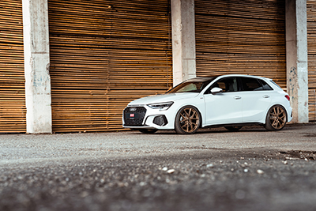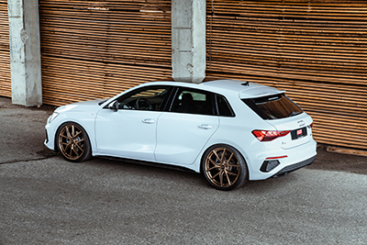

BBS CI-R Unlimited - Facts and figures

Dimensions: 8.0J x 19 to 11.5J x 19 inch, 8.0J x 20 to 11.5J x 20 inch,
In preparation: 8.5J x 21 to 12.0J x 21 inches
PCD: BBS Unlimited 5 x 117.5. Hub adapters of 14 to 50 mm thickness depending on application,
across 5 x 100 to 5 x 130 PCD.
Finishes: Standard: Platinum Silver Satin, Black Satin
Special colours: Racing Gold Satin, Diamond Black, Bronze Satin, White Gold Satin,
Indigo Blue Satin, Ceramic Polished
Design: one-piece, low-pressure casting, flow-formed, heat treated, weight optimised,
varied offsets, exchangeable BBS collision protection
Applications and reports: Parts report & ABE for Audi A3 8Y and other models
Prices: On request
Warranty: Five years
www.bbs.com

About BBS:

BBS is the world's best-known alloy wheel brand, a fact confirmed by continuous awards from leading German and international automotive trade journals. Founded in 1970 by Heinrich Baumgartner and Klaus Brand at the Schiltach site in the Black Forest, BBS stands for innovation, and has developed many industry-leading designs in its 50-plus-year history. Exacting controls ensure the high quality of BBS products, starting with low-pressure casting, flow-forming and special heat treatment, right through to the surface finish. Each wheel is checked several times by BBS employees throughout the manufacturing and finishing processes. Today, BBS automotive GmbH is part of the KW automotive group. In addition to the suspension manufacturer KW automotive with its brands KW suspensions, ST suspensions and ap Sportfahrwerke, these include the suspension manufacturers AL-KO Damping, Belltech and Reiger Suspension as well as the SimRacing brands TrackTime and Ascher Racing. With its immense product portfolio, KW automotive has been operating successfully worldwide for over 25 years.

Reprint free of charge * Proof requested

This press release can be found at: www.tuningpress.com

Contact press and document address:
MediaTel Communication & PR, Haldenweg 2, 72505 Krauchenwies-Ablach, Germany
Contact: Peter Hintze, Tel: +49 (0) 7576 /9616-12, E-mail: hintze@mediatel.biz

