The most X-treme composite material on the market

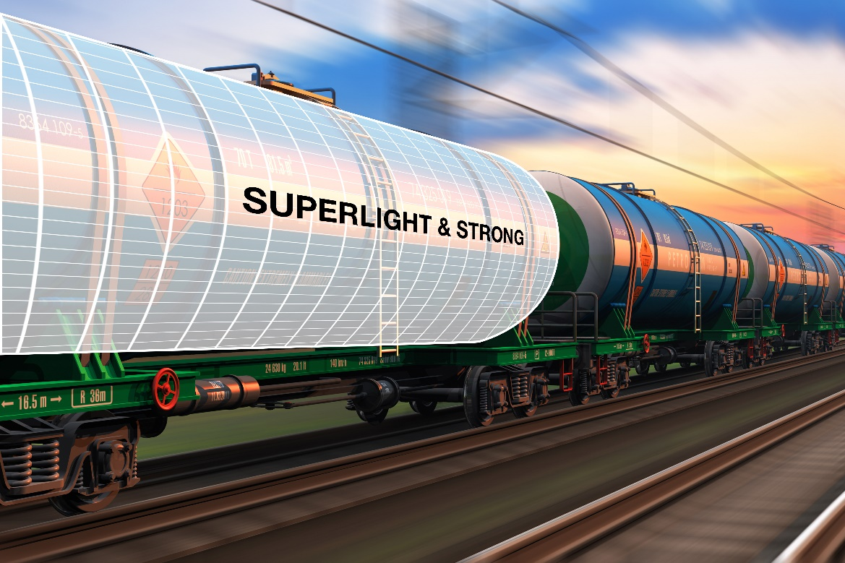
The strongest and lightest tank cladding
As the leading specialist for fibre-reinforced composites, LAMILUX Composites, has launched a revolutionary tank cladding material. The new material, developed and manufactured in Germany, is about five times stronger and 30 percent lighter than other tank cladding materials.

LAMILUX X-treme is the spearhead of tank cladding materials. It is a fibre-reinforced composite material with the maximum possible content of reinforcement fibres in a highly elastic epoxy resin matrix. The outstanding toughness saves operators time and money by reducing maintenance and repair costs and also container downtime.

For safe transport in difficult conditions
Tank containers of all kinds are subjected to very high mechanical loads during loading and transport, whether they are used as containers on a cargo ship or as tank containers on trains or on a truck. This is where LAMILUX X-treme comes in: it provides safe and energy-efficient transport of tank containers.

Even under the harshest conditions on the world's roads and seas, the material remains visually appealing and maximizes the durability of the entire structure. The operator also saves on running costs for his fleet, as the tank container has a significantly lower dead weight than one with a conventional exterior shell.

Advantages with LAMILUX X-treme tank cladding
- Reduced maintenance and repair costs
- Maximum durability and less downtime
- High-quality appearance even under the toughest conditions
- Reduced operating costs due to weight reduction

The customer's brand is the most import business value
It's not just about time and money to fix damaged containers, but it's also annoying. Mostly, the containers are repaired via patches, or they are partially replaced with new cladding. This results in containers looking like patchworks and not near a representative as when they were new. The LAMILUX X-treme protects the containers from being damaged, so they don't have to be repaired most of the time. It means that tank containers can remain their new look much longer and represent the customer's brand much better.

LAMILUX fibre-reinforced composites are produced in a continuous, automated production process. The separate production lines ensure minimum delivery times while providing consistently optimum quality, which can be reproduced at any time. The X-treme product range can be made in widths of up to three metres, and the length of sheets or rolls can be changed to meet the customer's needs.

LAMILUX at the transport logistic in Munich
From 9 - 12 May, numerous specialized service providers will be presenting their services for logistics, transport and forwarding at the transport logistc Fair in Munich, and LAMILUX Composites will be among them. The specialist for fibre-reinforced composites can be found in the ITCO Tank Container Village in hall B4 at stand P62.

…

www.lamilux.com

About LAMILUX Composites GmbH
LAMILUX Composites GmbH has been producing fibre-reinforced plastics for around 70 years. The medium-sized company is the leading European producer thanks to its technologically advanced continuous production process, large manufacturing capacities and wide product range. LAMILUX supplies customers around the globe in a wide range of sectors, such as the building industry, the automotive and recreational vehicle sectors, refrigerated store room and cell construction, and many other industrial sectors. In 2021, LAMILUX and its some 1,300 employees achieved a turnover of over 300 million euros. The family-managed company is based in Rehau, Bavaria.

