Celle – a Town between Tradition and Modernity
Ducal Town. Half-Timbered Town.
Bauhaus Town. Horse Town. Light Art Town
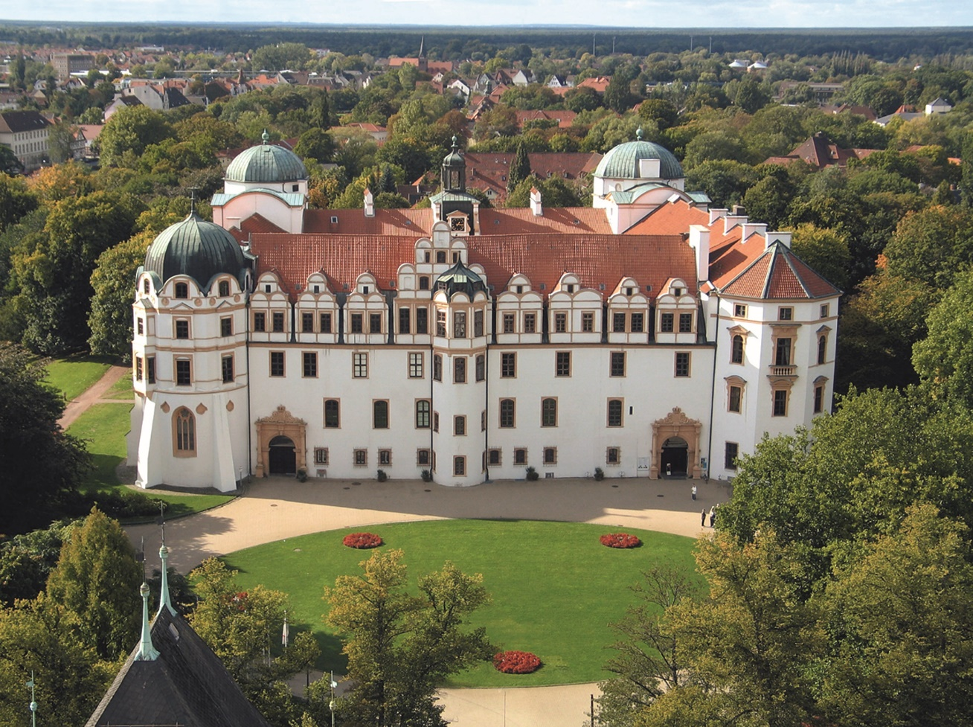
Celle's famous Ducal Palace (Copyright: Celle Tourismus und Marketing GmbH)

CELLE | Celle is a place of exciting contrasts, effortlessly combining tradition and modernity. Located about 40 kilometres northeast of Hanover, Celle is the picturesque Southern Gate to the Lüneburg Heath, and it is therefore no coincidence that in 2014 Celle was rated among the most likeable and lovable German towns with fewer than 80,000 in population (Celle has just under 70,000 inhabitants).

The travel magazine Geo even listed Celle as one of the top ten most beautiful towns in Germany. This is no surprise, as the ducal town is not only home to one of the most beautiful Guelphic palaces in Northern Germany, it also prides itself for hosting award-winning modern architecture and accessibility. History and culture, tradition and modernity, shopping and local delicacies as well as numerous events throughout the whole year, make Celle an attractive destination, offering most of its treasures to its visitors right in the heart of or close to its picturesque Old Town.

Celle which celebrated its 725th anniversary in 2017, welcomes about 2 million visitors every year, some of which just come for a day, but many extend their stay to a couple of nights (about 300,000 bookings are made every year). The picturesque Old Town - comprising almost 500 listed half-timbered connected buildings from several centuries, is a unique architectural ensemble from medieval and early modern times.
In January 2017, Celle was certified to be the first town in Northern Germany to be an environmentally sustainable destination. Therewith, the ducal town of Celle is the first town to achieve this certification in Northern Germany and within the whole state of Lower Saxony.
Princesses, Dukes and the British Monarchy - Celle's Royal Heritage
Celle's famous Ducal Palace dates back to the 13th century. The palace chapel was consecrated in 1485. This sacred Gothic building is one of the most important examples of Renaissance architecture in Northern Germany and is today considered to be the only surviving virtually complete ecclesiastical building in Germany from the early Protestant period.
Celle's palace was once frequented by European nobility. For many centuries, it was the home of the Dukes of Brunswick-Lüneburg. Duchess Éléonore is often called the Grandmother of Europe as her descendants are now kings and queens in many European countries. Her husband Georg Wilhelm was fond of Italy and put much effort into extending the palace in the 17th century, employing Italian craftsmen. Together, they established the Schlosstheater (Castle Theatre) which is Germany’s oldest continually performing baroque theatre with a resident company. Another highlight is a visit to the Welfengruft (Burial Vault of the Guelphs) in the Stadtkirche St. Marien (St. Mary’s Town Church). There you will find Princess Sophie Dorothea of Celle buried next to her ancestors. Her great granddaughter, English Princess Caroline Mathilde, who brought splendour and glamour to the town as the exiled Queen of Denmark, also found her final resting place here.
Apart from the castle, horses are as much associated with Celle as the river Aller. The famous Hanoverian State Stud lies within the town's boundaries and holds famous annual Stallion Parades, attracting not only numerous statesmen and women, crowned heads of state and many other celebrities, but also visitors from all over the world to this little town at the edge of the Lüneburg Heath.
Culture, History and a Museum that is unique in the World
The Residence Museum directly in the Celle Palace gives the visitor an insight into the “inappropriate” relationships of the castle's female inhabitants: Both Sophie Dorothea and Caroline Mathilde fell from grace due to having love affairs not befitting their stations. One of them might even have been Queen of England. But it was not to be, and the antics of Celle's “Grand Dames” still cause deep upset in historical discourse and provide many entertaining stories for cinema, theatre and literature.
Right opposite the Celle Palace you can find the Bomann Museum, one of the most important museums on cultural history in Lower Saxony. Its exhibition stretches over 5,000 square meters, showcasing the history of the town and region from their earliest times until today. Seven guided tours will take you past objects that focus on the life and work of ordinary local people.
If you are interested in the arts, you should definitely pay a visit to the Celle Art Museum next door. It displays exhibits from the early twentieth century to today. The Eberhard Schlotter Foundation deserves special mention as well as the Tansey Collection of Miniatures which is an internationally renowned collection of miniaturised paintings spanning works from the 16th to the 20th century. At night, the museum turns into a 24-hour art spectacle that is unique in the world: As soon as the doors close in the evening, the big square glass front of the building is illuminated by changing colourful lights. The museum is home to one of the most comprehensive collections of contemporary light installations such as “Zone Zero” by Otto Piene, “Blaulichttreppe” (Blue Steps) by Vollrad Kutscher and “Capri Battery” by Joseph Beuys.
Baroque meets Bauhaus
Celle is also just the place to go to for lovers of modern architecture, because many buildings here belong to the “Neues Bauen” (“New Objectivity”) that revolutionised living in Germany in the 1920s and 1930s: In today's terms, you might call it the cradle of social housing. During this period, the town had an excellent reputation and fared well in comparison with bigger cities such as Berlin or Frankfurt. One of the ten internationally most appreciated Bauhaus buildings is the Altstädter Schule (Old Town School), designed by Celle architect Otto Haesler in 1927/28. This so-called “glass school” and the rector's building next door made Celle a mecca for architecture lovers and put its name on the world map.
Local Specialities and Delicacies
A visit to Celle's Old Town with its many privately-owned shops is an experience not to be missed. Of course, you can also find big brand name stores here. Once you have worked up a good appetite on your extended shopping tour, why not pay a visit to one of the many restaurants in the middle of the historic Old Town in order to indulge in local delicacies such as meat dishes made from wild animals or Heathland sheep, finest confectionary, buckwheat cakes, herb-flavoured liqueurs and all the best the Heath has to offer: honey, asparagus, potatoes and much more. The Celle Rohe Roulade (raw steak roll) is definitely worth sampling. Even celebrities are coming from afar to stop by and enjoy this dish which is served with bread or roasted potatoes. The recipe is very unique and only served in Celle.
The beautiful surroundings known as Cellerland, with their wide, open heath areas (giving Celle a carpet of flowers in late summer), its moors and forests, invite you for day trips. However, you might not find the time, as you have not yet explored Celle's roles as a location for oil production, rowing sport, flute music, Reformation history, cracker bread production, orchid growing and so much more.
(7.183 letters)
# # #

Please send us a voucher copy after publication.
You will find picture material and further information on our website. Should you require additional picture material, please contact us.
www.celle-tourismus.de
celle.travel

