PRESS RELEASE
Schwaebisch Hall, March 15, 2023

OPTIMA at INDEX 2023
Flexible packaging solutions from OPTIMA are meeting challenges in the paper hygiene industry

Optima will be presenting at INDEX, the world's leading trade show in the nonwovens sector, from April 18 to 21, 2023, in Geneva. The new OPTIMA HSC horizontal high-speed cartoner is regarded as an exhibition highlight. The cartoner takes speed combined with format flexibility to a new level in the packaging industry. Its agility greatly exceeds previous solutions on the packaging machine market. Optima will also be presenting an innovative and flexible solution that enables a variety of environmentally friendly packaging materials to be used in the paper hygiene sector. The group is therefore opening up new opportunities for customers in terms of packaging flexibility.
Sustainable packaging materials are in greater demand than ever before. Optima supports companies meet this challenge by providing flexible packaging systems such as the new horizontal high-speed cartoner OPTIMA HSC. "Our exhibition appearance has the motto "Delivering new flexibility in packaging". The new horizontal high-speed cartoner OPTIMA HSC paves the way for this. As a company, we can only achieve honest packaging based on the principle of a holistic view of the circular economy with innovative technologies. At Optima, we have understood and embraced this," explains Oliver Rebstock, Managing Director of OPTIMA nonwovens GmbH.
The new horizontal high-speed cartoner OPTIMA HSC opens up new possibilities in terms of packaging flexibility for the paper hygiene industry. What makes this machine special is that the horizontal cartoner enables agility far exceeding the solutions currently available on the market. The system features a packaging process that sets new standards for speed and format flexibility in the paper hygiene industry. The OPTIMA HSC can also be flexibly connected to bag packaging machines. With this combination, it is possible to use a wide variety of packaging materials in one system, including cardboard, paper, biodegradable and PE bags.
Digital service solution for sustainable production
Employees in production are increasingly becoming “Connected Workers”. Optima applications support machine operators during their daily work with the machine. They are provided with digital assistance systems that support them in handling the machine. This includes the OPTIMA Format Change Assist, for example, which provides step-by-step instructions for changeovers made between different pack sizes. A remote connection for Optima Service and much more are also included in the service portfolio. The process optimizations achieved reduce waste, increase efficiency thanks to fewer interruptions and improve system availability, which in turn has a positive effect on conserving resources in production.

Optima at INDEX 2023 (Geneva), April 18 to 21, 2023: Palexpo, Hall 2, Booth no. 2581

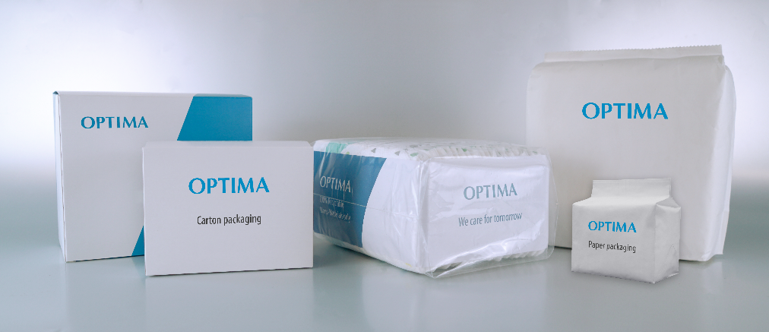
The new OPTIMA HSC horizontal high-speed cartoner opens up new possibilities in terms of packaging flexibility for the paper hygiene industry. It is possible to use a wide variety of packaging materials in one system, including cardboard, paper, biodegradable and PE bags. (Source: Optima)

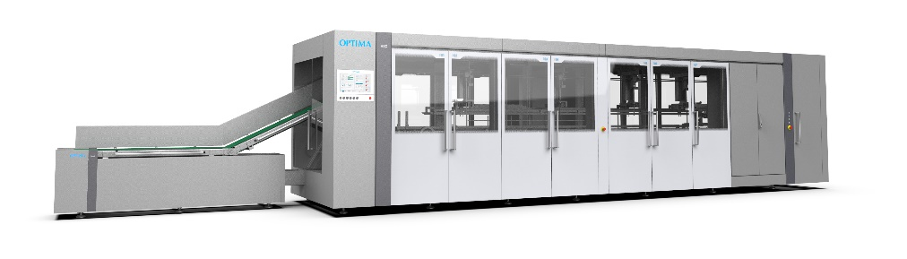
What makes the OPTIMA HSC special is that the horizontal cartoner enables agility far exceeding the solutions currently available on the market. The system can be flexibly connected to existing OPTIMA bag packaging machines. (Source: Optima)

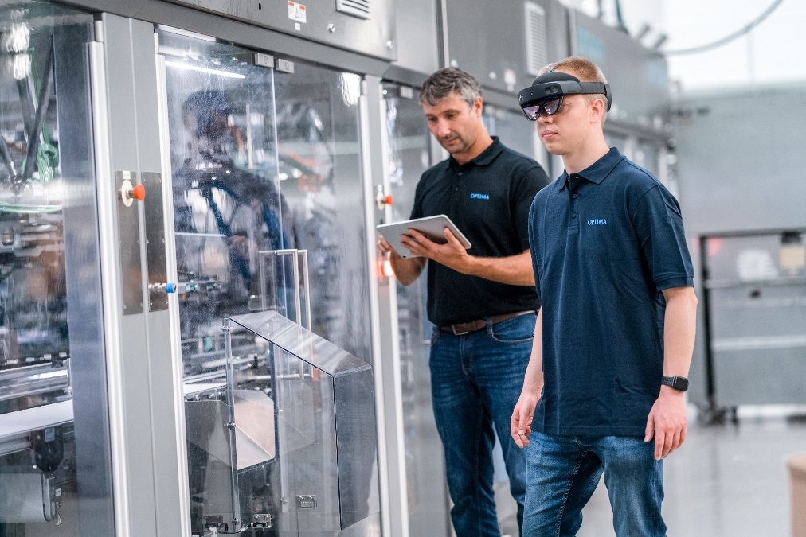
The "Connected Worker" service approach offers customers a complete digital solution for the first time. Machine operators are provided with digital assistance systems that support them in handling the machine and ensure sustainable production. (Source: Optima)

Characters (incl. spaces): 2,801

Press contact:
OPTIMA packaging group GmbH
Jan Deininger
Group Communications Manager
+49 (0)791 / 506-1472
pr-group@optima-packaging.com
www.optima-packaging.com

About OPTIMA
Optima supports companies worldwide with flexible and customer-specific filling and packaging machines for pharmaceuticals, consumer goods, paper hygiene and medical devices markets. As a provider of solutions and systems, Optima accompanies these companies from the product idea through to successful production and throughout the entire machine life cycle. Over 3,000 experts around the globe contribute to Optima's success. 20 locations in Germany and abroad ensure the worldwide availability of services.

Thank you very much for your publication. We look forward to receiving a digital specimen copy.

