Neue Pistole für Hochdruckreiniger EASY!Force Advanced ausgezeichnet

Kärcher gewinnt den CMS Purus Innovation Award 2017

Pressekontakt
Linda Schrödter
Pressereferentin
Alfred Kärcher GmbH & Co. KG
Alfred-Kärcher-Str. 28-40
71364 Winnenden
T +49 71 95 14-3918
F +49 71 95 14-2193
linda.schroedter@de.kaercher.com
Winnenden, 19. September 2017 – Kärcher hat für seine neue Pistole für Hochdruckreiniger EASY!Force Advanced bei der in Berlin stattfindenden Reinigungsfachmesse CMS 2017 den Purus Innovation Award erhalten. In der Kategorie Equipment setzte sich die neuartige Lösung gegen zwei weitere Finalisten durch.
Das wesentliche Merkmal der neuen Pistole ist der Abzug, der mit dem Handballen in den Griff geschoben wird. Dadurch erübrigt sich nach dem Auslösen praktisch jegliche Haltearbeit, da der Rückstoß des Wasserstrahls den Abzug von selbst in die Hand drückt. Die bisher nötige, dauerhafte Anspannung von Hand- und Fingermuskulatur entfällt, einer Verkrampfung der Muskulatur wird somit vorgebeugt. Ungewolltes Auslösen wird durch einen gelben Sicherungshebel, an der Innenseite des Griffs, verhindert. Nach einmaligem kurzem Betätigen kann er wieder losgelassen werden.
Kärcher ist weltweit führender Anbieter für Reinigungstechnik. Das Familienunternehmen beschäftigt in 67 Ländern und mehr als 110 Gesellschaften über 12.000 Mitarbeiter. Für einen weltweit lückenlosen Kundendienst sorgen 50.000 Servicestellen in allen Ländern. Im Jahr 2016 erzielte Kärcher mit 2,33 Mrd. Euro den höchsten Umsatz in seiner Geschichte.

Eine Word-Datei und druckfähige Bilder zu dieser Presseinformation liegen für Sie auf unserer Internetseite www.kaercher.com/presse zum Download bereit.

Kaercher_CMS_Purus_Innovation_Award_Easyforce_2017_de.docx

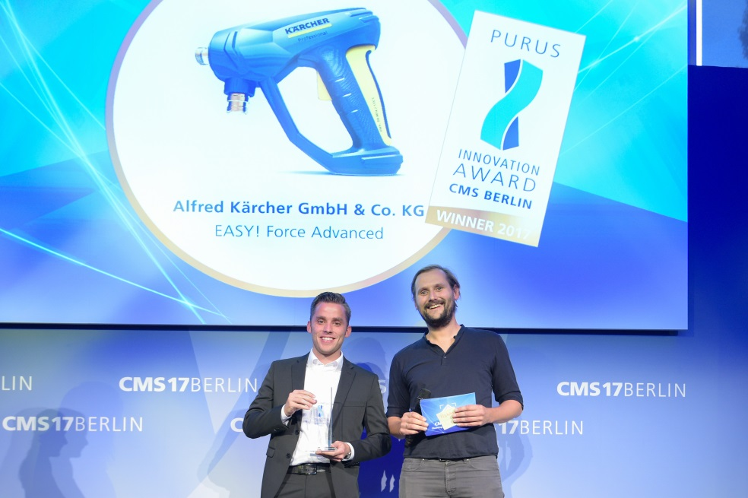
Steffen Burger (Links), Produktmanager Hochdruckreiniger bei Kärcher, nimmt den CMS Purus Innovation Award 2017 für die neue Pistole für Hochdruckreiniger „EASY!Force Advanced“ entgegen.

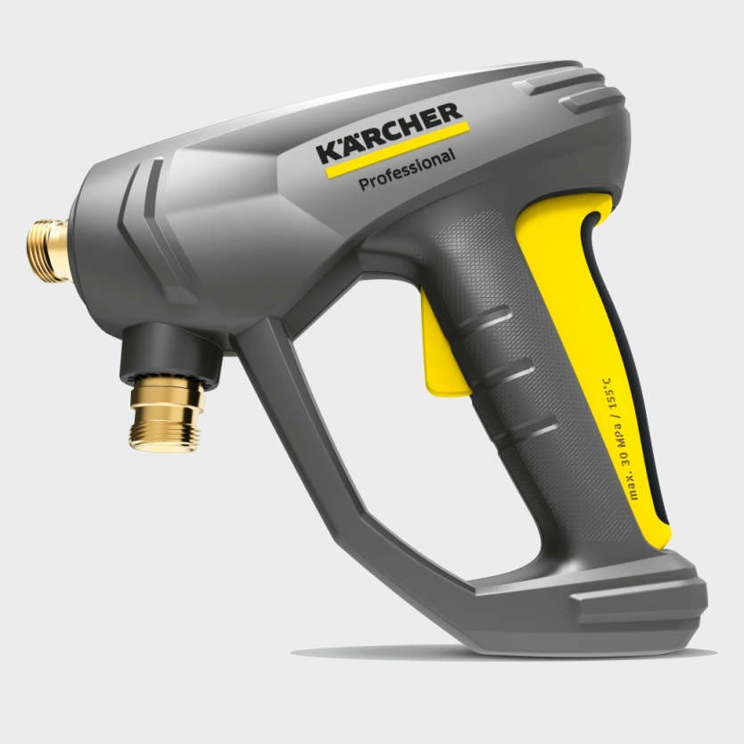
„EASY!Force“, die neue Pistole für professionelle Heiß- und Kaltwasser-Hochdruckreiniger von Kärcher. Auffälligstes Merkmal ist der erstmals an der Rückseite des Griffs eingebaute, gelb-schwarze Abzugshebel. Er wird durch den Rückstoß des Wassers in den Handballen gedrückt. Ohne zusätzlichen Kraft- und Halteaufwand kann so die Pistole im Dauerbetrieb genutzt werden. Im Innern des Griffs befindet sich der gelbe Sicherungshebel gegen ungewolltes Auslösen der Pistole.

