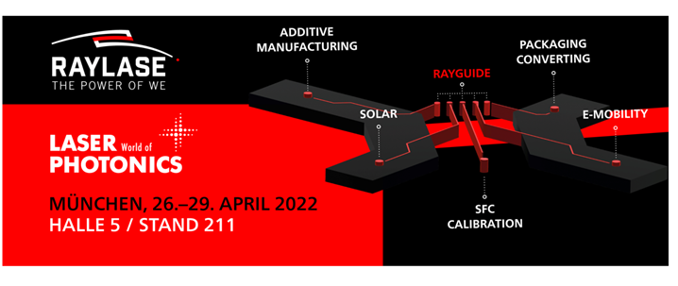

**Laser systems: innovative software ensures optimum production results**

**At this year’s Laser World of Photonics 2022 in Munich, RAYLASE will be presenting its RAYGUIDE software – which is a game-changer for an extremely wide range of industries**

Making production processes more efficient and ecological is a major challenge in these times we live in. Laser-based manufacturing processes in industrial production are among the most innovative methods in this respect. But to fully harness all the components’ potential, they need to be networked using coordinated software that optimally connects the lasers, the laser deflection unit, the mechanical system and the optical system via the control electronics, including all the features. The software makes a considerable contribution to enhancing the efficiency of laser systems’ precision in manufacturing with less material and resources. RAYLASE, the high-tech laser technology company, will present its latest software (RAYGUIDE) at this year’s Laser World of Photonics in Munich, which is set to run from 26 to 29 April 2022. It enables mechanical engineers and integrators to achieve more precise and faster results for the e-mobility, solar, Additive Manufacturing and packaging sectors. This once again makes the vision of a fully networked, 100% quality-monitored, data-driven Industry 4.0 process world more tangible.

**RAYGUIDE: a plus point for many areas**

The software’s new architecture is designed to achieve the goal faster and more flexibly, all the while ensuring high product stability and maximum user-friendliness. Together with the powerful SP-ICE-3 control electronics, it offers high functionality for solar applications and perfect solutions for the welding process in electromobility. Numerous welding ramp functions and overlapping operability on several process fields at the same time are extremely important, especially in battery production and fuel cell manufacturing. The smart software power package, complete with outstanding intelligence and a modern and intuitive graphical user interface (GUI), also optimises laser cutting of electrode foils and current collector lugs in battery production.

RAYGUIDE is also used in numerous other applications, including the likes of marking, perforating, surface and MOTF processing in electromobility, not to mention cutting electrode foils, scoring packaging foils and cutting paper packaging and cardboard boxes in the packaging sector. Highly automated integration over the programmable API in the software developer kit is another plus for users. The user interface has a modern visual design, and the required panels are arranged freely. “RAYGUIDE is still a fairly new product, but even though we are still at the start of the product cycle here, we are at the forefront with this software package in terms of process time, process quality and creating new opportunities for the market,” affirmed Robert Kachel (Software & Control Electronics Product Manager at RAYLASE).

**AXIALSCAN FIBER 50 + FOCUSSHIFTER 14: new additions to the portfolio**

The AXIALSCAN FIBER 50 pre-focusing deflection unit with the latest digital and highly dynamic RAYVOLUTION DRIVE focus axis offers the smallest spot diameters for large field sizes, direct laser-fibre connection and process monitoring without optical or chromatic distortions. RAYLASE’s RAYSPECTOR monitoring module can be attached as an option. When combined, both of these components enable mechanical engineers in the “contacting battery cells” segment to do more than just determine the cells’ exact position using coaxial camera technology; they can also connect welding monitoring systems to assess the quality of welds. The same is also true of welding bipolar plates for fuel cells.

The new, compact FOCUSSHIFTER 14 from RAYLASE is also proving to be an excellent tool here for marking on electronic circuit boards, especially for stripping and cleaning contact surfaces in electromobility.

**SFC: a quantum leap in laser system calibration technology**

RAYLASE’s current trade fair range is rounded off by its presentation of the SCAN FIELD CALIBRATOR, which takes over the calibration of a scan field as part of a fully automatic process. The reason for this is the fact that, at present, manual setup of laser systems is increasingly reaching its limits when it comes to challenging requirements. Especially in additive manufacturing and electromobility, manual processes are often too inaccurate and error-prone, and require hours and days of time just to calibrate machine fleets and laser process fields correctly. The new SFC is defining a high level of perfection in terms of step, time and accuracy savings. “This new tool guarantees the industry both maximum precision and a maximum calibration process speed at the same time, so it’s proving to be an extremely useful industrial resource. We are currently unique in the market,” commented Harnesh Singh, Sales & Marketing Director at RAYLASE.

**Campaign: Meet the Originals**

Since RAYLASE never stops competing for bright minds, the company has come up with something special for this fair. Not only does it have an aggressive social media campaign with profiles of individual departments; it is also offering a meeting point at Laser World of Photonics in Munich for students, PhD candidates and professionals: booth 211 in Hall A5 – Laser Systems for Industrial Manufacturing. Under the “MEET THE ORIGINALS” slogan, interested individuals can have close contact with RAYLASE experts from a wide range of divisions and departments. After all, as we all know, nothing beats personal contact.

__________________________________________________________________________________

**About RAYLASE**

*RAYLASE GmbH is a highly innovative, international laser company based in Wessling near Munich. Founded in 1999, the Bavarian company offers high-precision opto-mechanical components, control cards and software for the rapid deflection and modulation of laser beams for laser material processing in industrial manufacturing. With over 130 employees worldwide, the RAYLASE Group stands for innovative technology of the highest quality. Since 2007, the company has a subsidiary and its own production facility in Shenzhen, China, as well as several international representatives in the US, Italy, Japan, Korea, and Taiwan.*

*The laser deflection units comprise opto-mechanical scanners and digital control electronics with an intuitive software interface. These form the core of industrial laser systems and enable more flexible, economical, and precise processing of a wide variety of materials such as metal, plastic, paper, textiles and many more. Opto-mechanical deflection units also offer excellent image processing for better calibration, simple automation, and exact monitoring of a range of laser processes.*

*Customers come from the electronic, automotive, photovoltaic, textile and packaging industries. RAYLASE’s current focus markets are electromobility, for example, in battery production, solar wafer production for photovoltaics in the solar industry and additive manufacturing. RAYLASE supports its customers primarily in four core applications: laser cutting, laser welding, laser surface processing and selective laser sintering or welding for additive manufacturing. In each of these areas, the company drives digital innovations by combining these with established technologies. Visit RAYLASE at the Laser World of Photonics in Munich at booth* 211 in Hall A5

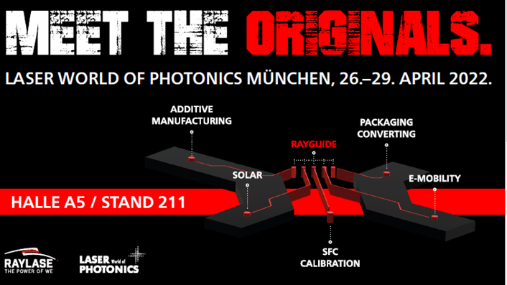

BU: RAYLASE is recruiting skilled professionals with the ‘MEET THE ORIGINALS’ campaign

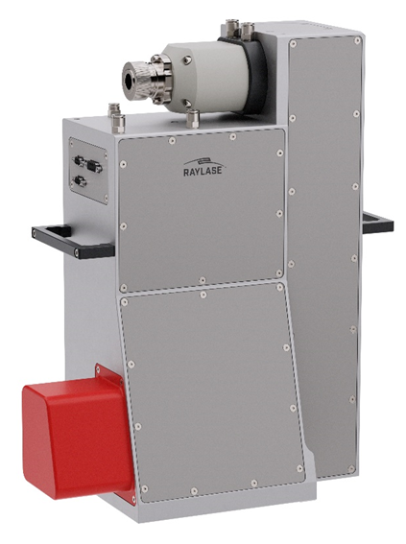The AXIALSCAN FIBER-50