The keys to decarbonization lie in Berlin, Halle/Saale, and Prenzlau – 75 years of GEA Refrigeration Germany

Duesseldorf (Germany), July 9, 2025 – GEA Refrigeration Germany celebrated its 75th anniversary at its Berlin site. GEA Refrigeration Germany also includes the sites in Schkopau near Halle and GEA AWP in Prenzlau. Their employees were also invited to the anniversary celebrations in Berlin. GEA is a global leader in heating and cooling technology. As a global specialist in industrial heating and cooling technology and temperature control, GEA offers sustainable energy solutions for a wide range of industries, including the food and beverage industry, the dairy industry, the marine industry, the chemical and pharmaceutical industry, the oil and gas industry, energy production, and the sports and leisure sector. The proven technologies by GEA are characterized by reliability, efficiency, sustainability, and long life cycles, contribute significantly to decarbonization, and keep total operating costs low.

The “magic triangle” in heating and cooling technology

GEA Heating & Refrigeration Technoligies (HRT) provides key technologies for decarbonization in the field of heating and cooling technology. At its sites in Berlin and Schkopau near Halle, GEA Refrigeration Germany develops, manufactures, and sells screw compressors, compressor units, liquid chillers, and heat pumps. GEA AWP develops and manufactures valves and components for industrial refrigeration systems and machines in Prenzlau. In particular, it manufactures valves that are specially designed for heat pump applications. Its main products include safety valves, shut-off valves, ball valves, suction filters, and oil management valves. The components are used in all types of heating and cooling systems, such as in the heat pump industry, in cooling and freezing technology in the food industry, in cooling in the dairy industry, in component equipment for oil drilling platforms and ships, as well as in cooling processes in the brewing industry, in the chemical and pharmaceutical industries, and in special cooling applications such as indoorwinter sports facilities, artificial ice rinks, and ski halls.
Many of GEA's heating and cooling systems use natural refrigerants such as ammonia. They enable GEA customers to reduce their energy consumption and carbon footprint.
“We look to the future with creative enthusiasm and a spirit of innovation.”

Hardly anyone was quoted as often at the official anniversary celebration of the GEA site in Berlin, headquarters of GEA Heating & Refrigeration Technologies Germany, as refrigeration researcher and university rector Rudolf Plank. He is considered the founder of scientific refrigeration technology. Plank, also known as the “cold pope,” died in 1973. His statement on the connection between history in heating and refrigeration technology and the constant look ahead has been passed down: "It is necessary to look back in order to recognize the possibilities of the future. Looking back should not be a matter of sentimental complacency and childish pride in what others have achieved. The past, however successful it may have been, lies behind us. Only the future can captivate a creative spirit, only the unsolved tasks that appear in ever greater numbers as we progress." At the anniversary celebration of the GEA site in Berlin, the managing directors of GEA Refrigeration Germany, Tom Trinkaus and André Krychowski, said in unison: "With the passage of time, Rudolf Plank's message remains as relevant as ever. We, too, look to the future with creative enthusiasm and a spirit of innovation. At our Berlin location, ideas take shape, challenges are mastered with ingenuity, and progress is driven forward by visionary people.“ And they both add: ”Our turnkey cooling and heating systems, customized systems, compressors and compressor packages, refrigeration systems, controls, and heat pumps are designed to precisely meet temperature requirements. With comprehensive service programs, we support our customers throughout the entire life cycle of their systems, ensuring optimum performance at all times."

Career opportunities at GEA HRT Germany

Even though the average length of service and thus team membership in Berlin, Halle-Schkopau, and Prenzlau is high, skilled workers will be needed in the future. These include mechatronics engineers, machining mechanics, and plant mechanics. GEA also offers a dual study program in mechanical engineering, which provides applicants and interested parties with unique prospects and an efficient way to achieve their personal goals: a completed education, good integration into the company, and a dedicated course of study. Studying and gaining professional experience thus complement each other perfectly.

The history of GEA HRT Germany and the Berlin location

The history of GEA screw compressors dates back to 1950, when VEB Kühlautomat Berlin (KAB) was founded. In the former GDR, “VEB” was the designation for state-owned enterprises. KAB was founded to meet the urgent need for repair and maintenance of refrigeration technology and to develop new products for commercial cooling – both of which were in high demand after the Second World War. The first compressors from 1952 were based on aircraft engines and were manufactured in nine sizes with flow rates from 112 to 880 m³/h in a star-shaped design. In the mid-1950s, around 50 employees worked in offices and factory buildings in southeast Berlin – a location with plenty of room for expansion and good rail connections. Unlike the Federal Republic of Germany, the GDR did not benefit from the Marshall Plan. Instead, it had to pay reparations, including the construction of large shipyards in Wismar and Stralsund, where refrigerated and fishing vessels with refrigeration systems were produced. Smaller refrigeration units remained the core business at first. From the end of the 1950s, however, the production of refrigeration systems for ships grew, especially for the Soviet Union. Material testing chambers for the Soviet space program were also developed. In 1958, VEB Kälte and VEB KAB merged, strengthening the company's position in the ship refrigeration market. In the 1960s, the focus shifted to freezers and drinking water coolers for hot climates. A merger with VEB Diesel-Motorenwerk Johannisthal in 1968 finally enabled the company to develop its own screw compressors. In 1969, KAB launched its first screw compressor: the S3-800 with a capacity of 770 m³/h. This was followed shortly afterwards by the S3-900, optimized for maritime applications. This led to larger models such as the S3-1800 and S3-2500.
Two technological breakthroughs were decisive:
• The rotor profile: In 1976, the symmetrical profile was replaced by an asymmetrical profile generated by a moving point, which improved efficiency and service life. The tooth ratio was changed from 4:6 to 5:6.
• The Vi adaptation: In the 1980s, a new slide valve system was introduced that adapted the internal compression to changing operating conditions – for example, with different refrigerants or seawater temperatures.
These technologies can now be found in all 24 screw compressor sizes from GEA.

Dr. Dieter Mosemann The “heat and cooling guru” of GEA

Dr. Dieter Mosemann, former head of development and later external consultant at GEA, describes how the work of companies in the East was long underestimated or portrayed negatively. Yet these companies had outstanding technologies and solutions at their disposal. Nevertheless, KAB had no opportunity to enter the market. After the fall of the Berlin Wall, there was a lack of sales experience. It was only through the merger with GEA GRASSO that the opportunity arose to enter the market under a well-known and respected brand. From the very beginning, this developed into an open and fruitful partnership.
“A tour of the GEA site in Berlin is a celebration of where we come from, who we are, and where we are going,” says Managing Director Tom Trinkaus. He mentions the areas described below.

Warehouse, spare parts, logistics: Goods receiving

The warehouse is not only used for storage, but is also an important part of the GEA quality assurance system. Around 6,500 components are in stock. Each part must meet GEA quality standards, be tested, and verified with a certificate of authenticity. These certificates accompany the components throughout the entire assembly process and provide complete documentation of all components used. They are also part of the documentation package that accompanies each compressor throughout its entire service life. In addition, the warehouse holds a comprehensive stock of spare parts so that we can supply our customers worldwide with original parts.

Housing machining lines

A wide range of compressors are manufactured at the GEA plant in Berlin. Each one starts as a precision-cast housing developed by GEA engineers for maximum durability – with a unique design and shape that allows for quick and easy maintenance. GEA technicians machine the housings with the utmost care on CNC-controlled machines, paying close attention to every detail.

Rotor machining lines

This is where the heart of the compressor is located. The precise fit of the male and female rotors is the decisive factor for the performance of each individual unit. The GEA compressor portfolio includes 48 different rotor types, each of which is turned, milled, and hardened—perfectly machined for many years of reliable operation. Each rotor uses GEA's patented 5/6 rotor profile, which is compact, rigid and designed for higher energy efficiency.

Quality control room

The GEA quality control room stands for maximum precision. Specialized measuring instruments record 50 reference points to ensure that the rotors are manufactured with a tolerance of only a few micrometers. To guarantee this, the room is temperature and humidity controlled to prevent material deformation. This attention to detail ensures that less refrigerant flows past the rotors without being compressed – which means that the efficiency and performance of the compressor meets the defined GEA standards.

Assembly of screw compressors

GEA compressors are assembled with the utmost care by experienced engineers. The M and LT series compressors are assembled according to the line principle. Two assembly lines, each with four stations, are available for this purpose. The particularly large compressors are assembled at a fixed assembly location. A digital life cycle file is created for each compressor, which accompanies the entire production documentation. Before the compressor leaves the factory, it is given a fresh coat of paint

Finally, the end-of-line test (EoL)

Each compressor undergoes an end-of-line test (EoL) before leaving the factory. The tests include:
• a leak test using ultrasonic monitoring in a water tank,
• a strength test at 1.5 times the maximum permissible operating pressure,
• a leak test at maximum permissible operating pressure,
• a function test on the test bench,
• automatic monitoring of functionality, volume flow, oil quantity, and power consumption during operation with nitrogen gas.

Assembly of screw compressor units

GEA supplies many compressors as pre-assembled units in which the compressor is connected to a motor – including all necessary piping, electronics, and control technology – mounted on a frame. The units are individually tailored to each application and customer requirements. Each unit includes refrigerant and oil piping as well as the installation of electrical and control components. The motors are precisely aligned using laser optics. Before leaving the factory, the units are tested, labeled with the relevant safety information, and painted using HVLP (high volume, low pressure) technology in accordance with European VOC (volatile organic compounds) guidelines.

Test center Validation

The GEA validation test center in Berlin fulfills a dual function. It is used to test screw compressors and larger reciprocating compressors as well as complete heat pumps. At the same time, it serves as a test facility for new product development.

The test bench

The N4 test bench is used to test large screw compressors from the XB to XH series and the L-XHP series for heat pumps before delivery to customers. 3.8 MW of drive power is available for the tests. Natural ammonia is mainly used as the refrigerant.

New development

The Validation Test Center (VTC) enables new products and components to be tested under real operating conditions and new applications to be identified – particularly in the field of heat pumps. New requirements for heating temperatures above 95 °C and solutions for refrigeration based on natural refrigerants can be developed together with our customers and tested under the necessary conditions. An example: GEA high-pressure compressors for heat pumps, which achieve water temperatures of up to 95 °C in heating systems, were developed by GEA engineers and extensively tested at the VTC to reduce costs.

Service

With GEA products in use worldwide, it is essential to provide customers with sustainable and effective service throughout the entire life cycle of our machines – which can exceed 30 years – regardless of where they are located. This service includes not only the timely delivery of original spare parts, but also scheduled annual maintenance and unscheduled troubleshooting. After around 50,000 operating hours, every machine requires a general overhaul, during which components are reconditioned or replaced depending on their condition. Before a reconditioned machine is put back into operation, it is thoroughly tested to ensure that it works just as safely and efficiently as a new compressor.

Photos:

Photo 1:

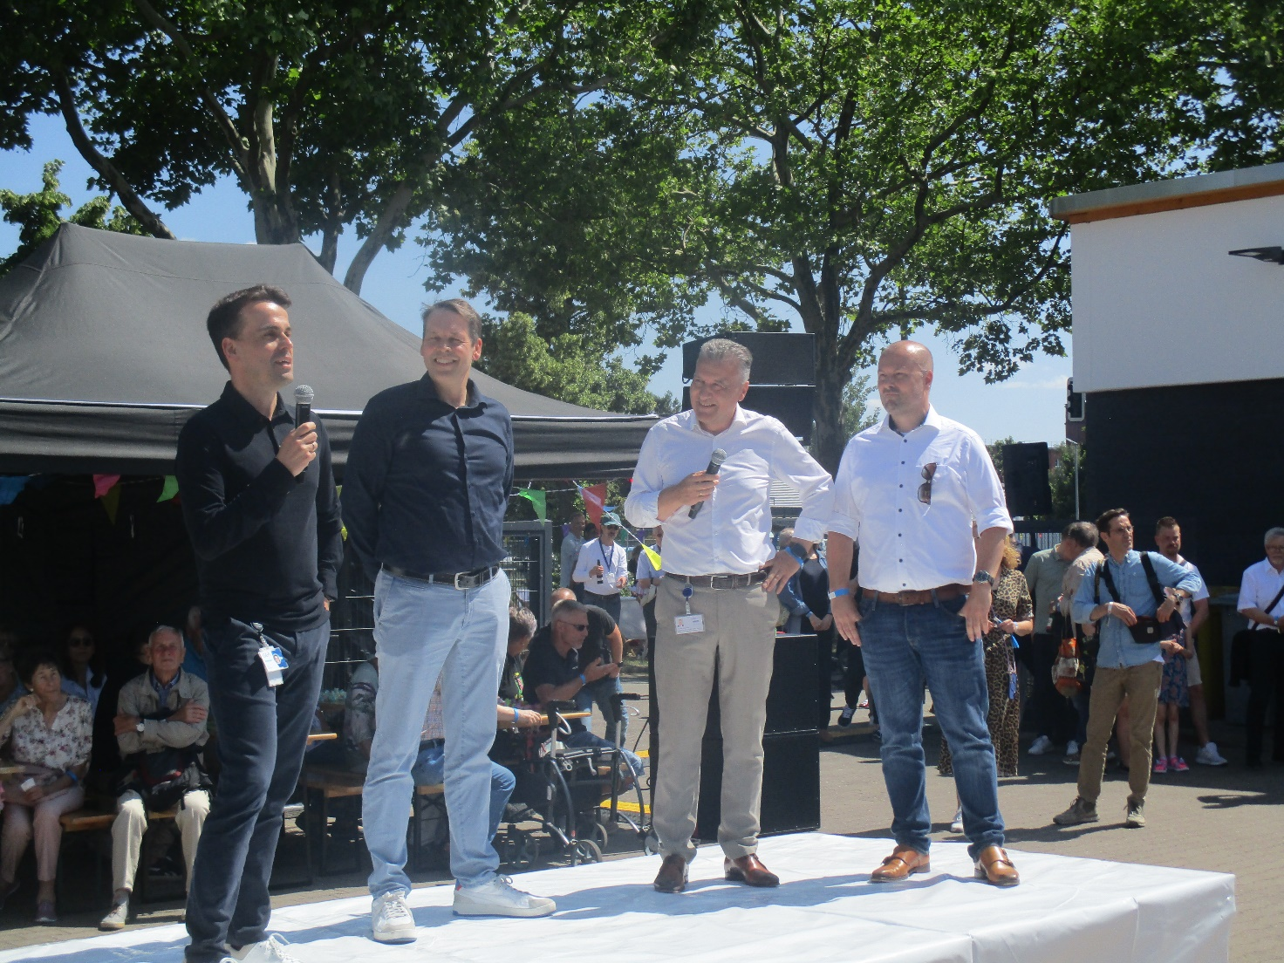

Photo 1, caption: Kai Becker, Head of the Heating & Refrigeration Technologies Division, Tom Trinkaus, Site Manager Berlin and Halle, Thomas Strotkötter, Head of the Compression Technologies Business Unit, and André Krychowski, Head of Finance for the Compression Technologies Business Unit, welcomed around 1,000 guests to the opening of the anniversary celebrations at the GEA HRT site in Berlin. (Photo: GEA)

Photo 2:

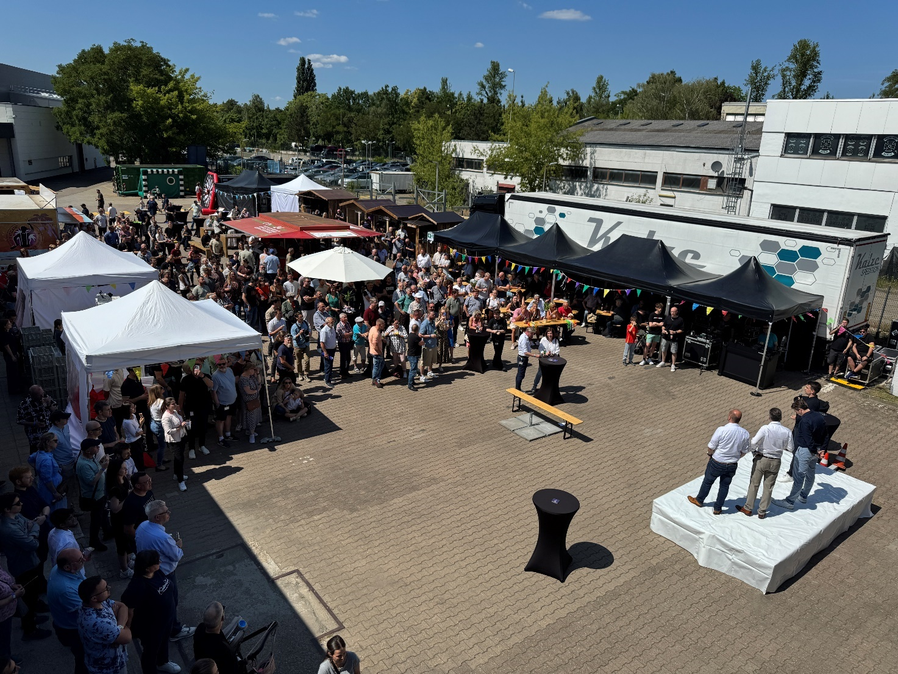

Photo 2, caption: There was a large turnout at the anniversary celebration at the GEA HRT site. (Photo: GEA)

Photo 3:

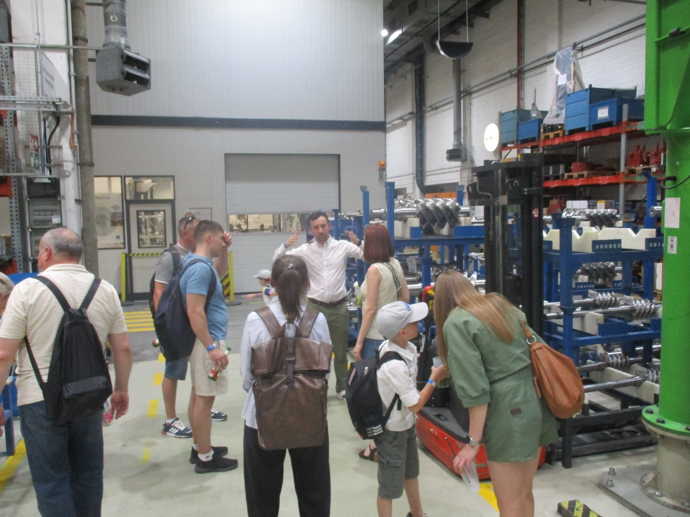

Photo 3, caption: Many guests took the opportunity to visit the production facilities. (Photo: GEA)

About GEA
GEA is one of the world’s largest suppliers of systems and components to the food, beverage and pharmaceutical industries. The international technology group, founded in 1881, focuses on machinery and plants, as well as advanced process technology, components and comprehensive services. For instance, every second pharma separator for essential healthcare products such as vaccines or novel biopharmaceuticals is produced by GEA. In food, every fourth package of pasta or every third chicken nugget are processed with GEA technology. With more than 18,000 employees, the Group generated revenues of about EUR 5.4 billion in more than 150 countries in the 2024 fiscal year. GEA plants, processes, components and services enhance the efficiency and sustainability of customers’ production. They contribute significantly to the reduction of CO2 emissions, plastic usage and food waste. In doing so, GEA makes a key contribution toward a sustainable future, in line with the company’s purpose: ”Engineering for a better world.”

GEA is listed on the German MDAX, the European STOXX® Europe 600 Index and is also a constituent of the leading sustainability indices DAX 50 ESG, MSCI Global Sustainability and Dow Jones Best-in-Class World.

More information can be found online at gea.com.
If you do not wish to receive any further information from GEA, please send an e-mail to pr@gea.com.

NOTE TO EDITORS

- Further information about GEA
- To the GEA Press page
- To the GEA Media Center
- Background information on current topics can be found at Features
- Follow GEA on  

GEA
Media Relations GEA
Dr. Michael Golek
Peter-Müller-Str. 12, 40468 Düsseldorf
Phone +49 211 91361505
Tel. +491736205746
michael.golek@gea.com

