Skylights from LAMILUX combine aesthetics with a high level of soundproofing, fire and heat protection

Design meets safety

Optimal lighting conditions can be achieved in modern architecture, especially with the help of glass roofs or skylights. Here, the skylights used must be both fall- and fall-through-proof and ensure soundproofing, fire and heat protection. Architects or specialist planners should also pay attention to sufficient sun and glare protection when making their selection. LAMILUX's multifaceted product portfolio offers a combination of diverse design and considerable safety: Glass Roofs, Glass Skylights and Flat Roof Access Hatches fulfil equally high visual and functional requirements.

Modern architecture is usually characterised by unusual shapes that create a special effect. Daylight has always played a central role in this. Be it through large windows, glass roofs or skylights: Over time, skylights have become an integral part of overall architectural compositions – especially in industrial and commercial buildings. However, when choosing the right elements, it is not only the look that counts. Likewise, various aspects that serve the safety and well-being of the users must be taken into account during planning.

Prevent fire spread in the roof structure

For example, planners must take certain precautions with regard to organisational fire protection. Smoke and heat exhaust ventilation systems have proven their worth here because, thanks to mechanical opening, they reliably guide toxic smoke gases to the outside in the event of a fire. This creates a low-smoke layer inside, enabling both endangered people to escape and emergency services to attack the fire. All product groups of the renowned skylight manufacturer LAMILUX are available as natural smoke and heat exhaust ventilation units and fulfil all regulations of DIN EN 12101-2, DIN 18232-2, the Industrial Building Directive (IndBauRL) and partly various VdS guidelines. In addition, they can be used to successfully prevent fire propagation in the roof structure in accordance with DIN 18234. The interactive planning aid from LAMILUX provides an overview of the possible combinations for skylights in accordance with DIN 18234. In just a few simple queries, it records all design options, outputs the required measures and offers a less costly alternative solution.

To protect the health of people on roofs, fall and fall-through safety must also be considered when planning buildings. Skylights from LAMILUX can also be advantageous here: All flat roof windows made of real glass – including the "FE" and "F100" product categories – are tested for fall-through safety in accordance with DIN 18008-6. In addition, the outer panes are always made of toughened safety glass, which makes them less susceptible to breakage and, in the worst case, they break without dangerously sharp edges. The falling end not only remains on top, but also without cuts. Furthermore they are equipped with a seamlessly manufactured upstand made of glass-fibre reinforced plastic with integrated insulation, which further optimises the already high level of thermal protection. The Glass Skylight F100 Circular ultimately achieves U-values of up to 0.76 W/(m²K) in this way.

If planners opt for LAMILUX Glass Skylights, Glass Roofs or Flat Roof Access Hatch Comfort units, they benefit from further advantages: This means that the elements can withstand extreme weather such as heavy rain, storms, hail and high wind loads without any problems. Draughts and water from outside therefore have no chance. This also applies to noise, where sound insulation values of up to 46 decibels can already be achieved with LAMILUX solutions. This is currently proven by the Glass Roof PR60.

Give free rein to creativity

However, products from LAMILUX do not only fulfil increased functional requirements: There are no limits to their design in terms of shape, colour and features. The elements are made to measure for the respective project so that they fit optimally into the overall look of a building. At the same time, they impress thanks to a smooth interior design, as all components are integrated in the frame of the skylight if desired. The package of safety and design also convinced the operators of the St. Severin day care centre in Garching: With the help of LAMILUX Glass Skylight F100 Circular units, a playful roof was created in the new building that makes the large recreational and dining area shine brightly – and ensures a smile on the children's faces.

Further information on LAMILUX's diverse product portfolio is available online at www.lamilux.com

LAMILUX Heinrich Strunz Group, Rehau, Germany

Continuous rooflights, glass roofs or rooflight domes: The LAMILUX Heinrich Strunz Group is one of the leading manufacturers of skylights in Europe. The visually appealing products ensure efficient use of natural daylight in a wide variety of buildings. In addition, special smoke and heat exhaust ventilation systems provide safety in case of fire and are thus essential components of fire protection concepts. Furthermore, the medium-sized family business founded in 1909 is one of the world's largest producers of carbon and glass fibre reinforced plastics. These special composite materials are used in commercial vehicles and impress above all with their stability, lightweight construction and impact resistance in roof, wall and floor cladding and their lightness. The company, headquartered in Rehau, currently employs more than 1250 people and achieved a turnover of around 335 million euros in 2021.

Captions

[21-01 Glass Roof PR60]
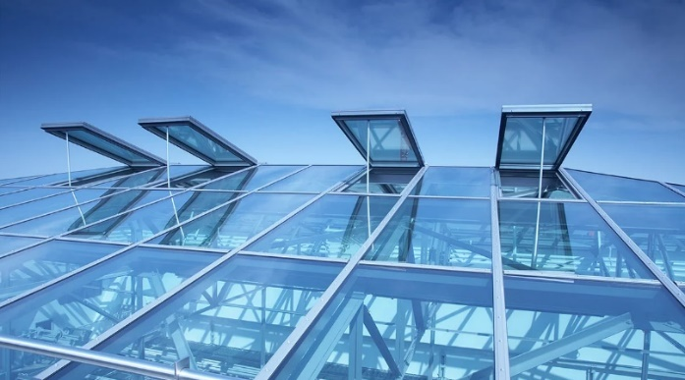
The Glass Roof "PR60" from LAMILUX was used for the renovation of various roofs on the administration building of the University of Music and Performing Arts, Munich.
Photo: LAMILUX
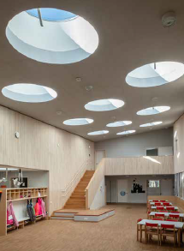
[21-01 Glass Skylight F100]

Recipient of the German Design Award 2020: The LAMILUX Glass Skylight F100 Circular units were also used for the playful roof of the new St. Severin day care centre in Garching.
Photo: LAMILUX

[21-01 Flat Roof Access Hatch Comfort]
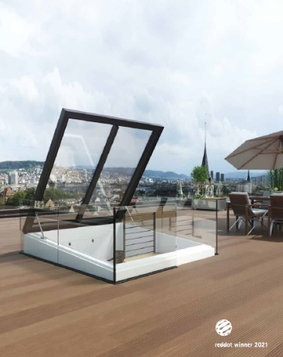
.
Delivered pre-assembled to the construction site: LAMILUX Flat Roof Access Hatch Comfort allows direct roof access, automatically opening and large enough for comfortable stairs.
Photo: LAMILUX

