LAMILUX wins Silver at the Architect’s Darling 2024

Award-Winning Customer Magazine Creates Highlights for Architects

The LAMILUX customer magazine Lichtblicke has been honoured with the prestigious Architects’ Darling Award 2024, receiving Silver in the category “Best Architecture Customer Magazine.” This accolade, one of the most significant awards in the industry, was conferred by a distinguished jury of renowned architects.

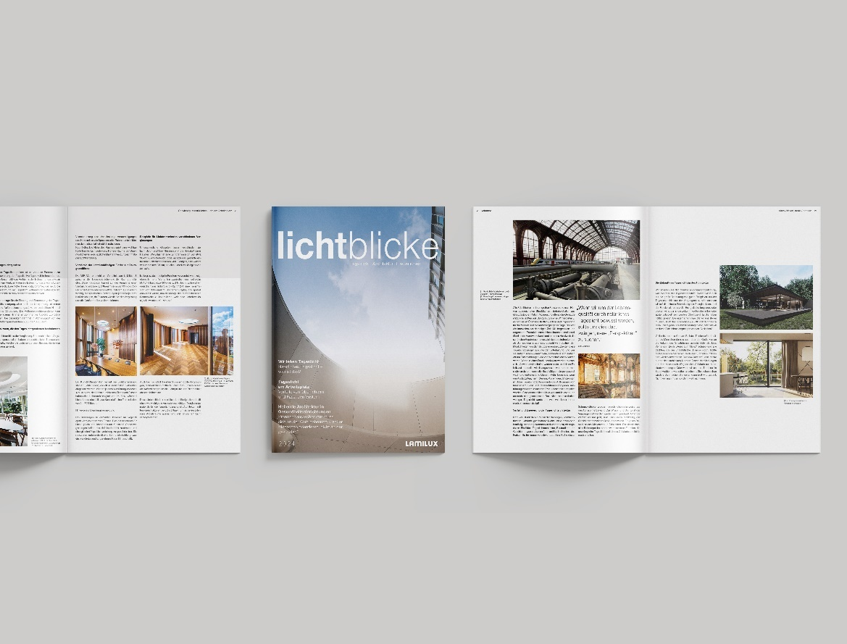

The award-winning edition of Lichtblicke centres around the core theme of daylight. Aligned with LAMILUX's motto, "We live daylight," which runs throughout the year, the leading manufacturer of innovative skylights creates a narrative dedicated to natural lighting. The magazine’s compelling articles highlight the diverse significance of daylight in architecture and construction: from its impact on people to its role in workplaces, educational facilities, healthcare, renovation projects, and even private homes.

“With this edition, we aim not only to emphasize the benefits of daylight but also to showcase how it sustainably enhances the quality of life and efficiency across different environments,” explains Hartmut Manske, Marketing Director at LAMILUX. “Thanks to our products, we create a unique atmosphere in buildings that enriches both people and architecture. This is precisely the effect we want to vividly convey to our readers.” The creators rely on an inspiring concept: interviews with leading experts in architecture and research, as well as exclusive insights into impressive reference projects featuring LAMILUX skylights, form the centrepiece of the magazine.

The Architects’ Darling Award is presented annually to manufacturers and service providers who excel in impressing architects and planners with their outstanding achievements. This year marked the 14th edition of the competition for the "Oscars of the construction industry." Over 2,000 jury members determined the 36 winners across various categories. In the “Best Architecture Customer Magazine” category, criteria such as look and feel, content and benefit, and performance were evaluated. LAMILUX excelled in these areas, securing its place on the podium.

Read the award-winning issue of Lichtblicke here.
…

www.lamilux.com

LAMILUX Heinrich Strunz Group, Rehau
Continuous rooflights, glass roofs or rooflights: the LAMILUX Heinrich Strunz Group is one of the leading manufacturers of skylights in Europe. The skylights ensure efficient use of natural daylight in a wide variety of buildings. In addition, special smoke and heat extraction systems provide safety in case of fire and are therefore essential components of fire protection concepts. LAMILUX is also known for its solutions for object smoke extraction. Furthermore, the medium-sized family business founded in 1909 is one of the world's largest producers of carbon and glass fibre reinforced plastics. These composite materials provide stability, lightweight construction and impact resistance for instance in roof, wall and floor linings in commercial vehicles. LAMILUX strives to be the innovation and performance leader in all areas relevant to its customers. The family-owned company, based in Rehau, Germany, is managed by Johanna and Dr. Alexander Strunz in the fourth generation, currently employs around 1,300 people, and in 2023 generated sales of around 354 million euros.

Images

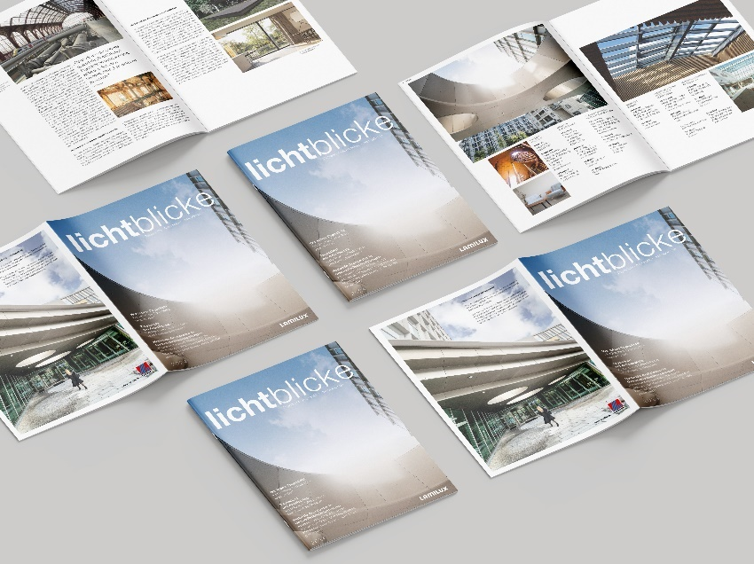
Award-winning customer magazine from LAMILUX

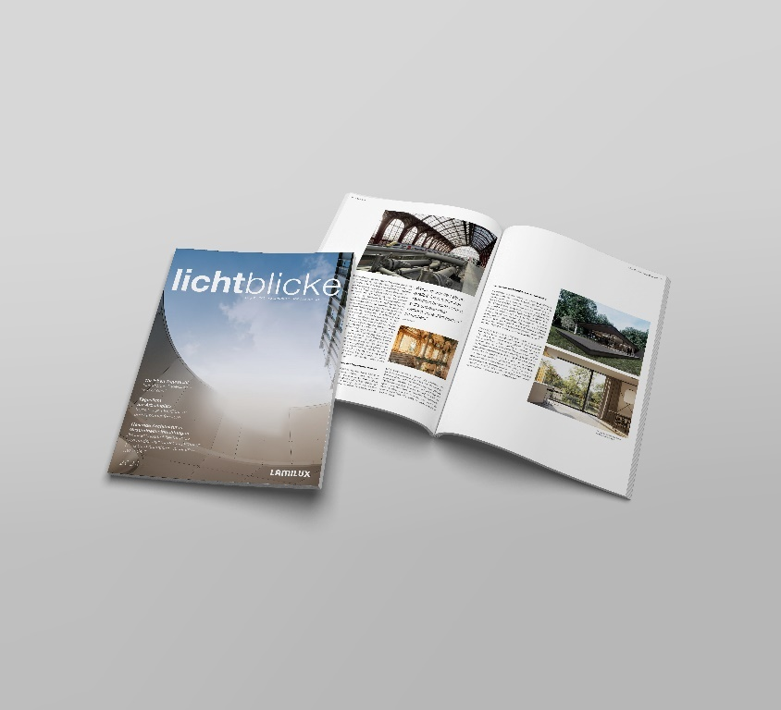
Appealing content for architects on the subject of daylight

