PRESS RELEASE
Schwaebisch Hall, August 21, 2019

High-tech methods for sterile processing going all the way to hyaluronic acid
OPTIMA at CIPM 2019

Aseptic processing is required at the highest level for new types of biopharmaceutical drugs and biosimilars, as is a high degree of flexibility. Optima Pharma's OPTIMA MultiUse Filler perfectly satisfies these requirements for filling and capping, as well as in other related processes. As well as this, the company's OPTIMA H6-10 is a flexible, high-performance system. The modular construction of the STISO sterility test isolator from Metall+Plastic also tests and safeguards the aseptic condition of the processed drugs. At CIPM, Optima Pharma will also be giving information on the filling of hyaluronic acid in pre-filled syringes.
At CIPM using the tagline "Smart Solutions for Pharma Experts", Optima Pharma will be presenting the latest machine technologies such as the OPTIMA MultiUse Filler. This type of machine is particularly suitable for efficiently and safely processing small to medium-sized batches and highly potent medicines. Vials, pre-filled syringes and cartridges can be processed without the need for format parts as a result of the flexible machine platform and the robot technology used. The MultiUse systems have already been designed for the use of isolators and for connecting freeze drying systems.
The OPTIMA H6-10 has been designed for high performance and flexibility. This type of machine is particularly suitable for nested pre-filled syringes. For example, its versatility is demonstrated by the various filling systems available, including rotary piston pumps, peristaltic pumps and time-pressure filling. An in-process control (IPC) can also be integrated for maximum filling accuracy. Its wide range of other options means that the system can be perfectly adapted to meet user requirements. It has a capacity of up to 36,000 containers an hour.
Carry out user-friendly sterility tests
The STISO sterility test isolator from Metall+Plastic is setting new standards. STISO offers extremely short decontamination cycle times and - together with the low-maintenance H₂O₂flash evaporation - particularly high levels of machine availability. When it comes to operation, the ergonomic design and a number of details such as the glove test that can be carried out via the HMI are particularly impressive. STISO has a modular construction and can be flexibly adapted to meet specific customer requirements. Two versions are available, for aseptic or aseptic high-potency applications.
Vacuum filling with no bubbles
Hyaluronic acid products have a range of applications, ranging from the treatment of arthritis to cosmetic treatments in the form of fillers for the skin. Because of what is sometimes a very high level of viscosity, precise filling of pre-filled syringes requires specific rotary metering pumps. To ensure that syringes are completely bubble-free – a particularly important quality criterion - filling and sealing processes are carried out under vacuum. Optima Pharma can successfully meet these demands thanks to the OPTIMA SV125 machine.
Optima experts from Germany and China will be available at CIPM to answer all your questions about these and many other types of machinery. Optima Pharma and Metall+Plastic, which are both subsidiaries of the international Optima Group based in Schwäbisch Hall, have been successfully rolling out projects in China for more than 20 years, working together with the Chinese office, Optima Shanghai. Services are provided directly from the Chinese offices. Chinese service staff are already involved in producing the systems for Chinese customers located in Germany and are familiar with them right from the assembly stage onward.
Optima at CIPM, Chongqing, China: 05 to 07 November 2019, Hall S1, Booth S1-13-3

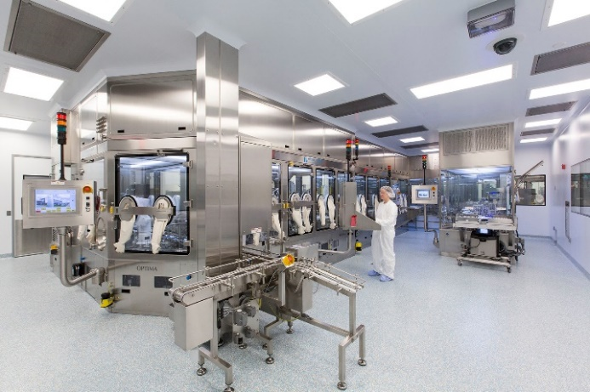
The OPTIMA MultiUse Filler has been specially designed for small to medium batches, as well as for high potency medicines. The modular machine platform also incorporates robot technology for maximum flexibility.

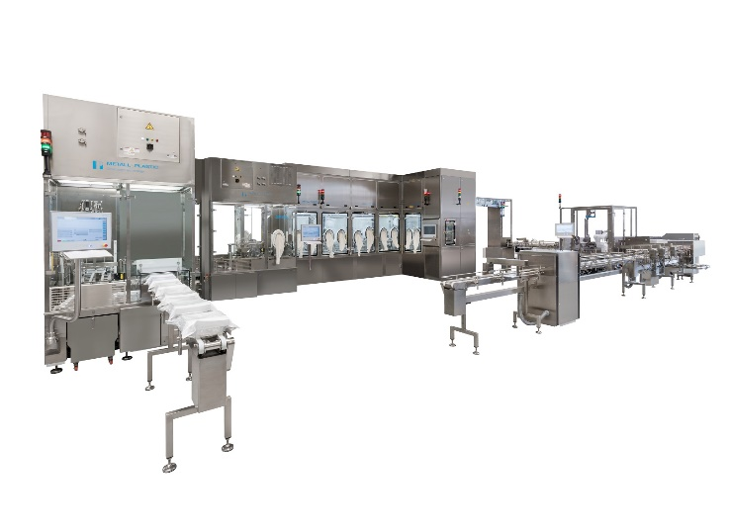
The OPTIMA H6-10 is suited to flexible, high-performance processing. It can handle syringes, cartridges and vials with ease. A variety of different dosage systems can be integrated into the machine.

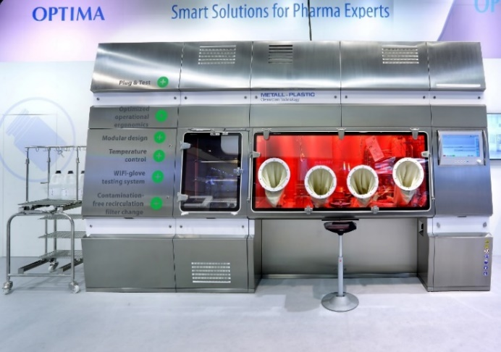
The STISO sterility test isolator from Metall+Plastic impresses with its rapid decontamination times. Users also benefit from its ergonomic design and modular structure.

Characters (incl. spaces): 3,711

Press contact:
OPTIMA packaging group GmbH
Jan Deininger
Editor
+49 (0)791 / 506-1472
jan.deininger@optima-packaging.com
www.optima-packaging.com
Thank you very much for your publication. We look forward to receiving a specimen copy.

