Bakery Technology
New electric tunnel oven from GEA increases energy efficiency and precision

Düsseldorf (Germany), May 28, 2025 – GEA introduces the E-Bake G2, a new electric industrial baking oven designed to deliver enhanced energy efficiency and improved process control. Developed to meet the evolving demands of sustainable food manufacturing, the E-Bake G2 represents a significant step forward in the transition away from legacy gas-based systems.

This second-generation oven is engineered to produce cookies (both soft and hard dough) and crackers, offering a compact footprint, advanced airflow design, and modular flexibility. Its design is optimized exclusively for electric operation – no gas integration – enabling significant CO₂ emission reductions while achieving precise, repeatable baking products.

Individually controlled baking zones and new baking chamber
Key to the oven’s performance is its modular architecture, which allows each baking zone to be individually controlled. This enables manufacturers to tailor baking parameters precisely to product requirements, improving both energy usage and baking consistency.

The baking chamber has been redesigned with a reduced internal volume, which minimizes heat loss and positions heating elements closer to the product, improving thermal efficiency. The inclusion of micro-convection technology, featuring localized air flow systems, ensures uniform heat distribution and reduces temperature gradients across the baking surface.

Thermal bridges-pathways through which heat can escape—have been minimized. Additionally, a new configuration of electric resistances supports targeted heat generation, contributing to a potential energy consumption reduction of up to 40% compared to the previous generation gas-fired model.

Flexible heat transfer configurations
The E-Bake G2 is available in multiple heat transfer zone configurations, including:

- RE (Radiant Electric)
- CVE (ConVective Electric)
- ConRad (Combined Radiant + Air Turbulence)
- RE + CVE (a hybrid, ultra-flexible configuration)
- Hybrid models (custom combinations of the above)

These options enable manufacturers to configure baking lines based on process needs, thermal profiles, and product types, offering both thermal flexibility and redundant reliability across modules.

Addressing market needs
According to Marco Girimondo, Product Manager at GEA, “Our Voice of the Customer research highlighted growing interest in sustainable baking solutions, particularly electric baking. However, customers face high operational costs due to energy tariffs and capital costs for plant infrastructure upgrades. The E-Bake G2 directly addresses these concerns by significantly lowering energy consumption and reducing both installed power and total cost of ownership compared to conventional electric ovens.”

High product quality and consistency
The oven delivers superior baking performance by replicating a small-scale airflow circuit within each module. This allows for precise micro-control of airflow and a uniform heat flux directed toward the product surface. As a result, the system ensures consistent baking conditions in each zone, yielding repeatable results and measurable improvements in critical-to-quality (CTQ) parameters such as texture, color, and moisture content.

Easy accessibility and maintenance
The design of the E-Bake G2 improves operational accessibility with continuous access doors along the baking chamber. The base configuration includes one access door per module, with an optional version providing up to three doors per module. The reduced distance between maintenance points, along with removable bottom plates in the baking chamber, facilitates cleaning and maintenance, thereby minimizing downtime.

Quick installation time
The modular design of the oven enables fast, plug-and-play installation. Each module is preassembled with its electric cabinet mounted on top, eliminating the need for extensive on-site electrical wiring. This configuration can reduce installation time by up to 70%, based on a reference 90-meter-long electric oven with seven baking zones.

New machine design
The E-Bake G2 features GEA’s new Kinetic Edge machine design, which provides a visually modern and functional aesthetic while supporting circular economy principles. The structural redesign uses 64% less iron in the frame and baking chamber, reduces the total number of components, and is based on a standardized module that can be configured to order. These improvements result in a lighter oven system with reduced material usage and easier end-of-machine-life recyclability.

GEA Bakery Technology
GEA's bakery business unit integrated the Comas and Imaforni brands in 2016 and has more than a century of experience in industrial baking. The unit provides turnkey lines for cookies, crackers, cakes, and more, emphasizing sustainability and efficiency and is part of GEA Group, one of the world’s largest suppliers of technology for the food, beverage, and pharmaceutical industries. This latest innovation reinforces the company’s commitment to reducing environmental impact and improving operational excellence across the baking sector.

gea.com

Picture Overview (Download high resolution versions of 2 pictures)

Pic. 1 - 3: The new E-Bake G2 tunnel oven from GEA significantly reduces energy consumption in industrial baking.
Source: GEA

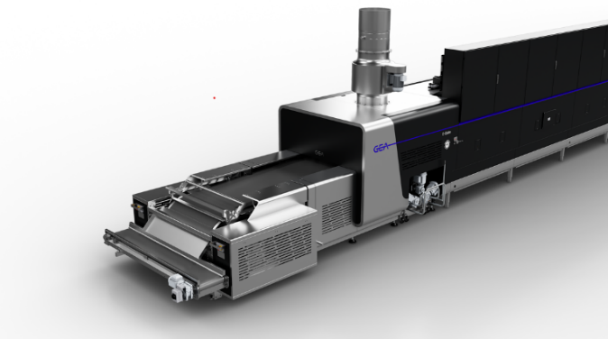
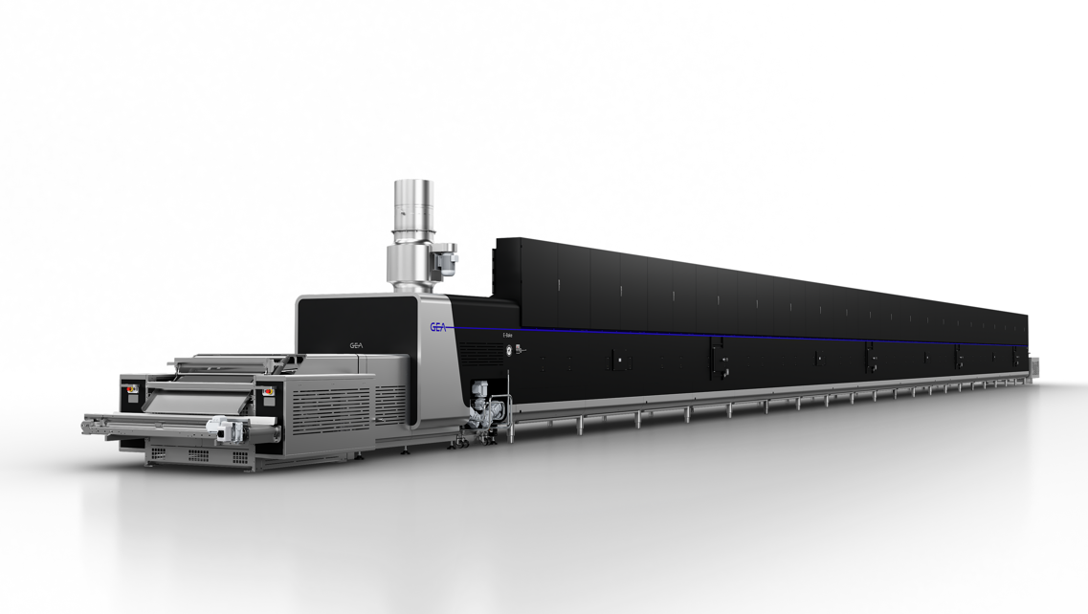

NOTES TO THE EDITORS
- Further information about GEA
- To the GEA Media Library
- Features on current topics
- Overview press events
- Follow GEA on  

Media Relations
GEA Group Aktiengesellschaft
Nicole Hoffmann
Peter-Müller-Str. 12, 40468 Düsseldorf, Germany
Phone +49 211 9136-1503
nicole.hoffmann@gea.com

About GEA
GEA is one of the world’s largest suppliers of systems and components to the food, beverage and pharmaceutical industries. The international technology group, founded in 1881, focuses on machinery and plants, as well as advanced process technology, components and comprehensive services. For instance, every second pharma separator for essential healthcare products such as vaccines or novel biopharmaceuticals is produced by GEA. In food, every fourth package of pasta or every third chicken nugget are processed with GEA technology. With more than 18,000 employees, the group generated revenues of about EUR 5.5 billion in more than 150 countries in the 2024 fiscal year. GEA plants, processes, components and services enhance the efficiency and sustainability of customers’ production. They contribute significantly to the reduction of CO2 emissions, plastic usage and food waste. In doing so, GEA makes a key contribution toward a sustainable future, in line with the company’s purpose: ”Engineering for a better world.”

GEA is listed on the German MDAX, the European STOXX® Europe 600 Index and is also a constituent of the leading sustainability indices DAX 50 ESG, MSCI Global Sustainability and Dow Jones Best-in-Class World.

More information can be found online at gea.com.
If you do not want to receive any further information from GEA, please send an e-mail to pr@gea.com.

