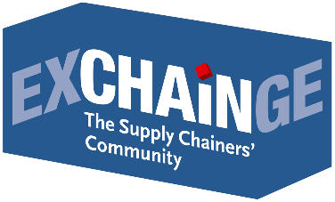
Press Release

CEMEX wins Supply Chain Management Award 2018 –
InstaFreight earns Smart Supply Chain Solution Award 2018

Frankfurt am Main, November 21, 2018 – CEMEX, a global manufacturer of building materials, has won the Supply Chain Management Award 2018. The award was presented for the 13th year by Strategy&, the global strategy consulting team at PwC, and by the industry trade journal LOGISTIK HEUTE, a publication of HUSS-VERLAG in Munich. InstaFreight, the digital freight forwarding company, was honored with the inaugural Smart Supply Chain Solution Award 2018. The award ceremony took place in Frankfurt on November 21, 2018, at “EXCHAiNGE – The Supply Chainers’ Community” as part of the Hypermotion event platform.
The jury of prominent supply chainers, researchers, consultants, and industry journalists reached its decision after vetting the field of finalists – which included BASF, Schaeffler, and CEMEX for the Supply Chain Management Award as well as Bossard, Synfioo/SAP, and InstaFreight for the Smart Supply Chain Solution Award. These six companies presented their outstanding concepts live at EXCHAiNGE on November 20. Attendees were also encouraged to submit their votes, and the results were taken into consideration in the jury’s deliberations.
Supply Chain Management Award
Winner: CEMEX
Concept: CEMEX Deutschland AG (based in Rüdersdorf, outside Berlin) implemented an integrated solution for the purchase-to-pay (P2P) process. A paradigm shift toward digital transformation coupled with consistent employee training has yielded the first positive effects on sales and supply chain operations. The corporate group CEMEX S.A.B. de C.V., based in Monterrey (Mexico), is a leading global manufacturer of building materials. The core business is the production, distribution, and marketing of cement, ready-mixed concrete, and mineral raw materials. With more than 42,000 employees worldwide, the company generates some $13.6 billion in annual sales.

Gerhard Uhl (initiator and driver of the international supply chain optimizations at CEMEX): “We are very pleased to be recognized with this great honor. The supply chain will be instrumental—both in the digital transformation of CEMEX and in building material logistics as a whole. Optimizing the coordination of all workflows noticeably enhances quality and slashes the process costs of all players. This is a key element of the faster, more affordable construction of the future. Our global, interdisciplinary team at CEMEX achieved this using state-of-the-art agile methodologies. We can all be very proud of this.”

Voices from the jury
Presenter and juror Dr. Patric Spethmann (COO of the previous year’s winner Gries Deco Company: owner of DEPOT brand, home accessories and small furniture retailer): “With this award, we honor the outstanding implementation of a supply chain solution that unifies the entire customer interaction – from purchase order to delivery to payment – on a single platform. This platform – designed and developed in house as a highly collaborative, agile team effort – revolutionizes the nature of the customer experience.”

Harald Geimer (Partner at PwC Strategy&): “One hallmark of the solution is how it puts the customer front and center, adding value and bringing transparency to the ordering and supply chain process. Having a customer platform that provides information on material availability as you place your order and lets you track the delivery of cement to a construction site in real time is an outstanding innovation for the building materials industry. This is what we are honoring with the Supply Chain Management Award 2018.”

Dr. Petra Seebauer (Managing Director of EUROEXPO Messe- und Kongress-GmbH, Publisher of the trade journal LOGISTIK HEUTE): “The breadth of change that CEMEX has introduced with its solution in an industry as conservative as construction is truly remarkable. The fact that digital hubs were set up here and employees were trained in CEMEX universities had a significant impact on the success of the project. This underscores that systematic change management should be a core element of digital transformation.”

About the award
The Supply Chain Management Award is presented by Strategy&, the global strategy consulting team at PwC, and by the industry trade journal LOGISTIK HEUTE, a publication of HUSS-VERLAG in Munich. The honorary sponsor in 2018 is Steffen Bilger, Member of the German Bundestag and Parliamentary State Secretary at the Federal Ministry of Transport and Digital Infrastructure. Each year since 2006, the award has honored outstanding solutions in industrial value chains and the companies that exhibit perseverance or creativity in optimizing their supply chain. Candidates must exhibit powerful end-to-end supply chain solutions or outstanding implementations within individual links in the value chain. Previous winners include Gries Deco (2017), PERI (2016), Nokia Networks (2015), and GF Piping Systems (2014).

Smart Supply Chain Solution Award 2018
Winner: InstaFreight
Concept: Platform operator InstaFreight (Berlin) was presented with the Smart Supply Chain Solution Award 2018 for an integrated solution that harnesses intelligent matching algorithms to help both shippers and freight companies drive down their logistics costs. InstaFreight acts as a digital freight forwarding company for B2B customers, enabling fast and easy freight transport management. The company was founded in 2016 and now has 60 employees at three locations in Germany.

Maximilian Schäfer (co-founder and Managing Director of InstaFreight): “We are proud that our business idea is resonating not only with customers and carriers but also with the logistics experts at EXCHAiNGE. This prize confirms that the digitization and optimization of processes is key to logistics and that our solution at InstaFreight gets to the very heart of the issue. I wish to extend my special thanks to our team, without whom this success would never have been possible.”

Voices from the jury
Presenter and juror Johannes Giloth (Chief Procurement Officer, SVP Global Operations at Nokia Solutions and Networks): “The solution represents a significant disruption of today’s freight forwarding business. The platform not only eliminates some of the steps in the value chain, it also enhances the service for end users by constantly refining the internally developed algorithms.”
Juror Harald Geimer (Partner at PwC Strategy&): “InstaFreight drastically revolutionizes the logistics industry with its digital freight forwarding solution, which models the end-to-end process for customers—from immediately available prices for freight shipments to digital document management and a track-and-trace option. The ongoing evolution was made possible through a close collaboration with customers, IT providers, and external logistics providers.”
Juror Dr. Petra Seebauer (Managing Director of EUROEXPO Messe- und Kongress-GmbH, Publisher of the trade journal LOGISTIK HEUTE): “InstaFreight underscores the hypothesis that successful solutions focus on the needs of their end users. The digital freight forwarder meets this standard by offering user-friendly services for the broad target group of shippers –from the small business next door to the global internet giant –as well as improved capacity utilization and the accompanying cost benefits for forwarders.”

About the award
The Smart Supply Chain Solution Award was introduced in 2018 to honor innovative ideas that have the potential to transform traditional value chains.

About EXCHAiNGE
The “Supply Chainers’ Community” brings together movers and shakers from the worlds of SCM, finance, logistics, and purchasing. Representatives from businesses of all sizes – from start-ups to large enterprises – meet to talk about new business models, disruption, and approaches to successful integration. EXCHAiNGE offers roadmaps for navigating today’s top issues: sustainability, culture and mindsets, blockchain, big data, and artificial intelligence. Visitors get valuable tips on repositioning their businesses to become drivers of innovation with the goal of generating a critical competitive advantage. EXCHAiNGE stands as an established networking platform that keeps visitors engaged through robust case studies and illuminating roundtables. The event is organized by EUROEXPO Messe- und Kongress-GmbH in Munich.

Save the date:
EXCHAiNGE – the Supply Chainers’ Community 2019 | November 26 and 27, 2019

Click here for more information.

About HYPERMOTION
Mobility and logistics become one – at Hypermotion in Frankfurt am Main, November 20-22, 2018.
Following its successful debut in 2017, Hypermotion returns as a platform for forward-looking issues with a focus on smart systems and solutions for mobility, transport, logistics, and digital infrastructure and offering an innovative program for the mobility and logistics industries. Core questions: How will digitization and decarbonization transform transportation systems? How can we find unique, intermodal solutions for logistics and mobility chains in smart cities and digital regions?
The agenda blends seven interrelated topics: smart & digital regions, data analytics & security, synchronized & urban logistics, hypermodality (intermodal, multinational, digital), sustainability, monitoring & transparency, and connectivity. The event includes businesses of all sizes – from start-ups to large enterprises – together with researchers, policymakers, and representatives of professional associations. For the first time, the EXCHAiNGE conference is offered both as a part of Hypermotion 2018 and as a standalone event.
Learn more about Hypermotion.

About EUROEXPO Messe- und Kongress-GmbH
EUROEXPO Messe- und Kongress-GmbH was founded in 1996. Today, EUROEXPO organizes LogiMAT – the annual international trade show for intralogistics solutions and process management – as well as LogiMAT China and TradeWorld, the professional platform for trade processes.
EUROEXPO also organizes “EXCHAiNGE – the Supply Chainers’ Community.” The international business conference, now in its sixth year, targets leaders from the areas of SCM, finance, logistics, and purchasing at start-ups, small and medium-sized businesses, and large enterprises. EUROEXPO is also a service provider offering B2C and B2B event management services, such as the organization and implementation of the LOGISTIK HEUTE series.
For more information, please visit: www.euroexpo.de.

Supply Chain Management Award 2018
Award Winner 2018: CEMEX Deutschland AG
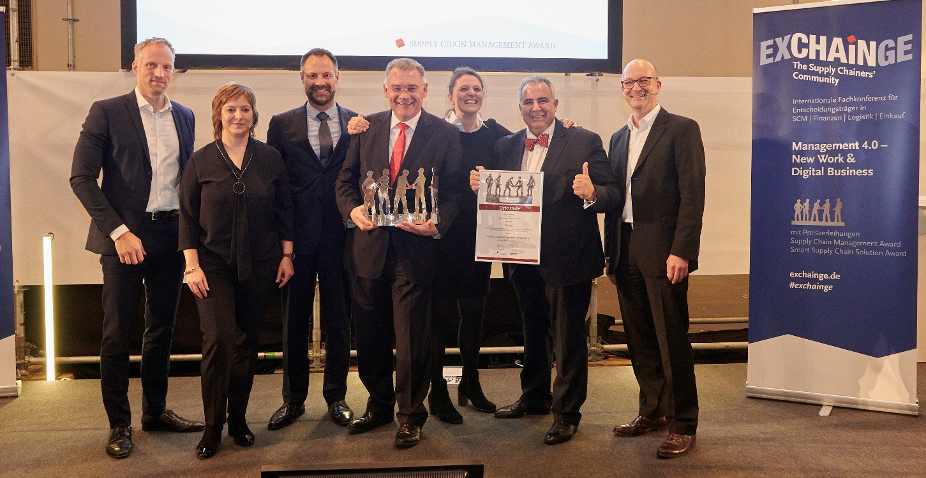
Happy winners: Gerhard Uhl (VP Supply Chain & Logistics; 4th from right) and team, CEMEX Deutschland AG, are delighted to receive the Supply Chain Management Award 2018. Dr. Petra Seebauer (Managing Director EUROEXPO Messe- und Kongress-GmbH and Publisher LOGISTIK HEUTE; 2th from left), Harald Geimer (Partner at PwC Strategy&; right.) and Dr. Patric Spethmann (Laudator and COO, Gries Deco Company; Brand DEPOT, award winner in 2017; left) congratulate on behalf of all jury members.

Finalists Supply Chain Management Award 2018

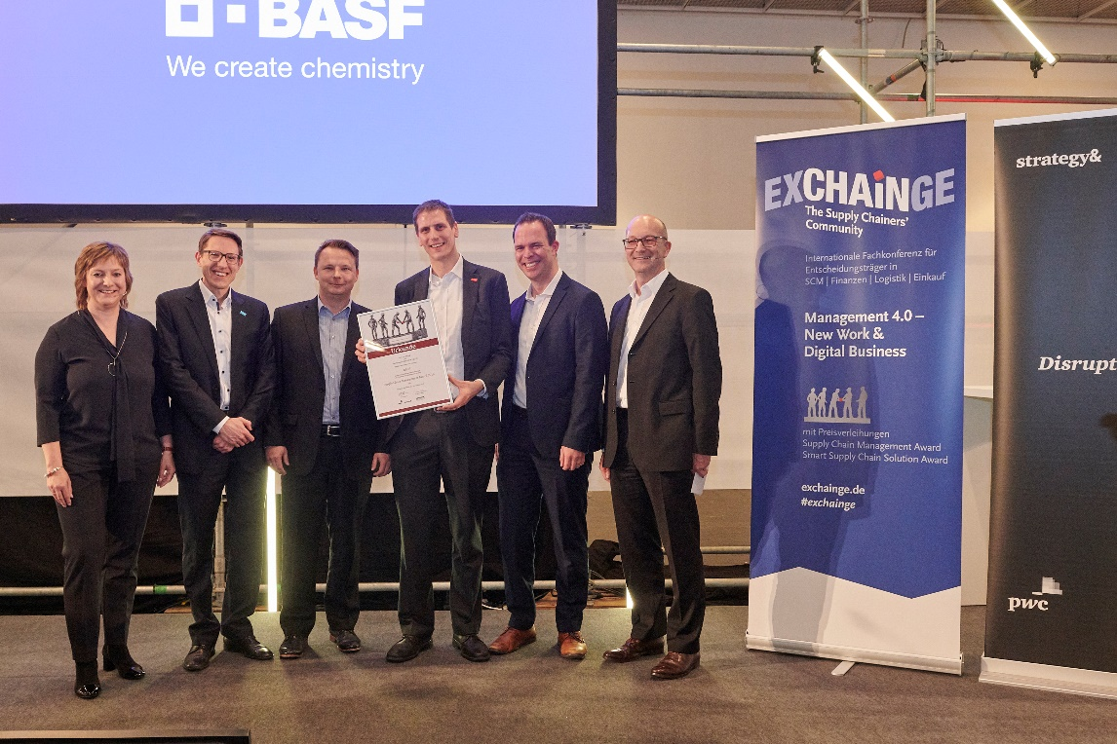
The finalists for this year’s award also included BASF, represented here by Jan Brüning (Cluster Head Smart Supply Chain; 3rd from right) with his team, BASF SE. Congratulated by Dr. Petra Seebauer (Managing Director EUROEXPO Messe- und Kongress-GmbH and Publisher LOGISTIK HEUTE; left) and Harald Geimer (Partner at PwC Strategy&; right)

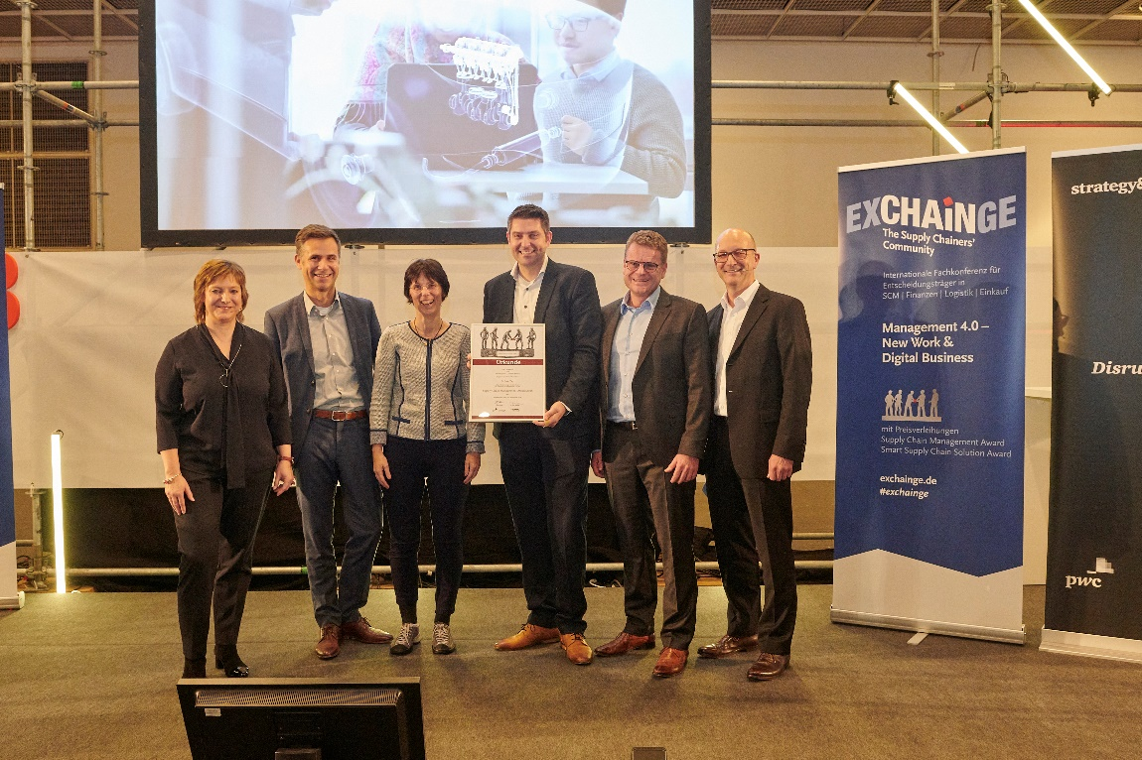
Schaeffler was also a finalist for the Supply Chain Management Award 2018 and was represented by Benedikt Birner (Director Regional Network Design & Transportation Greater China; 3rd from right) and his team, Schaeffler AG. The jury members Dr. Petra Seebauer (Managing Director EUROEXPO Messe- und Kongress-GmbH and Publisher LOGISTIK HEUTE; left) and Harald Geimer (Partner at PwC Strategy&; right.) congratulate cordially.

Smart Supply Chain Solution Award 2018
Award Winner 2018: InstaFreight
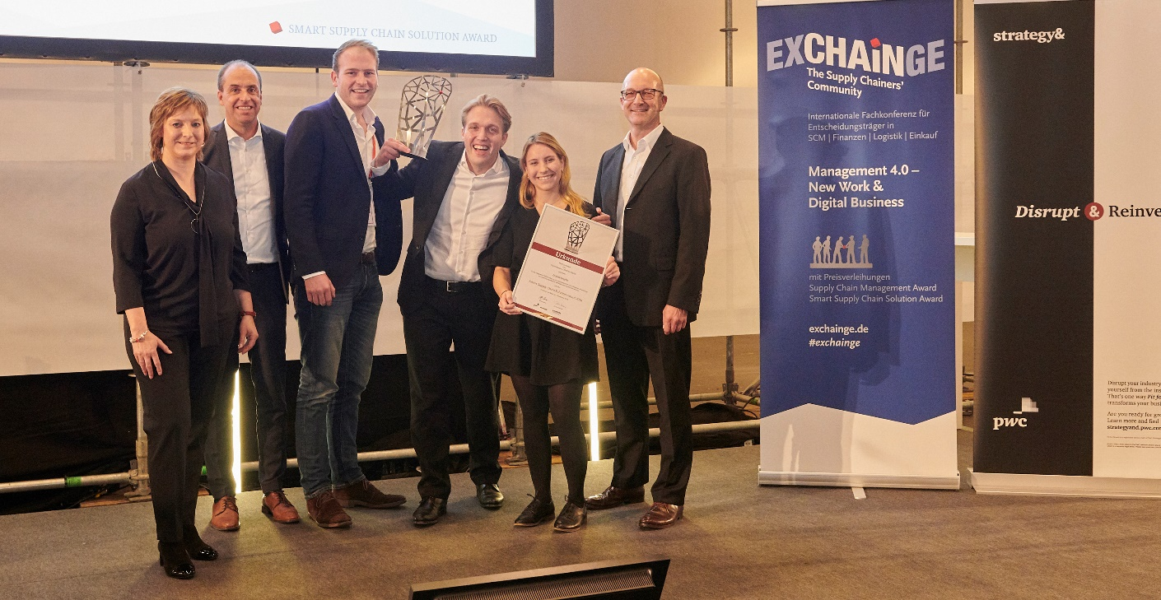
You can see the joy in them: InstaFreight wins the Smart Supply Chain Solution Award 2018 and is received by Maximilian Schäfer (Managing Director; 3rd from left) and his team, InstaFreight GmbH. Dr. Petra Seebauer (Managing Director EUROEXPO Messe- und Kongress-GmbH and Publisher LOGISTIK HEUTE; 2th from left), Harald Geimer (Partner at PwC Strategy&; right.) and Johannes Giloth (Laudator and CPO/SVP Global Operations, Nokia Solutions and Networks GmbH & Co. KG, Supply Chain Management Award winner 2015; 2nd from left) congratulate on behalf of all jury members.

Finalists Smart Supply Chain Solution Award 2018

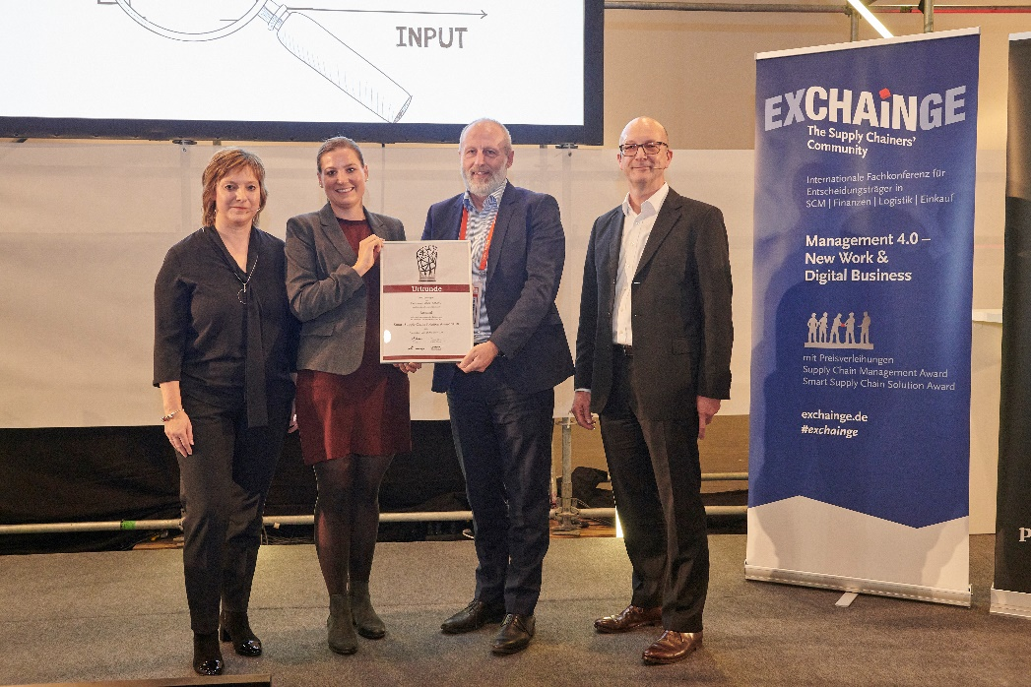
The Bossard Group was also a finalist for the Smart Supply Chain Solution Award 2018. The picture shows Marion Keller (Solutions Manager Smart Factory Logistics; 2nd from left.) and Urs Güttinger (Chief Technology Officer; 2nd from right), both Bossard Group. Dr. Petra Seebauer (Managing Director EUROEXPO Messe- und Kongress-GmbH and Publisher LOGISTIK HEUTE; left) and Harald Geimer (Partner at PwC Strategy&; right.) handed over the deed.

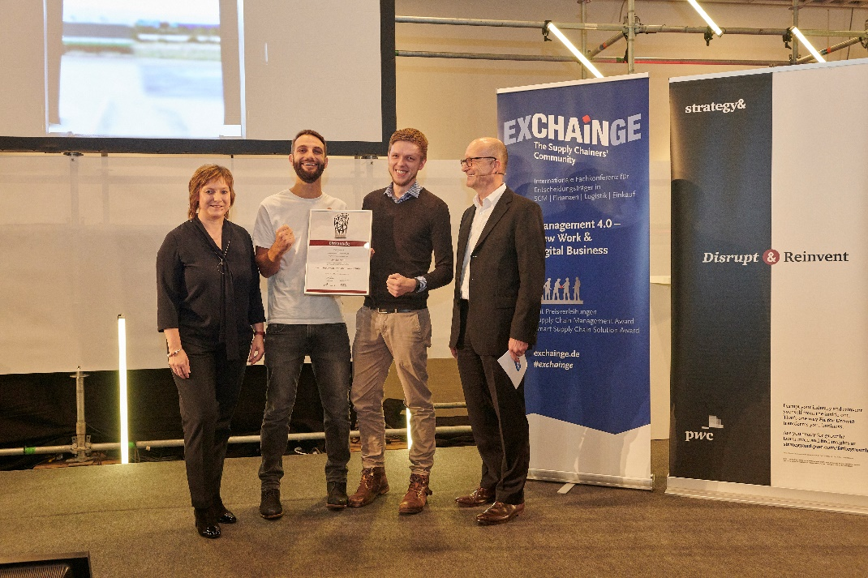
SAP and Synfioo were also among the finalists for the Smart Supply Chain Solution Award 2018. They were represented by Marian Pufahl (CEO, Co-Founder, Synfioo GmbH; 2nd from right) und Ignatz Schatz, (Director Startup Engagement SAP IoT Startup Accelerator, SAP SE; 2nd from left).

Images are available at www.exchainge.de/en under BLOG/PRESS in the top navigation.

For more information, please contact:
Hendrikje Rother
Marketing/Press
EUROEXPO Messe- und Kongress-GmbH
Phone: +49 89 323 91 240
hendrikje.rother@euroexpo.de
www.exchainge.de/en

(Characters with spaces: 10,447)

EUROEXPO blog postings may be reprinted free of charge. Texts and images can be found at the EXCHAiNGE blog page under www.exchainge.de.
Please send a copy of any republication by email to hendrikje.rother@euroexpo.de or by postal mail to EUROEXPO Messe- und Kongress-GmbH | Presse- und Öffentlichkeitsarbeit | Joseph-Dollinger-Bogen 7 | 80807 München.

