PRESS RELEASE
Schwaebisch Hall, December 19, 2018

Complete solution for manufacturing blood collection tubes
R+E Automation presents new BCT-200 machine solution at Interplastica, Arab Health, and Pharmapack trade fairs

R+E Automation Technology GmbH will be appearing at no less than three trade fairs at the start of 2019. The company will exhibit at Interplastica in Moscow, Arab Health in Dubai, and Pharmapack in Paris. One of its main focuses will be the new system for manufacturing and packaging blood collection tubes – the BCT-200. R+E is located in Fellbach, near Stuttgart, and is one of the newest members of the Schwäbisch Hall-based Optima Group. At the trade fairs, R+E will establish itself as a solution provider for manufacturing blood collection tubes with the required process expertise.
“Our new complete solution BCT-200 can be used to manufacture and package both vacuum and non-vacuum blood collection tubes,” says Sales Director Eugen Wanner. The machine can therefore dispense all common additives, such as gel, EDTA.K2, EDTA.K3, lithium herapin, trisodium citrate, and many more. The system stands out with its modular design and can be extended with further stations if necessary. It covers every required process step all the way to packaging, in polystyrene trays, for example.
The company’s portfolio also includes assembly machines for medical products such as pen and auto-injectors, IV sets, syringes, and cannulas. R+E’s range of machine solutions for pen and auto-injectors includes both semi-automatic machines with manual loading and fully automatic machines. The company’s portfolio is topped off by its own feed systems. In partnership with Optima Pharma, R+E Automation is able to provide complete systems that incorporate both companies’ technology and expertise.
R+E Automation is represented in Russia by a distribution partner. Waldemar Stil from Industrie-Kontor GmbH (based in Malsch) supports the company and will be present at Interplastica.
Further information is available at: www.re-automation.de.
R+E at Arab Health 2019 in Dubai, United Arab Emirates: January 28 to 31, 2019: Za'abeel Hall 2, Booth no. Z2.H57
R+E at Interplastica 2019 in Moscow, Russia: January 29 to February 1, 2019: Hall 2, Booth no. 3B04
R+E at Pharmapack 2019 in Paris, France: February 6 to 7, 2019: Hall 7.2, Booth no. K94

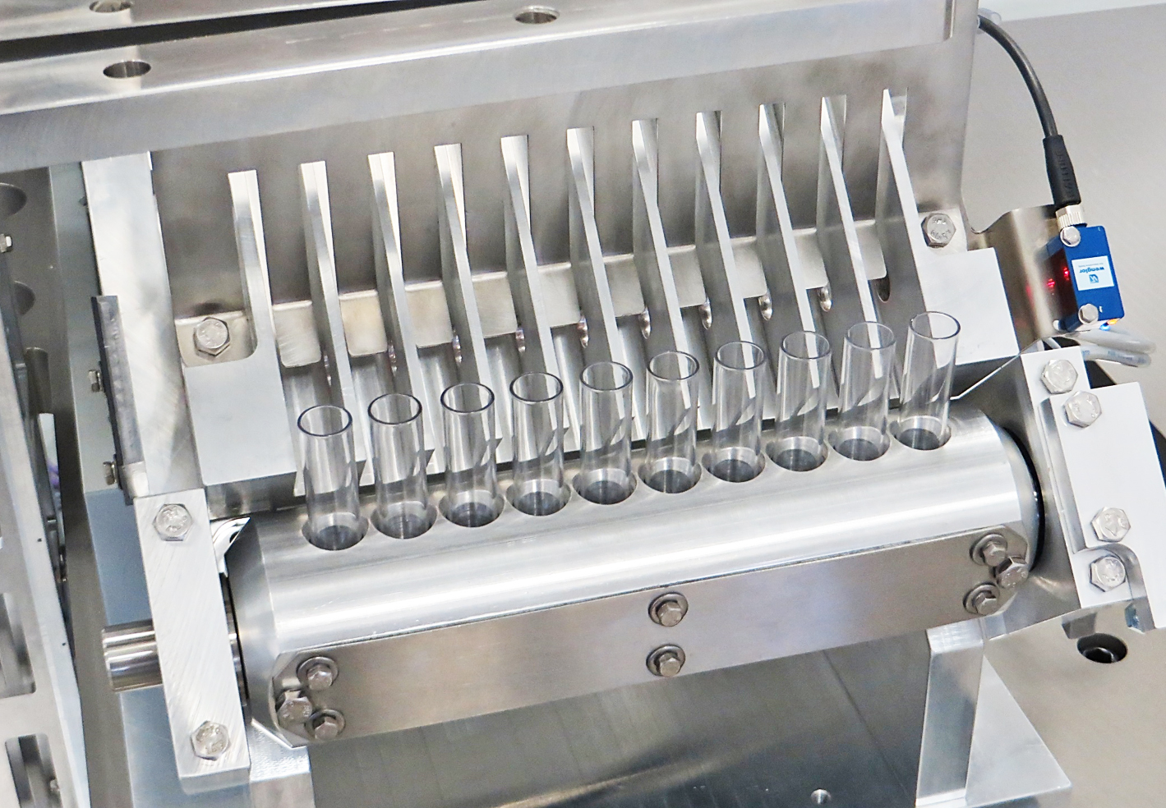Feeding and separation of the empty blood collection tubes at the beginning of the assembly line.

Characters (incl. spaces): 1,996

Press contact:
OPTIMA packaging group GmbH
Jan Deininger
Editor
+49 (0)791 / 506-1472
jan.deininger@optima-packaging.com
www.optima-packaging.com
Thank you very much for your publication. We look forward to receiving a specimen copy.

