New to the Collection!  August 8–September 7, 2025  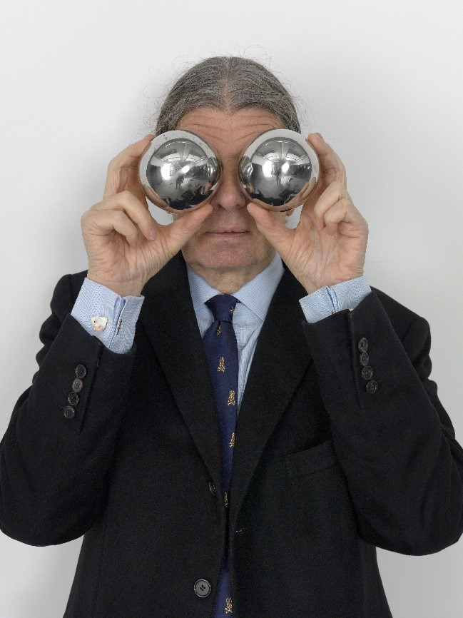  John M Armleder, 2019, Photo: Annik Wetter  The Kunstmuseum St.Gallen presents New to the Collection!, a group exhibition showcasing the latest additions to its collection of contemporary art. At the heart of the exhibition are artists whose works engage with pressing social and political issues, offering fresh perspectives on justice, identity, and gender. The show brings together Swiss and international voices and features works by John M Armleder, Dave Bopp, Alex Burke, Elena Dahn, Sam Durant, Tala Madani, Walter Pfeiffer, Lucie Schenker, Arthur Simms, Maria Guţă and Lauren Huret, and the collectives Studio for Propositional Cinema and RM (formerly Real Madrid). Included in the breadth of media on display are large-scale paintings and sculptures, text-based installations, video art, and graphic works.  Laura Feurle, Collection Curator at the Kunstmuseum St.Gallen, on the exhibition: “The Kunstmuseum St.Gallen considers it part of its mission to not only purposefully expand its historical collections but also ensure that the diversity of both regional and international contemporary art is represented within its holdings. This year’s summer exhibition offers insights into the institution’s new collection strategy. We understand our museum as an open space—one that encourages diversity, challenges established structures, and repositions art in dialogue with societal developments.”  Lorenz Wiederkehr, Assistant Curator at the Kunstmuseum St.Gallen, on the exhibition: “The works on display—acquired or received as donations in 2024 and 2025—exemplify the new thematic orientation of the collection. They reflect transcultural experiences, postcolonial critique, and artistic practices in contemporary art. The open, fragmented scenography of the exhibition invites a multi-perspective encounter with contemporary art.” | Exhibition Dates  August 8–September 7, 2025 Kunstmuseum St. Gallen  Press Conference  August 8, 2025  11:00 a.m.  Exhibition Opening  August 8, 2025  6:30 p.m.  Opening Hours  Tue – Sun: 10:00 a.m. – 5:00 p.m.  Thu: 10:00 a.m. – 8:00 p.m.
Press Contact

Nadine Sakotic
Head of Communications
Museumstrasse 32
9000 St. Gallen
T +41 71 242 06 84

kommunikation@kunstmuseumsg.ch
kunstmuseumsg.ch

Factsheet
New to the Collection!

Exhibition Dates | August 8–September 7, 2025
Exhibition Venue | Kunstmuseum St. Gallen
Press Conference | August 8, 2025, 11 a.m., Kunstmuseum St. Gallen
Exhibition Opening | August 8, 2025, 6:30 p.m., Kunstmuseum St. Gallen
Curators | Laura Feurle, Collection Curator  Lorenz Wiederkehr, Assistant Curator
Opening Hours | Tue – Sun: 10:00 a.m. – 5:00 p.m.  Thu: 10:00 a.m. – 8:00 p.m.
Press Contact | Nadine Sakotic  T +41 71 242 06 84  kommunikation@kunstmuseumsg.ch
Website | kunstmuseumsg.ch
Press Photos | kunstmuseumsg.ch/presse

