Neuer Höchstdruckreiniger
HD 9/100-4 Cage von Kärcher

Für hartnäckigen Schmutz

Pressekontakt
Alexander Becker
Pressereferent
Alfred Kärcher GmbH & Co. KG
Alfred-Kärcher-Str. 28-40
71364 Winnenden
T +49 71 95 14-4256
alexander.becker@de.kaercher.com
Winnenden, im September 2018 – Mit dem neuen HD 9/100-4 Cage erweitert Kärcher seine Ultrahöchstdruck-Kompaktklasse um ein 1.000-bar-Gerät. Mit starker Reinigungskraft löst das Gerät auch hartnäckigen Schmutz, wie Betonrückstände von Schalungen oder Korrosion an Metalloberflächen. Der Höchstdruckreiniger eignet sich für vielfältige Aufgaben, besonders in Baugewerbe, Industrie und Transportwesen.
Die leistungsstarke Pumpe vom Höchstdruck-Spezialisten WOMA ist das Herzstück des Geräts. Hochwertige Materialien und fortschrittliche Technik gewähren einen einfachen Service und eine lange Standzeit. Die Hartmetall-Plunger und andere Verschleißteile können schnell gewechselt werden. In der Advanced-Variante reduziert ein automatisches Druckentlastungsventil bei geschlossener Pistole den Druck im Schlauch. Das sorgt für eine spürbare Entlastung bei der Handhabung des Gerätes und verbessert die Arbeitssicherheit.
Für ein Gerät im Druckbereich von 1.000 bar ist der HD 9/100-4 Cage sehr kompakt aufgebaut. Gemeinsam mit den vier großen Rädern sorgt das für eine gute Mobilität. Ein Kranhaken auf der Oberseite des stabilen Stahlrohrrahmens erleichtert den Transport auf Baustellen. Ebenso problemlos kann der Höchstdruckreiniger mit einem Gabelstapler zum Einsatzort bewegt werden. Die zuverlässige Feststellbremse gewährleistet einen sicheren Stand – auch auf unebenen Untergründen.
Die Bedienung ist einfach. Der große Ein-/Aus-Drehschalter lässt sich auch mit Handschuhen sicher betätigen. Die Softstart-Funktion steigert die Aufnahmeleistung kontinuierlich. Motor und Pumpe werden keinen plötzlichen Leistungsspitzen ausgesetzt. Das Elektrokabel und der Höchstdruckschlauch können an der Geräterückseite aufgewickelt werden. In Halterungen und Aufnahmen kann verschiedenes Zubehör mitgeführt werden, um schnell zwischen Reinigungsaufgaben wechseln zu können.

 |  | HD 9/100-4 Cage
Stromart | 3 Ph / 380-415 V / 50 Hz
Anschlussleistung | 30 kW
Fördermenge | 980 l/h
Arbeitsdruck | 1.000 bar
Max. Druck | 1.100 bar
Gewicht | 400 kg
Abmessungen (L x B x H) | 1385 x 790 x 1090

Eine Word-Datei und druckfähige Bilder zu dieser Presseinformation liegen für Sie in unserem Newsroom https://www.kaercher.com/presse zum Download bereit.

Kaercher_HD_9_100_Cage_DE.docx

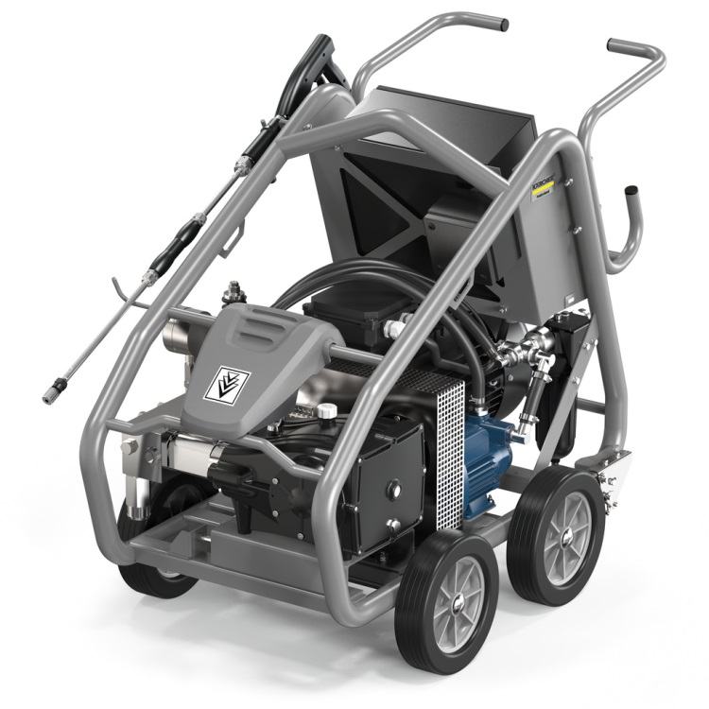Der neue HD 9/100-4 Cage von Kärcher.
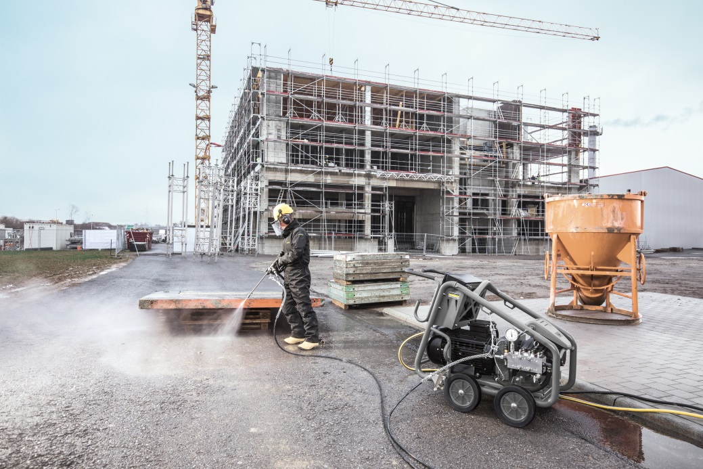
Betonreste von Schalungen zu entfernen ist eine der Hauptaufgaben des neuen HD 9/100-4 Cage von Kärcher.
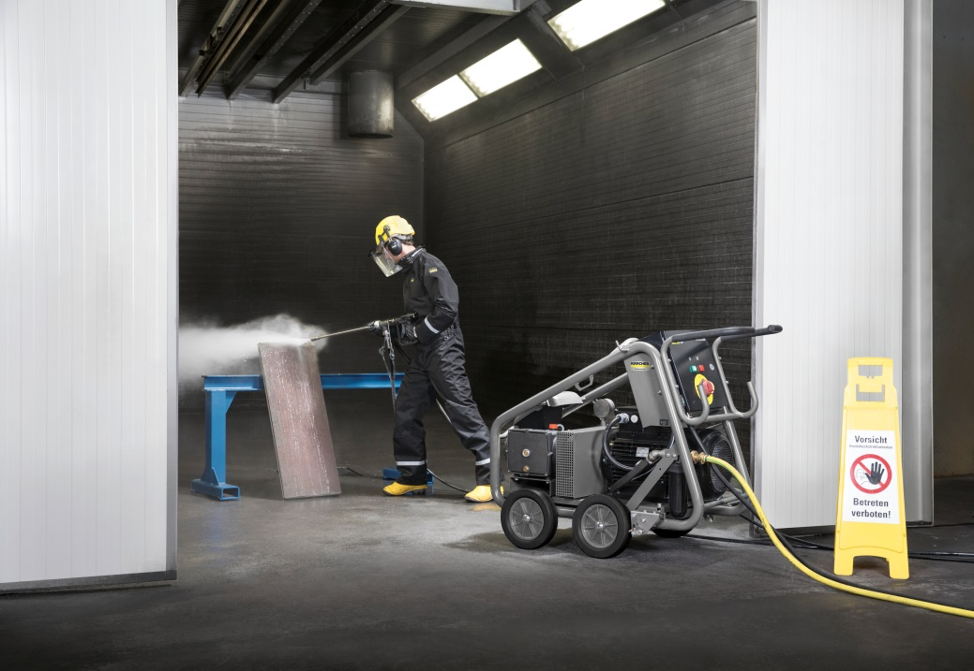
Mit einem Arbeitsdruck von 1.000 bar entfernt der HD 9/100-4 Cage hartnäckige Verschmutzungen.

