Bakery technology

GEA developed new service of preassembled modules for quicker installation of ovens at customers plant – GEA Bakery Plug&Play

Düsseldorf (Germany), May 22, 2024 – In the dynamic landscape of the bakery industry efficiency and speed represent a fundamental shift in how bakers approach their production process. To assist customers in overcoming complexities in the installation process, hence reducing downtime, GEA has been offering the possibility of preassembling modules at the production facility in Verona, Italy.

“The aim of plug & play ovens is to speed up the installation process, in order to reduce production downtime at the customer facility” says Mario Da Ros - Senior Director Project Management at GEA. “Preassembled ovens are a great way to ensure a high-quality installation phase of our ovens, given that it is mainly carried out at our own facility” he continues.

GEA engineers develop time efficient solution
At the beginning of the project to create a Plug-and-Play-Service, the GEA engineers carried out a theoretical study on a 65 m long and 1.2 m wide oven. Considering that there are many factors in place such as conveyor belt, fuel and heating system used, a good estimate of the time needed to install the disassembled oven is around 45 days. With the Plug-and-Play option it is now possible to reduce the installation time to as little as 20 days. This study looked at both the mechanical assembly and electrical connections but did not include commissioning.

The impressive benefits of this new plug-and-play option were recently demonstrated during the installation of a very large oven for an overseas customer. Gianluca Dolci - Senior Director Project Execution at GEA reports: “In December 2023 we delivered a 124 m long and 1.6 m wide oven to Indonesia. We managed to display all 58 pre-assembled modules in five days, which meant that GEA electricians could start working on the oven at the customer’s site at the same time as GEA mechanics, a huge advantage that guarantees a much faster installation”. In this case, the 124 m oven took four weeks instead of eight thanks to the pre-assembled modules.

Lower costs for the baker
With Plug & Play ovens, significantly reduce labor costs: the total number of people working on the line is reduced, both for mechanics and electricians. In particular, the need for highly specialized personnel is no longer fundamental, as the most complex operations are carried out during the pre-assembly of the modules at GEA’s production site.

Increased safety standards
By installing Plug-and-Play ovens, the baker no longer comes into contact with the rock wool used to insulate the baking chamber. This is a very important aspect in terms of safety for the operators and it also guarantees lower costs for the producers because the workers need less personal protective equipment. Furthermore, without rock wool management, it is no longer necessary to isolate the production environment to avoid the risk of contamination with other production lines in operation during the installation process.

gea.com

Picture Overview (Download link for high resolution versions of one pictures)

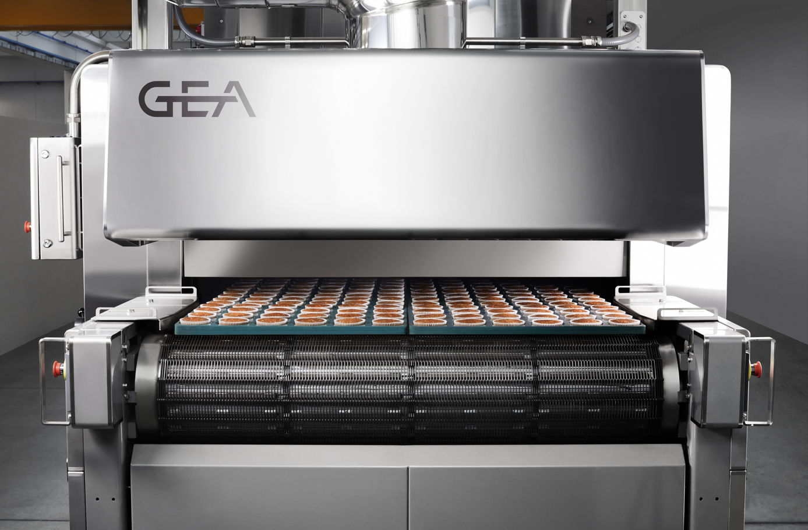

Pic. 1: Highly efficient installation time of bakery ovens and reduced production downtime are the main benefits of the production process are the main advantages of GEA’s new Bakery Plug&Play module service. Source: GEA

NOTES TO THE EDITORS
- Further information about GEA
- To the GEA Media Library
- Features on current topics
- Overview press events
- Follow GEA on

Media Relations
GEA Group Aktiengesellschaft
Nicole Meierotto
Peter-Müller-Str. 12, 40468 Düsseldorf, Germany
Phone +49 211 9136-1503
nicole.meierotto@gea.com

About GEA
GEA is one of the world’s largest suppliers of systems and components to the food, beverage and pharmaceutical industries. The international technology group, founded in 1881, focuses on machinery and plants, as well as advanced process technology, components and comprehensive services. With more than 18,000 employees, the group generated revenues of about EUR 5.4 billion in more than 150 countries in the 2023 fiscal year. GEA plants, processes, components and services enhance the efficiency and sustainability of customer’s production. They contribute significantly to the reduction of CO₂ emissions, plastic usage and food waste. In doing so, GEA makes a key contribution toward a sustainable future, in line with the company’s purpose: ”Engineering for a better world“.

GEA is listed on the German MDAX the European STOXX® Europe 600 Index and is among the companies comprising the DAX 50 ESG, MSCI Global Sustainability as well as Dow Jones Sustainability World and Dow Jones Sustainability Europe Indices.

More information can be found online at gea.com.
If you do not want to receive any further information from GEA, please send an e-mail to pr@gea.com.

