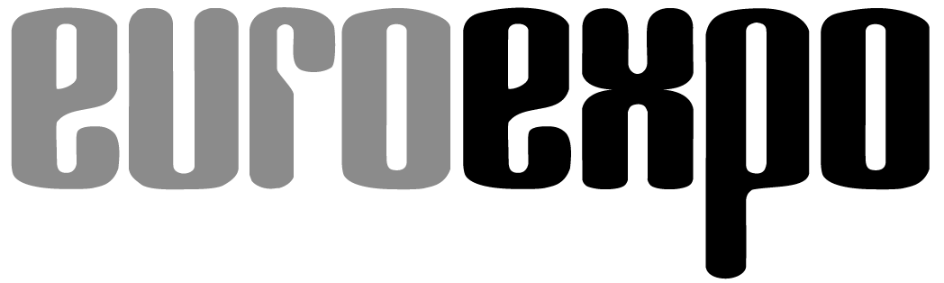
Messe- und Kongress-GmbH
Joseph-Dollinger-Bogen 7
D-80807 Munich, Germany
Phone: +49 89 32 391 259
Fax: +49 89 32 391 246
www.euroexpo.de/en
www.logimat-messe.de/en
www.tradeworld.de/en

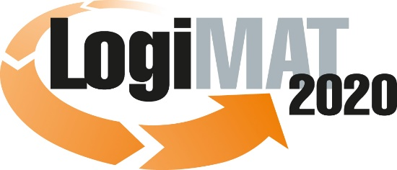

18th International Trade Show for
Intralogistics Solutions & Process Management
March 10–12, 2020 | Messe Stuttgart

Also featured at LogiMAT:
Munich, February 17, 2020

Invitation to PRESS EVENT at 18th LogiMAT
Tuesday, March 10, 2020 | Messe Stuttgart | Germany

We are proud to present LogiMAT 2020 with this year’s theme “First-Hand Intralogistics: Visions – Innovations – Solutions” featuring over 1,650 international exhibitors filling 125,000 square meters in all exhibit halls of the Stuttgart Messe convention center. Regarded as the world’s premier trade show for intralogistics solutions and process management, LogiMAT gives industry professionals insights into winning ideas and emerging trends and a sneak peek at exciting innovations, many never before seen anywhere else in the world.

Industry professionals can expect a comprehensive overview of current intralogistics products and innovations, including many not yet seen anywhere else, from an exciting mix of smaller players and global giants. LogiMAT 2020 focuses on the key drivers and challenges of intralogistics Industry 4.0, human-to-machine communication, big data, end-to-end digitization of supply chain processes – along with the integration of intralogistics, production, and trade.

Visitors benefit from an excellent accompanying program, making LogiMAT a trade show with the added value of an industry conference. Over 100 speakers from the business and academic communities will offer a program of 31 presentations in forums held right in the exhibitor halls. Live events also offer real-world insights into trends and solutions on the issues that move today’s markets.

The TradeWorld information platform, focusing specifically on retail logistics processes, is featured in a prominent new position in the Atrium, East Entrance, flanked by exhibitors offering digital solutions for automating trade processes.

We would be delighted if you would join us to experience the many brand-new innovations debuting at LogiMAT 2020 and celebrate the winners of the BEST PRODUCT award to be presented at the opening ceremony.
– Page 2, press invitation to LogiMAT/TradeWorld 2020 –

We would like to personally invite you to three special events:

Opening ceremony of LogiMAT 2020
followed by presentation of BEST PRODUCT awards

Tuesday, March 10, 2020 | 9:30 - 10:30 a.m. | Forum A, Hall 1 (German/English)

Opening remarks: Michael Ruchty, Exhibition Director of LogiMAT 2020

Keynote:
“What role for humans? When machines get smarter…”

Karsten Zimmer, forensic IT specialist and “ethical hacker”

Presentation of award for BEST PRODUCT 2020 in three categories:
1. Software, communications, IT
2. Order picking, conveying, lifting, and storing technology
3. Identification, packaging and loading technology, load securing

Presenter: Prof. Johannes Fottner (Dr.-Ing.), Chair of the Institute for Materials Handling, Material Flow, Logistics at the Technical University of Munich

LogiMAT 2020 press conference

When: Tuesday, March 20, 2020 | 1:00–2:00 p.m.

Moderator: Michael Ruchty, Exhibition Director of LogiMAT 2020
EUROEXPO Messe- und Kongress-GmbH
Featuring industry representatives and the winners of the BEST PRODUCT award

Where: Press Center at Messe Stuttgart, East Entrance (German/English)

Get-Together 2020

Tuesday, March 10, 2020 | 5:00 p.m. | Attention new venue: ICS congress hall C1, access via hall 2

Join the exhibitors to wind down at the end of day one at our traditional get-together featuring free beer and finger food.

We look forward to your visit!

Best regards from Munich,
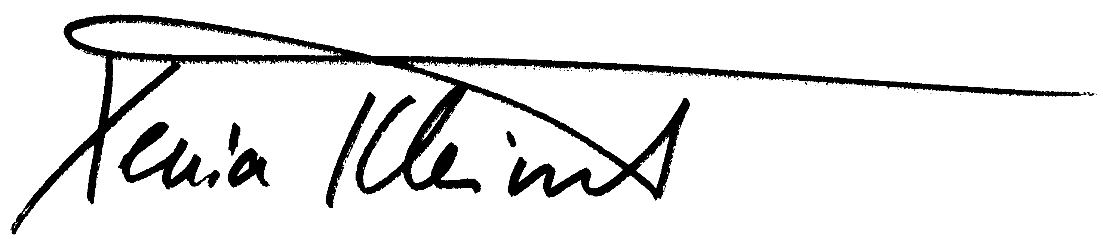

Xenia Kleinert
Head of Press and Public Relations

