PRESS RELEASE
Schwaebisch Hall, October 2, 2019

Topics inspiring the visitors
OPTIMA presents three focus topics and a new booth concept at FachPack

Optima presented a new trade show concept at FachPack. Three strong focus topics, and for the first time no large exhibits and round tables with external experts and partners. The concept was very well received by visitors. The presentation as a strong corporate group with multiple synergy effects was also received positively by visitors. Above all, the experts in sustainability were very much in demand and constantly involved in a lively exchange with visitors to the booth. On the topic of digitalization, the company demonstrated the new Smart Services. Optima recorded a high quality of contacts.
“Fachpack proves once again that packaging manufacturers, packaging machinery manufacturers, retailers and experts from a wide variety of sectors all have to pull together when it comes to sustainability”, says Ulrich Burkart, Sales Coordinator at Optima. In line with this, interested visitors from a wide range of industries gathered at the booth to discuss more sustainable packaging with the experts present. The experts included, for example, Thomas Reissig, Managing Director of VerDeSoft GmbH, a merger of a packaging design agency with an engineering office, which supports companies from all manner of industries in the development of new packaging concepts. Alongside the discussions, the emphasis was also on networking. The experts spoke of the many new contacts they made.
Burkart was very satisfied with the outcome of the show: “We have established many new interesting contacts and even completed an order directly at the trade show. Our thanks go to the dedicated experts, who we would like to invite again at a convenient time.”
Sustainable packaging thrives on the cooperation with partners
Guests at our booth included the founder of the company rezemo. This company is a startup that developed a coffee capsule made of wood, which is 100% percent biobased. Visitors had the opportunity to try the coffee from the capsules directly at the booth. And to match this, coffee was served in a reusable, personalized coffee-to-go cup made of rice husk. Optima provided a clear message with its trade show appearance that the company is aware of its responsibility, and open and ready for discussion to work together with customers and partners on new, more sustainable packaging solutions. Until now, Optima has taken such measures as saving packaging material with optimized machine concepts and minimizing product giveaways through a portioning method based on the nominal weight.
A comparison of the filling scale from the year 1957 with a modern auger filler illustrated the nearly centennial history of Optima and emphasized the unity of the corporate group, which comprises a wide variety of subsidiaries with expertise from many fields of application and market segments. Visitors were amazed at how much expertise is represented in the group and how broadly diversified Optima’s main focuses are. The areas benefit from one another’s main focuses – flexibility at Optima Consumer, safety at Optima Pharma, modularity at Optima Life Science and efficiency at Optima Nonwovens. In line with this, new contacts were made at FachPack for all business areas. “We will demonstrate this strategy of togetherness once again at Interpack 2020”, announces Joachim Dittrich, Chairman of the Optima Consumer Division.
Outlook for the digital future at OPTIMA
Holger Frey, Team Leader Smart Services, informed visitors about the new digital products of Optima, which will be combined on one platform in future. These include, for example, a knowledge database, a machine condition monitoring system, cyclic and predictive maintenance tools and a 3D spare parts catalog. In the knowledge database users will find all the important documents from manuals to training videos. “We will also provide an outlook for the future” adds Frey. There are also plans for remote customer support via smart glasses, tablets and smartphones or a 3D format change support. To ensure fast error analysis, reliable traceability of products and optimization of the overall equipment efficiency, Optima’s line management software OPAL is the right solution. This was also demonstrated at the booth.

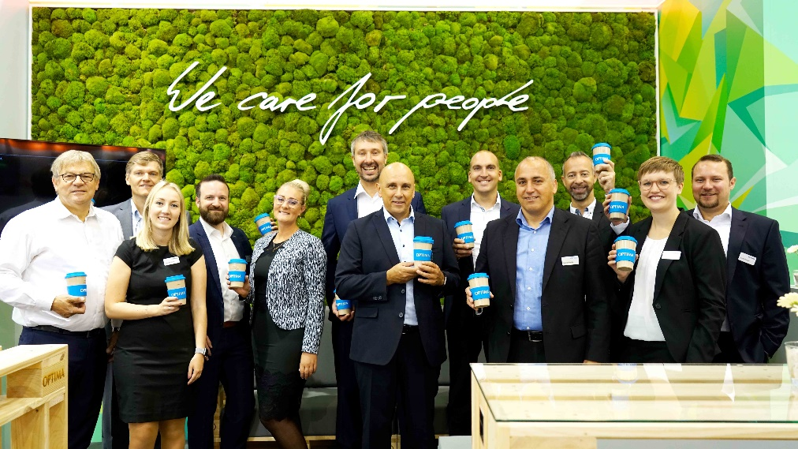
The Optima trade show team were very satisfied with the high quality of contacts at FachPack.

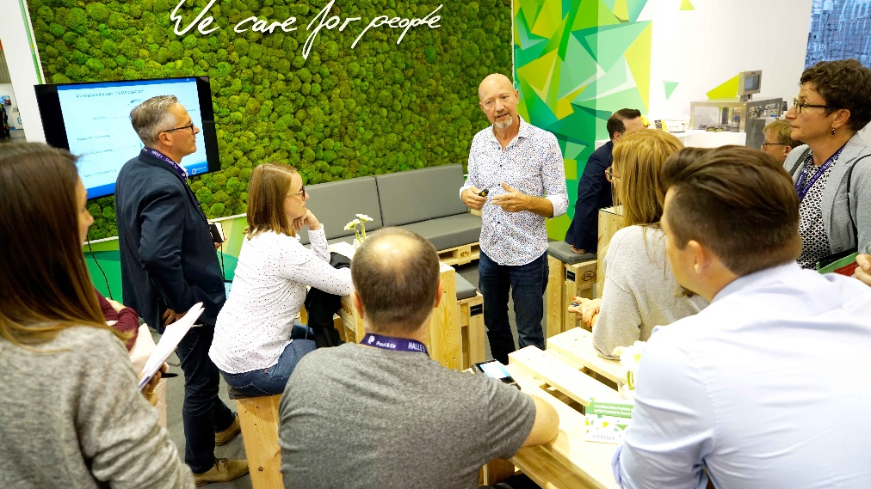
The opportunity to discuss the topic of sustainable packaging with experts such as VerDeSoft received a very positive response.

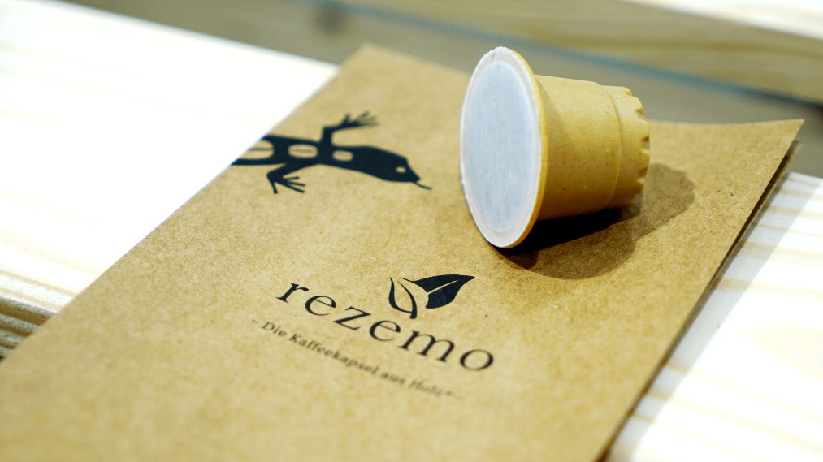
Environment-friendly alternatives to conventional packaging material were the focus at FachPack. These alternatives include capsules made of wood from the startup rezemo based in Stuttgart.

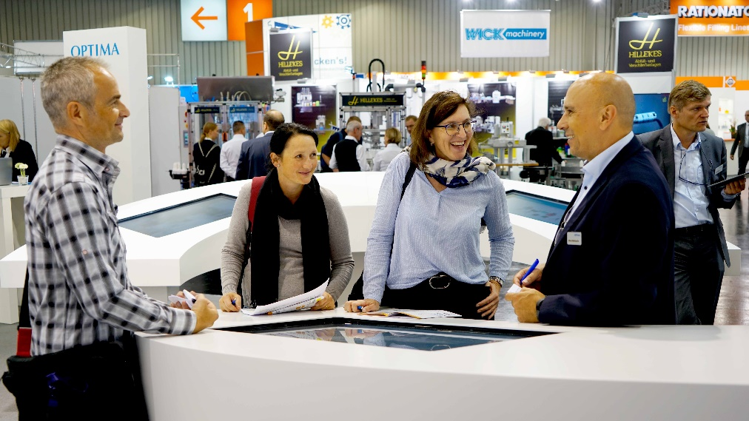
A futuristic video panel introduced visitors to the latest machine technology from Optima.

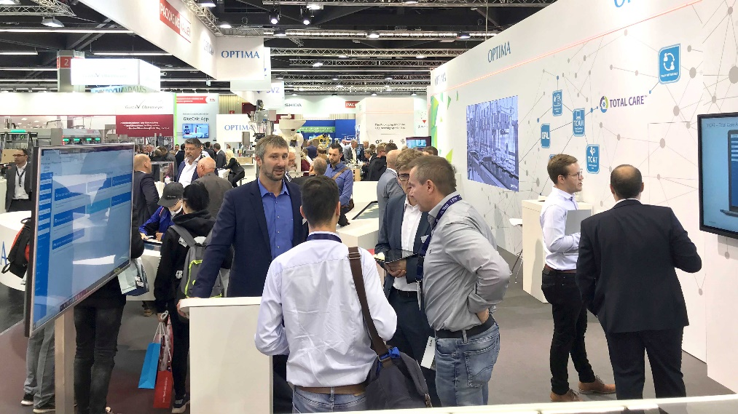
The area of digitalization was also a particular hit with visitors. Optima Smart Services could be called up and explained on the screens.

Characters (incl. spaces): 4,289

Press contact:
OPTIMA packaging group GmbH
Jan Deininger
Editor
+49 (0)791 / 506-1472
jan.deininger@optima-packaging.com
www.optima-packaging.com
Thank you very much for your publication. We look forward to receiving a specimen copy.

