Electromobility needs flawless welds
Laser systems under vacuum conditions improve efficiency while cutting costs for sustainable industrial production

Climate change presents massive challenges for our economy. One of these is the need for more renewable energies. We need more wind power, electric vehicles and fuel cells to power large loads like ships, trains and planes. Among other things, this places high demands on processing efficiency in industrial production. This is particularly true of the welding processes used in the production of bipolar plates for fuel cells, batteries for electric vehicles, busbars for power electronics, copper hairpins for electronic drive trains or steel components for offshore wind turbines. Laser beam welding under vacuum conditions scores highly in this context thanks to its range of benefits for clean, resource-efficient production – with this technique requiring less energy than conventional welding processes for deep weld penetration on stainless steel, aluminium and copper metal alloys and compounds. Combined with innovative laser deflection units, this adds up to greater quality and higher productivity at lower costs.

Traditional laser beam welding under ambient conditions – also known as “atmospheric” welding – unfortunately creates a considerable amount of spattering due to an unstable weld pool. In addition, welding under normal atmospheric conditions is always associated with oxidation, which is why it exhibits a higher degree of corrosion. Dr. Christian Otten, Managing Director of LaVa-X, explains: “My colleagues and I discovered the technique while I was working on research for my PhD. At that time, I was a research assistant at the Welding and Joining Institute at RWTH Aachen University, doing my doctorate on electron and laser beam welding of different combinations of materials. Back then, we were asking ourselves why electron beam welds were so much better than laser beam welds and how this was influenced by negative pressure”. The team tried out a wide range of methods and discovered the benefits of laser beam welding under vacuum conditions – which also presented none of the drawbacks of electron beam welding, such as X-ray radiation. Dr. Otten ultimately founded his own company in 2017 based on this new technique. That company is LaVa-X GmbH in Herzogenrath.

Laser beam welding under vacuum conditions – fewer problems, much higher quality

Compared to conventional methods, laser beam welding in vacuum (100 mbar) runs very smoothly – there are barely any pores or spattering, and heat and hardness cracks occur far less frequently. There is no need to rework the workpieces, since no oxidation takes place. The weld penetration for stainless steel can also be increased by up to 60% with the same welding parameters or, conversely, the laser power can be reduced. Specifically, this means that weld penetrations of 1 mm can be achieved with just 200 watts. The lasers’ lower power also means that the welding process requires significantly less energy. Components can be manufactured in a vacuum without any intermediate steps. All of this saves time and cuts costs and boosts productivity. And the evacuation of the product-specific chambers takes just 3 to 5 seconds. Dr. Otten adds: “In high-efficiency systems, the vacuum chambers are adapted to the product so that only a very small volume needs to be evacuated.” In other words, the quality that can be achieved under vacuum conditions is impressive in many respects.

Deflection units from RAYLASE support vacuum welding
“Personally, I really appreciate working with deflection units,” says Dr. Otten, “because, instead of rotating the component, it’s far easier to guide the laser beam accordingly, allowing us to process several components at once. Which increases our productivity hugely!” During this process, LaVa-X GmbH uses the SUPERSCAN IV-15 from RAYLASE, which is located outside the vacuum chamber. This saves space inside the chamber and minimizes integration costs. Dr. Otten is clearly happy with the powerful support provided for laser beam welding under vacuum: “We can use the SUPERSCAN-IV-15 to set particularly high oscillation frequencies and high amplitudes, and therefore make effective use of wobble welding.”

Easy switching between scanning systems is another important aspect for him, as he explains: “We also use the 20 and 30 versions of the SUPERSCAN IV, but only for powers above 2 kW or when we need a smaller spot with a long focal length at the same time.” Bernhard Dauner, Product Manager at RAYLASE, sees other benefits too: “When combined with lightweight and rigid silicon carbide mirrors, the SUPERSCAN IV’s model-based, digital control offers maximum dynamic responses and final speed. In addition, the water-cooled master block design, in conjunction with optional air flushing, enables applications at up to 6 kW laser power.” The impressive calibre of the SUPERSCAN-IV series – in terms of both optics and electrical engineering – therefore gives machine manufacturers and integrators a large degree of design freedom and allows them to use a range of high-performance lasers, including both pulse and continuous beam lasers.

Energy consumption reduced by up to 35 percent

The innovative process also helps reduce the user’s energy footprint. All in all, “LaVa welding” can produce energy savings of up to 35% compared to conventional laser welding. Not only does in-vacuum welding require less laser power and therefore less energy consumption – it also eliminates the need for compressed air to keep the optics free from spatter and smoke residue. And it should be a commonly known fact that compressed air is one of the most expensive and energy-wasting media that exist. All of these factors are of central importance given that energy prices are currently skyrocketing.

Summary: The logical combination of two technologies – comprising a laser deflection unit and in-vacuum laser welding from LaVa-X – enhances quality while cutting costs and also protects the environment by reducing resource consumption. Which is a really crucial aspect of industrial production today. In this way, users of the technique can make an important contribution to climate protection.

__________________________________________________________________________________

About RAYLASE

RAYLASE GmbH is a highly innovative, international laser company based in Wessling near Munich. Founded in 1999, the Bavarian company offers high-precision opto-mechanical components, control cards and software for the rapid deflection and modulation of laser beams for laser material processing in industrial manufacturing. With over 130 employees worldwide, the RAYLASE Group stands for innovative technology of the highest quality. Since 2007, the company has a subsidiary and its own production facility in Shenzhen, China, as well as several international representatives in the US, Italy, Japan, Korea, and Taiwan.

The laser deflection units comprise opto-mechanical scanners and digital control electronics with an intuitive software interface. These form the core of industrial laser systems and enable more flexible, economical, and precise processing of a wide variety of materials such as metal, plastic, paper, textiles and many more. Opto-mechanical deflection units also offer excellent image processing for better calibration, simple automation, and exact monitoring of a range of laser processes.

Customers come from the electronic, automotive, photovoltaic, textile and packaging industries. RAYLASE’s current focus markets are electromobility, for example, in battery production, solar wafer production for photovoltaics in the solar industry and additive manufacturing. RAYLASE supports its customers primarily in four core applications: laser cutting, laser welding, laser surface processing and selective laser sintering or welding for additive manufacturing. In each of these areas, the company drives digital innovations by combining these with established technologies.

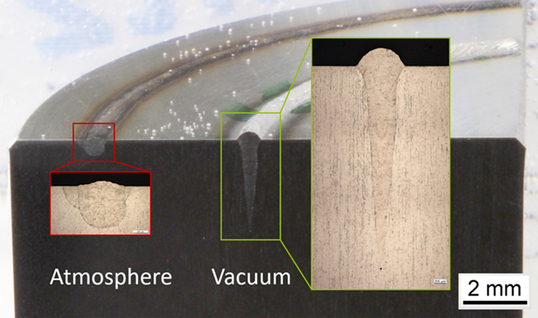

The figure clearly demonstrates the difference between welding in atmospheric conditions and welding under vacuum conditions. The quality of the weld seam is significantly better with in-vacuum welding. In 2020, LaVa-X won the “Rheinland Genial” innovation award for the new welding technique. Source: LaVa-X

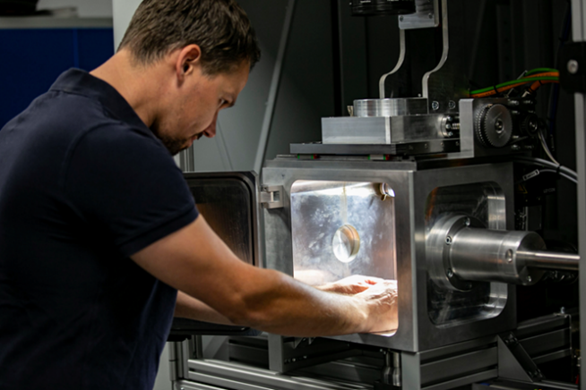

Caption: An employee of LaVa-X works on a laser welding machine with the
open evacuation chamber inside. It creates a vacuum over the component
in 3 to 5 seconds. Source: LaVa-X

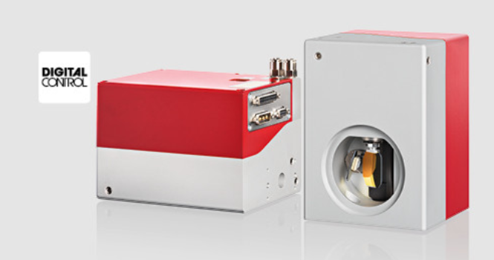
The SUPERSCAN IV series from RAYLASE supports laser beam
welding under vacuum conditions. It offers an impressively compact design
and highly dynamic responses. Source: RAYLASE

