Chris Pang Will Become New Managing Director of LAUDA Singapore

Focus on expanding market position in Asia

Lauda-Königshofen, December 15, 2025 – LAUDA DR. R. WOBSER GMBH & CO. KG announces that Chris Pang will take over as Managing Director of LAUDA Singapore Pte. Ltd. with effect from January 1, 2026. The 39-year-old has been working as General Manager at the company since December 1, 2025, and will succeed Teck Chia Lee, who will be leaving the company on December 31, 2025, to pursue new professional challenges.

Teck Chia Lee has played a key role in shaping the development of LAUDA Singapore as Sales Manager since February 1, 2015, and has intensified cooperation with distributors in the ASEAN region. On July 1, 2020, he was appointed Managing Director. Under his leadership, the sales territories were successively expanded: Taiwan was added in 2019, Korea in 2022, and Australia and New Zealand in 2024. LAUDA thanks him for his commitment and loyalty and wishes him all the best for his future.

Chris Pang has extensive experience in the life sciences and laboratory equipment sectors. From 2017 to 2025, he worked for a leading global supplier of scientific instruments and reagents as Business Manager for Southeast Asia in the life sciences sector. Prior to that, he gained further expertise as Sales Manager at a renowned manufacturer of specialty glass and laboratory technology (2012–2017) and as Product Specialist at an established supplier of laboratory equipment (2007–2010). Born in Malaysia, he completed a bachelor's degree in life sciences with a minor in statistics at the National University of Singapore and earned an MBA from Northumbria University in Newcastle upon Tyne (United Kingdom) in 2018.

Dr. Gunther Wobser, President & CEO of LAUDA, personally welcomed the new Managing Director in Singapore: “With Chris Pang, we are gaining a proven expert for the Southeast Asian market. His many years of experience in the life sciences industry and his deep understanding of regional characteristics will make a decisive contribution to further expanding our position in Singapore and the ASEAN countries. He will lead the subsidiary on a sustainable growth course and intensify our partnerships in the region.”

The subsidiary LAUDA Singapore Pte. Ltd. was founded in 2007 as a holding company for the business activities of LAUDA in Asia. Active sales support began in 2015. At the end of 2023, the branch moved into new business premises in the German Centre in Singapore with an area of over 200 square meters. The location has sales and service teams, a training center, and a modern service workshop. Singapore's strategic location on the equator makes the city-state a trading hub between East and West, between the Indian Ocean and the Pacific. From here, LAUDA supports sales activities in the ASEAN countries and cooperation with sales partners in Taiwan and South Korea.

The focus for 2026 is on expanding sales activities, intensifying existing customer relationships, and developing new business areas in the focus industries of semiconductors, server cooling, and automotive testing.
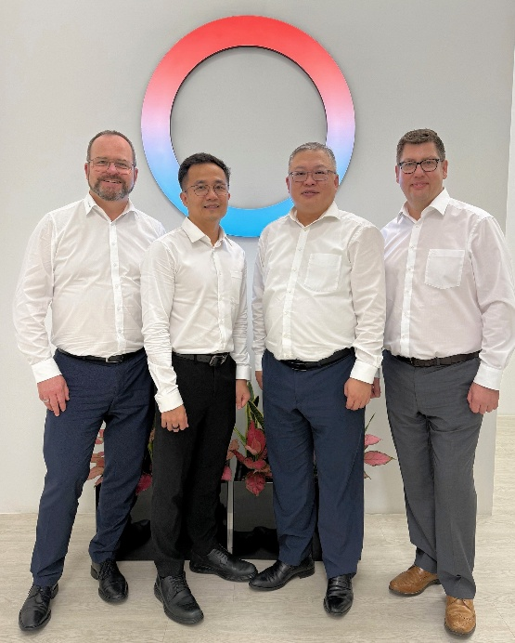 | 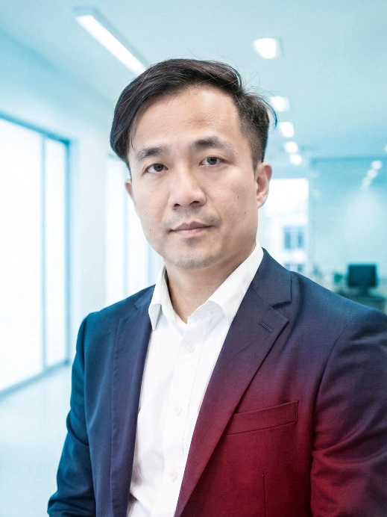
Picture 1: Dr. Gunther Wobser (left to right), President & CEO of LAUDA, personally welcomed Chris Pang to Singapore in the presence of outgoing Managing Director Teck Chia Lee and Stephen Bendefy, Area Sales Manager International. © LAUDA | Picture 2: Chris Pang will take over as Managing Director of LAUDA Singapore Pte. Ltd. on January 1, 2026. The experienced life science expert will put the subsidiary on a growth path and drive forward business in Singapore and the ASEAN countries. © LAUDA

We are LAUDA – the world leader in precise temperature control. Our constant temperature equipment and systems are at the heart of important applications, contributing to a better future. As a complete one-stop supplier, we guarantee the optimum temperature in research, production and quality control. We are the reliable partner for Aerospace, Electromobility, Hydrogen, Chemistry, Pharmaceuticals/Biotech, Semiconductors and Medtech. We have been inspiring our customers for almost 70 years with our expert mentoring and innovative solutions – every day anew and all over the world.

In our company, we always go one step further. We support our employees’ development and are constantly developing ourselves: to create a better future together.

Press contact
We are more than happy to make prepared information about our company, the LAUDA Factory Gallery and our projects in the area of innovation promotion, digitalization and idea management available to the press. We look forward to hearing from you – just give us a call!

CHRISTOPH MUHR
Director Corporate Communications
T + 49 (0) 9343 503-349
christoph.muhr@lauda.de

LAUDA DR. R. WOBSER GMBH & CO. KG, Laudaplatz 1, 97922 Lauda-Königshofen, Deutschland/Germany. Limited partnership: Headquarters Lauda-Königshofen, Registration court Mannheim HRA 560069. General partner: LAUDA DR. R. WOBSER Verwaltungs-GmbH, Headquarters Lauda-Königshofen, Registration court Mannheim HRB 560226. Managing Directors: Dr. Gunther Wobser (President & CEO), Dr. Mario Englert (CFO), Dr. Marc Stricker (COO)

