Tschabalala Self – Inside Out  25 February – 18 June 2023, Kunstmuseum St.Gallen  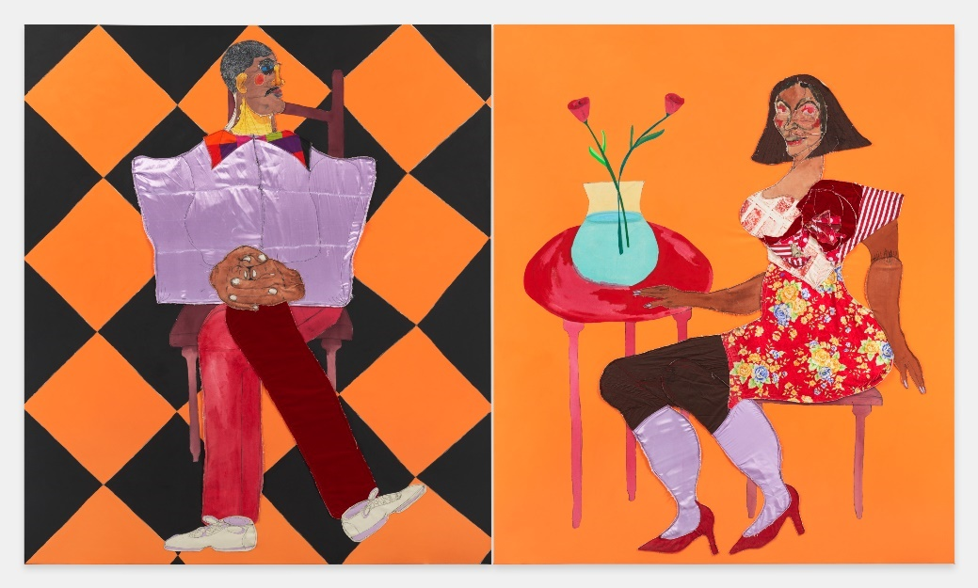  Tschabalala Self, Morning, 2022, Private Collection. Courtesy the artist, Pilar Corrias, London, and Galerie Eva Presenhuber  Kunstmuseum St. Gallen is pleased to present the first institutional solo exhibition of Tschabalala Self in Europe in collaboration with Le Consortium in Dijon. Self’s work often explores themes of Black female identity, sexuality, and the body, using vibrant colors and bold forms to create powerful, highly charged images.  Tschabalala Self (*1990 Harlem, New York) is deeply engaged with the medium of painting. She paints with various pigments, materials, textiles, and threads. Her unique technique includes found, acquired, and hand-dyed fabrics. With these, she creates figures that depict avatars rather than individuals. The artist draws from her personal experiences as a Black American woman. In this context, she stages bodies that are often exalted and excluded within her imagined environments.  Her solo exhibition at the Kunstmuseum St.Gallen brings together the largest and most diverse presentation of her multifaceted oeuvre to a museum to date. On display are nineteen canvases that exemplify Tschabalala Self's artistic development, alongside several new sculptures that take her painting into the third dimension, further intensifying the play of fiction and reality; in addition, the video of a performance Self staged for the renowned New York festival Performa in 2021 will be projected in the foyer of the museum.  In terms of interest, Self's works question the historically, culturally, and socially shaped ideas toward Black bodies; in the artist's words: "Collective fantasies surround the Black body and have created a cultural niche in which exists our contemporary understanding of Black femininity. My practice is dedicated to naming this phenomenon." The artist sets new standards in her work, liberating the Black body from readings that are impeding and limiting.  In her paintings, Self depicts individuals or couples, some of whom seem to float in their own world, isolated against a monochromatic or else patterned background. Tschabalala Self's figures are not to be understood as portraits; rather, they are composites of what she calls a "pantheon of invented characters." The people in her paintings are part of this world, partly abstracted from it. They thus embody an existential condition and are emblematic of interpersonal dynamics.  In addition to paintings, the exhibition will also feature larger-than-life figures: Seated Woman 1 and Seated Man 2, for example, explore the thematic complex of the seated or even enthroned figure, with which Self has recently been preoccupied. The chair thus becomes, as she says, "the stage." The seated figure has much to do with ideas of private and public space, the personal and the political, as experienced in sit-ins as a form of public protest.  Tschabalala Self earned her Bachelor of Arts degree from Bard College in 2012 and her Master of Fine Arts from Yale University School of Art in 2015. She has since exhibited her work at numerous galleries and museums, including the Studio Museum in Harlem, MoMA PS1 and the New Museum in New York. In 2020, she was the subject of a solo exhibitions at the ICA Boston and at the Baltimore Museum of Art in 2021. | Exhibition dates  25 February – 18 June 2023  Kunstmuseum St.Gallen  Press conference  24 February 2023  11 a.m.  Exhibition opening  24 February 2023  6:30 p.m.  Opening hours  Tue. – Sun.: 10 a.m. – 5 p.m.  Wed.: 10 a.m. – 8 p.m.

Factsheet
Tschabalala Self
Inside Out

Exhibition dates | 25 February – 18 June 2023
Exhibition venue | Kunstmuseum St.Gallen
Press conference | 24 February 2023, 11 a.m., Kunstmuseum St.Gallen
Exhibition opening | 24 February 2023, 6:30 p.m., Kunstmuseum St.Gallen
Curator | Gianni Jetzer
Opening hours | Tuesday – Sunday: 10 a.m. – 5 p.m., Wednesday: 10 a.m. – 8 p.m.
Admission | Single admission, regular price  Pensioners  Vocational, school, and university students  Members of the Kunstverein St. Gallen | CHF 12.–  CHF 10.–  CHF 5.–  Free
Press contact | Sophie Lichtenstern  T +41 71 242 06 85  kommunikation@kunstmuseumsg.ch
Website | www.kunstmuseumsg.ch

