SPECIAL HONOR FOR ITZIK AVNI FROM ISRAEL

Dr. Rudolf Wobser Medal awarded for outstanding partnership

Lauda-Königshofen, June 25, 2024 – LAUDA DR. R. WOBSER GMBH & CO. KG has awarded Itzik Avni, owner and Managing Director of the Israeli LAUDA representative Meshulam Avni & Son Ltd. with the Dr. Rudolf Wobser Medal. The world market leader for temperature control technology thus honored the outstanding achievements, tireless commitment and many years of successful cooperation with the Israeli partner from Nescher, southeast of Haifi. The award ceremony took place during the festive gala dinner, which was part of the LAUDA supporting program at the world's leading trade fair ACHEMA in Frankfurt am Main and was attended by numerous LAUDA dealers and international representatives.

The Dr. Rudolf Wobser Medal is the highest award given by the family business in recognition of an individual's outstanding achievements. The award ceremony was a moment of surprise and joy for the recipient: Itzik Avni is only the second recipient from outside the company. Dr. Gunther Wobser, President & CEO of LAUDA, who presented the medal together with his father and former Managing Director, Dr. Gerhard Wobser, emphasized the significance of the award: “The award is a sign of our deep appreciation for Mr. Avni's extraordinary achievements - especially in difficult times such as since the terrible events of October 7, 2023.”

The agency, which has been in business since 1970, tripled its turnover from 2022 to 2023 to over one million euros and was able to not only continue its business activities but also maintain a high turnover level. The personal connection between Meshulam Avni & Son and LAUDA was also highlighted. “The strong relationship between the Avni and Wobser families, which has grown over more than 50 years and generations, reflects our commitment to long-term and successful partnerships. It is our pleasure and privilege to maintain and strengthen these German-Israeli ties,” added Dr. Gunther Wobser. A special highlight will be Itzik Avni's 50th anniversary with the company next year. Health and enjoyment of work run in the family. The company founder, his father Meshulam, worked until the age of 90 and died in April 2010 at the age of 95.

LAUDA acknowledges the achievements of Meshulam Avni & Son and looks forward to future joint projects.

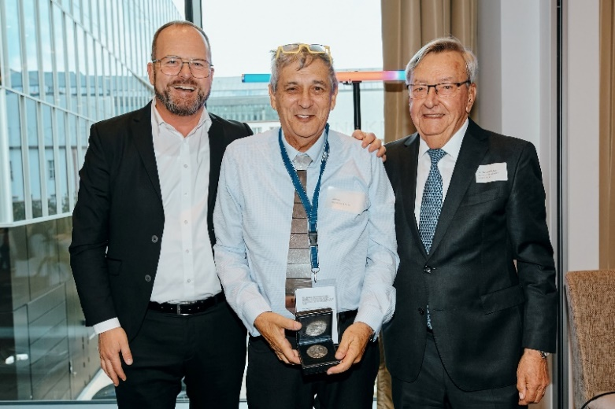
Fig.: Dr. Gunther Wobser (left), President & CEO of LAUDA, together with Dr. Gerhard Wobser (right) presented the Dr. Rudolf Wobser Medal to Itzik Avni (middle) and thanked him for the long-standing, successful partnership. © Chris Rausch

We are LAUDA – the world leader in precise temperature control. Our constant temperature equipment and systems are at the heart of important applications, contributing to a better future. As a complete one-stop supplier, we guarantee the optimum temperature in research, production and quality control. We are the reliable partner for electromobility, hydrogen, chemicals, pharmaceuticals/biotech, semiconductors and medical technology. We have been inspiring our customers for almost 70 years with our expert mentoring and innovative solutions – every day anew and all over the world.

In our company, we always go one step further. We support our employees’ development and are constantly developing ourselves: to create a better future together.

Press contact
We are more than happy to make prepared information about our company, the LAUDA Factory Gallery and our projects in the area of innovation promotion, digitalization and idea management available to the press. We look forward to hearing from you – just give us a call!

CHRISTOPH MUHR
Head of Corporate Communications
T + 49 (0) 9343 503-349
christoph.muhr@lauda.de

LAUDA DR. R. WOBSER GMBH & CO. KG, Laudaplatz 1, 97922 Lauda-Königshofen, Deutschland/Germany. Limited partnership: Headquarters Lauda-Königshofen, Registration court Mannheim HRA 560069. General partner: LAUDA DR. R. WOBSER Verwaltungs-GmbH, Headquarters Lauda-Königshofen, Registration court Mannheim HRB 560226. Managing Directors: Dr. Gunther Wobser (President & CEO), Dr. Mario Englert (CFO), Dr. Ralf Hermann (CSO), Dr. Marc Stricker (COO)

