Realising creative visions without restrictions

**Red Dot Design Award for LAMILUX Modular Glass Skylight MS78**

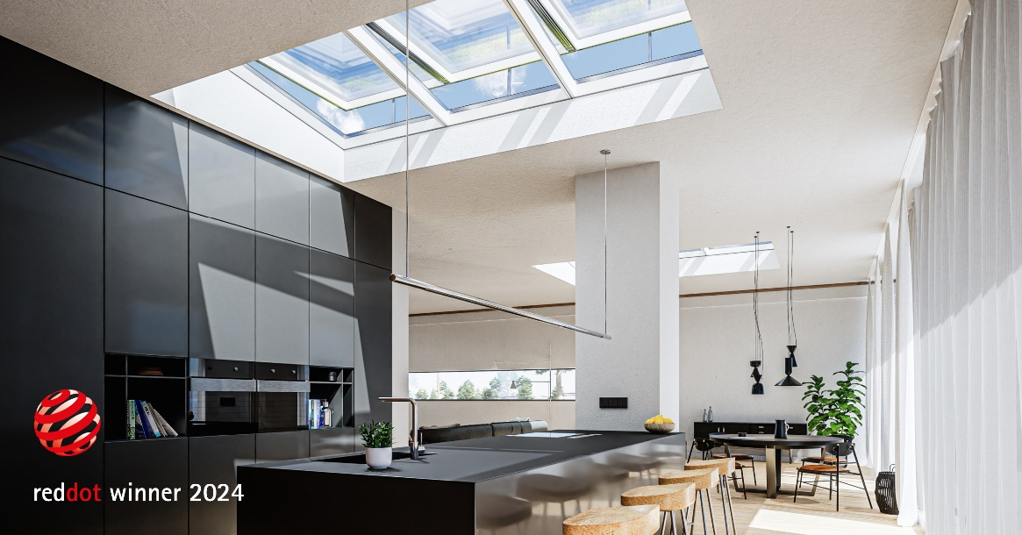**It's another triumph for LAMILUX. For the fifth time now, the skylight specialist has been honoured with the renowned Red Dot Design Award. In the "Product Design" category, the LAMILUX Modular Glass Skylight MS78 emerged as the winner. This award once again emphasises the excellent collaboration of design and functionality that makes LAMILUX skylights stand out.**

The Red Dot Design Award is one of the biggest design competitions in the world. Every year, outstanding products and projects that lead the way in design and innovation are honoured. With this award, the international jury recognises companies that offer forward-looking answers to the requirements of a changing world and at the same time focus on sustainable solutions.

Combining tradition and innovation

The LAMILUX Modular Glass Skylight MS78 combines proven daylight technologies with state-of-the-art glass roof innovations. The jury was convinced by the combination of aesthetic clarity and high product quality. Criteria that granted the LAMILUX Modular Glass Skylight MS78 the "Winner Label" in the "Product Design" category. Just recently, the LAMILUX Modular Glass Skylight MS78 was honoured with the renowned German Design Award in the category "Excellent Product Design - Building and Elements".

"The fact that we have now also received the Red Dot Design Award fills us with particular pride and encourages us in our pursuit of innovation, quality and environmental protection," explain the Managing Directors of LAMILUX, Johanna Strunz and Dr Alexander Strunz. "The award is a reflection of our company philosophy and our continuous commitment to creating products that are not only functionally convincing, but also offer sustainable added value in design processes and production."

Maximum flexibility and lasting quality

"Our LAMILUX Modular Glass Skylight MS78 enables architects to accomplish their creative visions without restrictions. They benefit from the simple realisation of their projects while guaranteeing the highest quality standards," says Niklas Braun, Technical Manager at LAMILUX.

With widths of up to 3.00 metres, variable lengths and pitches from 5° to 30°, the LAMILUX Modular Glass Skylight MS78 offers unique design freedom. The clear, homogeneous design and excellent safety performance from the first sealing level onwards speak in favour of the high quality and durability of the glass roof. In addition, automated processes ensure fast delivery times and the excellent thermal insulation ensures significant energy savings.

A new benchmark for ambitious architectural projects

The LAMILUX Modular Glass Skylight MS78 has already been on the market since August 2023 and is in great demand. It sets new standards in modern architecture and proves to be the ideal solution for innovative building projects.

LAMILUX Heinrich Strunz Group, Rehau

Continuous rooflights, glass roofs or rooflights: the LAMILUX Heinrich Strunz Group is one of the leading manufacturers of skylights in Europe. The skylights ensure efficient use of natural daylight in a wide variety of buildings. In addition, special smoke and heat extraction systems provide safety in case of fire and are therefore essential components of fire protection concepts. LAMILUX is also known for its solutions for object smoke extraction. Furthermore, the medium-sized family business founded in 1909 is one of the world's largest producers of carbon and glass fibre reinforced plastics. These composite materials provide stability, lightweight construction and impact resistance for instance in roof, wall and floor linings in commercial vehicles. LAMILUX strives to be the innovation and performance leader in all areas relevant to its customers. The family-owned company, based in Rehau, Germany, is managed by Johanna and Dr. Alexander Strunz in the fourth generation, currently employs around 1,300 people, and in 2023 generated sales of around 354 million euros.

[www.lamilux.com](http://www.lamilux.com)

**Image description**

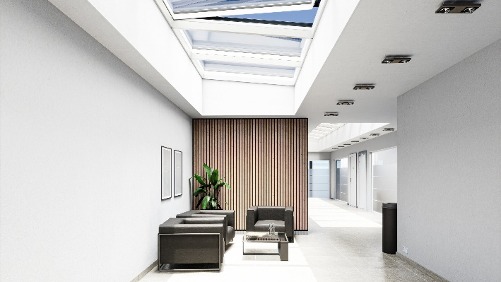

*The LAMILUX Modular Glass Skylight MS78 scooped the Red Dot Award for its combination of aesthetic clarity and high product quality.*

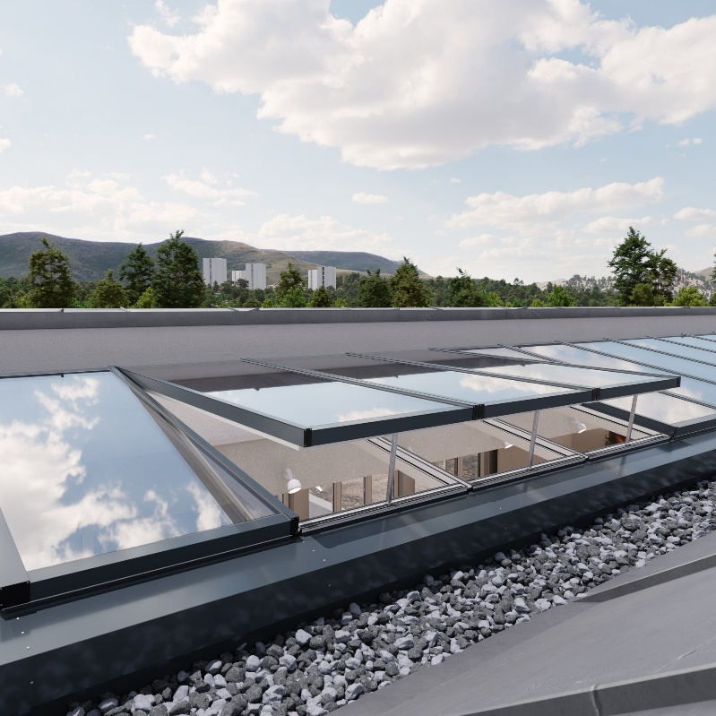

*The unrestricted arrangement of the ventilation sashes, even directly next to each other, creates a maximum ventilation area and an excellent supply of fresh air and oxygen to your building.*