Clear visibility in all situations
Always have everything in view
Ahaus, September 11th, 2020
Wearers of glasses are facing a hard time, especially in days of Covid-19. The reason: When wearing a face mask, whether for short periods of shopping or for long-term use in activities with colleagues and customers, the breathing mist causes a hazy view.
Briefly wiped with a handkerchief or standard spectacle cleaning cloth – problem solved. One would think so. Unfortunately, the clear view does not last for long – and the cleaning job becomes a permanent activity.
A brand-new special anti-fogging microfiber cloth that has just been launched on the market is currently causing a sensation. The innovative cloth from Polyclean, Europe's leading manufacturer of highly efficient cleaning products for sensitive surfaces, is based on a special impregnation that makes the decisive difference.
This makes the P-9000® microfiber cloth turns into a highly effective care cloth with long lasting anti-fogging effect for eyeglass lenses. This provides a clear view for up to 12 hours.
With its special anti-fogging cloth, which can be reused up to 200 times, the Ahaus-based company Polyclean offers a product with a unique selling point. By the way, the care cloth is not only suitable for corrective glasses, but also for sunglasses, reading glasses, safety glasses, diving goggles and helmet visors.
The anti-fogging cloth is available at a price of EUR 8.95 (RRP) in specialized stores and online shops.

The company
Polyclean International GmbH is the leading European manufacturer of highly efficient cleaning cloths made of P-9000® microfiber - especially for the care of sensitive surfaces. These include in particular spectacle lenses, optical lenses, touch screens and displays. With 20 years of experience, trend setting innovations and high-quality standards, the company is a well-known specialist in this segment. Leading customers from various branches rely on the competence and quality of the German manufacturer.
Characters: 2012 (including blanks and headlines)

Link to the download page for text and images

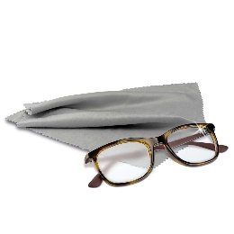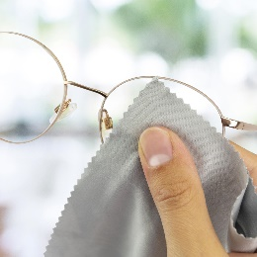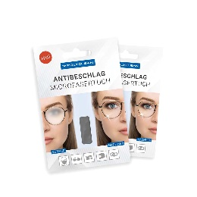
Image 1 Image 2 Image 3 Image 4 Image 5

Bildunterschriften
Image 1 The new microfiber anti-fogging cloth from Polyclean ensures clear view despite corona mask
Image 2 Always have everything in view - the P-9000® anti-fogging cloth prevents the fogging of spectacle glasses for up to 12 hours
Images 3 / 4 The new P-9000® care cloth for high-sensitive surfaces can be used up to 200 times
Image 5 The P-9000® anti-fogging cloth is packed in a practical zip bag and folding case

Picture Credits © Polyclean

