PRESS RELEASE
Schwaebisch Hall, August 20, 2019

Better Flavor, Better Efficiency
OPTIMA at Host 2019

At Host 2019, Optima will be exhibiting alongside Manes Macchine s.r.l., a company it has been cooperating with for many years. The technical solutions for coffee that they provide cover everything from aroma-optimized, efficient processing after roasting to the entire dosing and packaging process. At the trade show, Optima will also be demonstrating cutting-edge packaging technology for coffee portion packaging and exhibiting an OPTIMA CFL 1-6 for aluminum capsules. The Optima machines can easily be adjusted to take other capsule materials and systems. The portfolio being exhibited at the trade show also includes packaging technology for granulated beverages and beverage powders, for sales packaging made from cardboard, and for use on pallets. Furthermore, innovative services and line management software ensure highly efficient long term operation with a low total cost of ownership (TCO).
Optima coffee experts will demonstrate leading technological solutions live at the booth with an OPTIMA CFL 1-6 for aluminum capsules. This includes the controlled, pressure-free insertion of the delicate aluminum capsules into the process, followed by the packing of the coffee to the filling point, which is performed in a way that protects the product in a highly effective way. When sealing the capsules, the foil is fed in diagonally to ensure that it is used in an optimal way. A two-step sealing system ensures optimal results. To ensure the best impermeable seal possible, an initial sealing station quickly and continuously readjusts the seal settings. The second sealing station ensures that the foil seal has a top-quality appearance. The Optima systems' flexibility is also a great benefit to its users. For example, they can quickly and easily be adapted from aluminum to compostable capsules or expanded with additional stations. Optima works closely together with a variety of capsule manufacturers to provide solutions. At Host, Optima will provide more information on this and answer any other questions.
Optima and Manes share a proven partnership going back over many years. When brought together, the skills of both companies make for highly efficient processing of ground coffee that protects the aroma and the product. Manes makes use of gas supply systems for transportation so that the aromas of the coffee are fully retained all the way to the product containers and dosing units of the Optima packaging machines. The gas supply principle is continued in the Optima filling and sealing machines right up to the point when the containers are sealed to retain aroma. Special Manes silos can also separate aromas when degassing the coffee and add them back to the coffee before it is processed further. This means that the quality of the coffee is fully maintained even with up to 12 hours of intermediate storage. Both companies are appearing together at the same trade show booth.
The OPTIMA CBF cartoning machine, for example, can be integrated into the turnkey systems from Optima. It produces high-quality sales packaging for portions. As a full-service provider, Optima covers the entire packaging process with outer-packaging systems, palletizers, and other functions. Optima will provide information about this approach at Host.
The “InlineCan” cardboard cans and “SoftCan” foil cans provide significant logistical advantages and are more eye-catching at the point of sale (POS). Each of the innovative packaging solutions is produced, filled, and sealed on-site in a continuous process. This not only reduces the costs of transporting empty containers, but also hugely reduces warehousing costs.
Together with the machines' high quality, the services provided by Optima focus on optimizing total cost of ownership (TCO) for the operator. For example, the OPAL line management software will be presented running on the exhibition machine. It constantly evaluates the efficiency of the system in detail. OPAL can be used across different manufacturers for the entire production line. WEmaintain from Optima provides access to systematically secure maintenance. The system provides prompt notification of upcoming work to be performed based on the number of machine cycles and supplies parts subject to wear and tear in suitable packages. Visitors to Host will also be informed about the option of integrating an Embedded Engineer from Optima.
Optima at Host in Milan, Italy: October 18 to 22, 2019, Hall 1.4, Booth Pav. 22, T16 U15

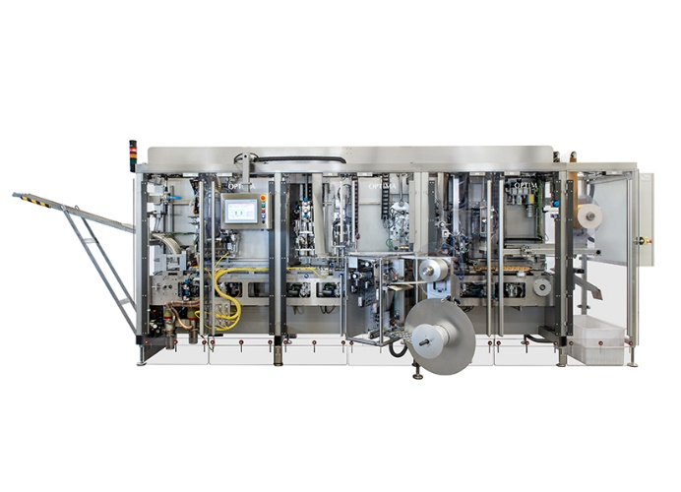
The OPTIMA CFL 1-6 doses coffee in a particularly gentle way in aluminum capsules. The machine, with a new sealing system, can be adapted to take compostable capsules in next to no time.

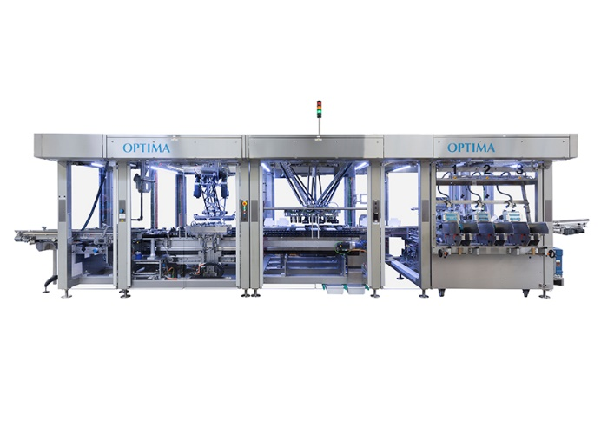
The OPTIMA CBF cartoning machine packs portion packages, for example, into eye-catching, high-quality sales packaging.

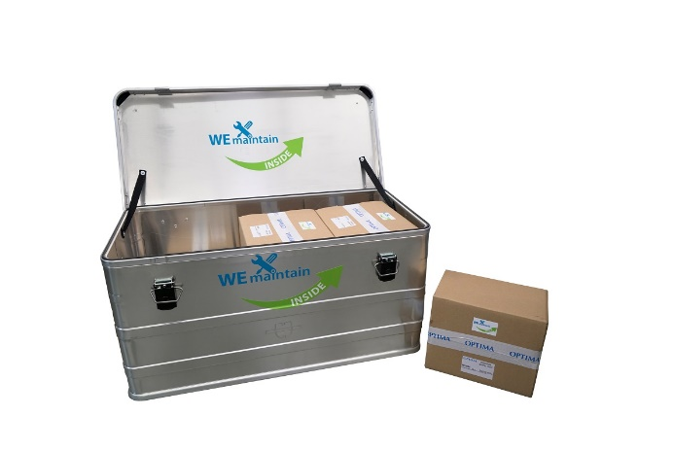
Packages of parts subject to wear that are coordinated with maintenance cycles are part of the WEmaintain service program from Optima. The operator is made aware of upcoming maintenance automatically and with good notice.

Characters (incl. spaces): 4,424

Press contact:
OPTIMA packaging group GmbH
Jan Deininger
Editor
+49 (0)791 / 506-1472
jan.deininger@optima-packaging.com
www.optima-packaging.com
Thank you very much for your publication. We look forward to receiving a specimen copy.

