GEA introduces the GEA Omni NG control panel to deliver flexible digital control and advanced cybersecurity

Düsseldorf, Germany, September 21, 2026 – GEA has introduced the next generation control panel, GEA Omni NG, delivering enhanced cybersecurity, scalability and digital connectivity for heating and refrigeration system operators. Designed for modern industrial environments, the control panel enables smarter, more secure and more efficient equipment control.

Built on a legacy of leadership and innovation
Since its introduction in 2014, more than tens of thousands of GEA Omni control panels have been sold worldwide, making it a trusted solution for operators. Known for its intuitive design and reliability, the GEA Omni set a benchmark in machine control with the industry’s first high-definition, multi-touch screen. The GEA Omni NG retains the flexibility, ease of use and cutting-edge capabilities that made the GEA Omni the control panel of choice.

The GEA Omni NG builds on this legacy with software and hardware upgrades that provide operators with better access to real-time data to help them easily manage, maximize and track system performance. For example, the IPC has been replaced with a Wi-Fi-enabled
GEA G-Plex® electronic module and separate touchscreen monitor, allowing for more flexibility. Operators, contractors and plant managers can now connect with their own devices, such as tablets and mobile phones. This facilitates remote monitoring, faster troubleshooting and easier access to historical data. In addition, the operating system has changed from Windows® to Linux, providing a faster, more secure and customizable system. To facilitate seamless upgrades, the GEA Omni NG is backward compatible with the GEA Omni.

Secure technology for machine control and monitoring
As factories become increasingly automated, cybersecurity threats are on the rise. Control systems, such as those utilized by industrial heating and refrigeration equipment, are vulnerable to these threats. The GEA Omni NG provides a secure digital control system that strengthens overall plant security. The control panel is on track for compliance with EU Machinery Regulation 2023/1230, Cyber Resilience Act, Network and Information Systems (NIS 2) Directive, and NIST Cybersecurity Framework (CSF) 2.0. Compliance with these frameworks helps prevent unauthorized access to programmable logic controllers and protects critical plant operations.

Digital solutions for smarter, more connected operations
By digitally connecting equipment, the GEA Omni NG empowers operators to run their systems more reliably, efficiently and sustainably. The control panel is GEA Cloud® ready, which opens the door to digital solutions that monitor equipment to deliver energy efficiency and sustainability benefits. By turning real-time data into meaningful insights, GEA digital solutions provide greater visibility and control over system performance, energy use, and maintenance needs. This helps operators reduce costs and improve uptime.

Continuous development backed by customer-centric approach
GEA’s experienced software engineers follow a customer-centric development approach, gathering direct feedback from users to continuously refine functionality. Combined with real-world factory experience and testing, faster development cycles are realized. This ensures the control panel meets evolving operational needs.

GEA Cloud® and GEA G-Plex® are registered as trademarks in several countries worldwide.
Windows is a trademark of the Microsoft group of companies.

Photo:
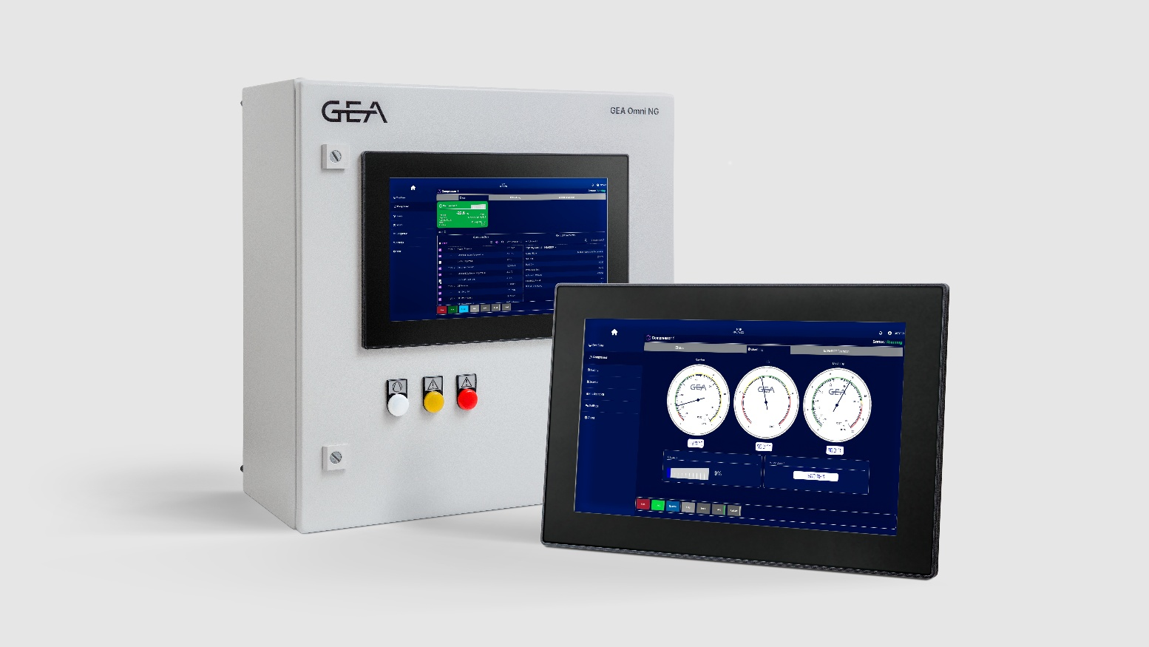

Photo, caption: GEA has introduced the next generation control panel. (Photo: GEA)

NOTE TO EDITORS

- Further information about GEA
- To the GEA Press page
- To the GEA Media Center
- Background information on current topics can be found at Features
- Follow GEA on  

About GEA
GEA is one of the world’s largest suppliers of systems and components to the food, beverage and pharmaceutical industries. The international technology group, founded in 1881, focuses on machinery and plants, as well as advanced process technology, components and comprehensive services. For instance, every second pharma separator for essential healthcare products such as vaccines or novel biopharmaceuticals is produced by GEA. In food, every fourth package of pasta or every third chicken nugget are processed with GEA technology.

With more than 18,000 employees, the group generated revenues of about EUR 5.5 billion in more than 150 countries in fiscal year 2025. GEA plants, processes, components and services enhance the efficiency and sustainability of customers’ production. They contribute significantly to the reduction of CO2 emissions, plastic usage and food waste. In doing so, GEA makes a key contribution toward a sustainable future, in line with the company’s purpose: ”Engineering for a better world.”

GEA is listed on the DAX, the STOXX® Europe 600 Index and is also a constituent of the leading sustainability indices DAX 50 ESG, MSCI Global Sustainability and Dow Jones Best-in-Class World.

More information can be found online at gea.com.
If you do not want to receive any further information from GEA, please send an e-mail to pr@gea.com.

GEA
Media Relations GEA
Dr. Michael Golek
Ulmenstraße 99, 40478 Düsseldorf
Phone +49 211 91361505
Tel. +491736205746
michael.golek@gea.com

