PRESS RELEASE
Schwaebisch Hall, November 26, 2018

New OPTIMA ImmuFill makes its grand entrance
OPTIMA Life Science returns happy from Compamed

The new OPTIMA ImmuFill made its debut appearance at Compamed. This machine dispenses (ancillary) reagents into bottles, topping off the range of products for manufacturing and packaging complete ELISA test kits. The subject of web converting for products such as transdermal patches and orally disintegrating films (ODFs) also met with great interest and was one of the reasons for Optima Life Science’s highly positive verdict on the trade fair.

A profile of the new machine

The OPTIMA ImmuFill was specifically designed for filling bottles with (ancillary) reagents. The rotary transfer machine dispenses the liquids in bottles of varying diameter and depth. As small batches are often produced in the diagnostics industry, it is essential that formats can be changed quickly. The machine only requires very few format parts, allowing the format to be changed in under 30 minutes.

One special feature is the integrated robot which inserts the bottles together with their caps into the star wheel. Only the robot’s vacuum cup needs to be switched when changing formats, which can be done particularly quickly and easily with a plug-in coupling. In addition, two-, four-, ten-, and one-hundred-milliliter bottles can be processed on one wheel.

The OPTIMA ImmuFill consists largely of aluminum components and is altogether a lot cheaper than machines from the pharmaceuticals industry, which predominantly uses stainless steel. Making the machine compact was also a key consideration. Occupying an area of three square meters, the machine is perfect for both smaller production spaces and for laboratories.

The system complements the modular OPTIMA ImmuCoat® machine platform, which covers the entire process of coating microtiter plates. Every process step required can be integrated into this platform. For instance, it includes incubators in which the microtiter plates are stored between the individual process steps. Also in the portfolio is the OPTIMA ImmuPouch machine, which packages the plates in three-side pouches and seals them. The OPTIMA Life Science machine range therefore covers the whole range of functions required for manufacturing and packaging complete test kits, including reagents.

Synergies within the Optima Packaging Group were systematically harnessed to design the OPTIMA ImmuFill, a process that saw Optima Life Science draw on the specific expertise of R+E Automation.

Web converting for transdermal patches and ODF products

Fair visitors were also very interested in the subject of web converting, especially the OPTIMA TDC 125. This is the ideal type of machine for new products and business areas in the field of transdermal patches (TDPs) and orally dissolving films (ODFs), which are manufactured in runs ranging from laboratory scale down to smaller batches. All production and packaging processes can be validated and later transferred to larger production machines as required. The scalable machine is suited to manufacturing product samples for clinical tests, for market launches, and for subsequent production. In its simplest form, the system works intermittently, but it can also be operated continuously with high throughput for mass production.

As a member of the COMEDCO alliance, Optima Life Science also offers complete solutions for TDS and ODF products. As well as the OPTIMA TDC 125, this includes manufacturing and coating the films for active substances. Both are done together with Oatema in Dormagen, which, as a development partner, can also provide support as required with its own laboratory.

Optima Life Science’s verdict on the trade fair

Optima Life Science came away from Compamed 2018 extremely satisfied. The excellent quality of contacts more than made up for the slight decrease in visitor numbers. This year, Optima Life Science received a particularly high number of prospective clients from the diagnostics industry thanks to the new OPTIMA ImmuFill machine and the complete solution for ELISA test kits. And the company from Schwäbisch Hall had every reason to be happy with how the trade fair went, with 70 percent of inquiries relating to specific projects and 70 percent of inquiries coming from new contacts.

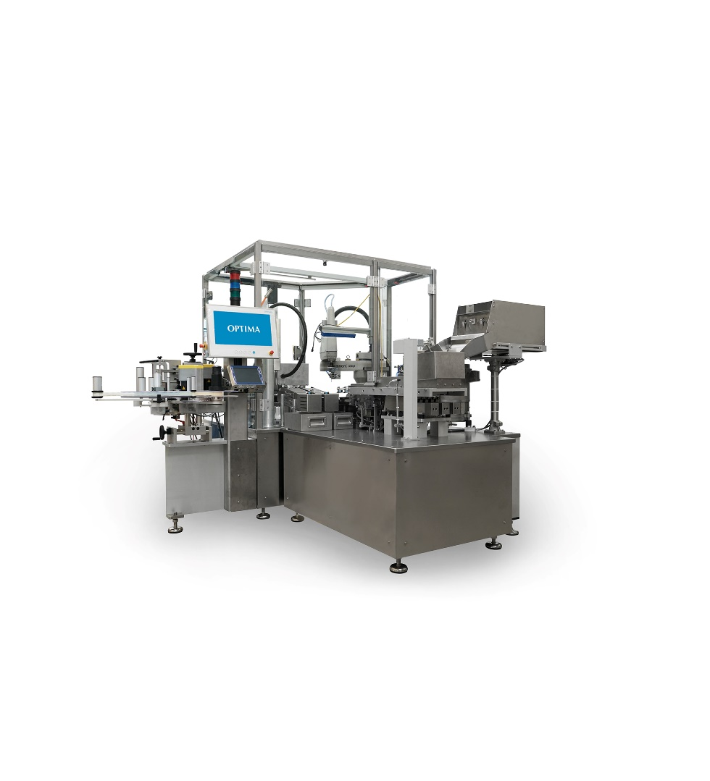
The OPTIMA ImmuFill tops off Optima Life Science’s diagnostics machine family. It is used to dispense (ancillary) reagents.

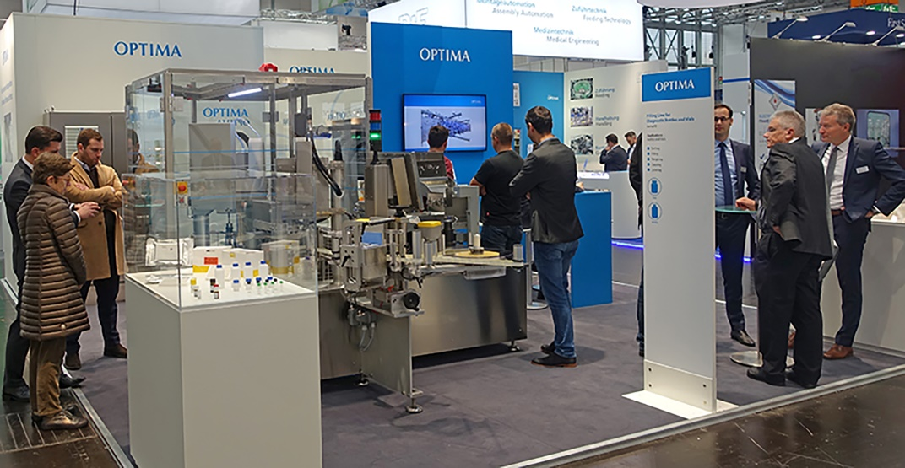
Optima Life Science secured many new contacts at Compamed and discussed specific projects.

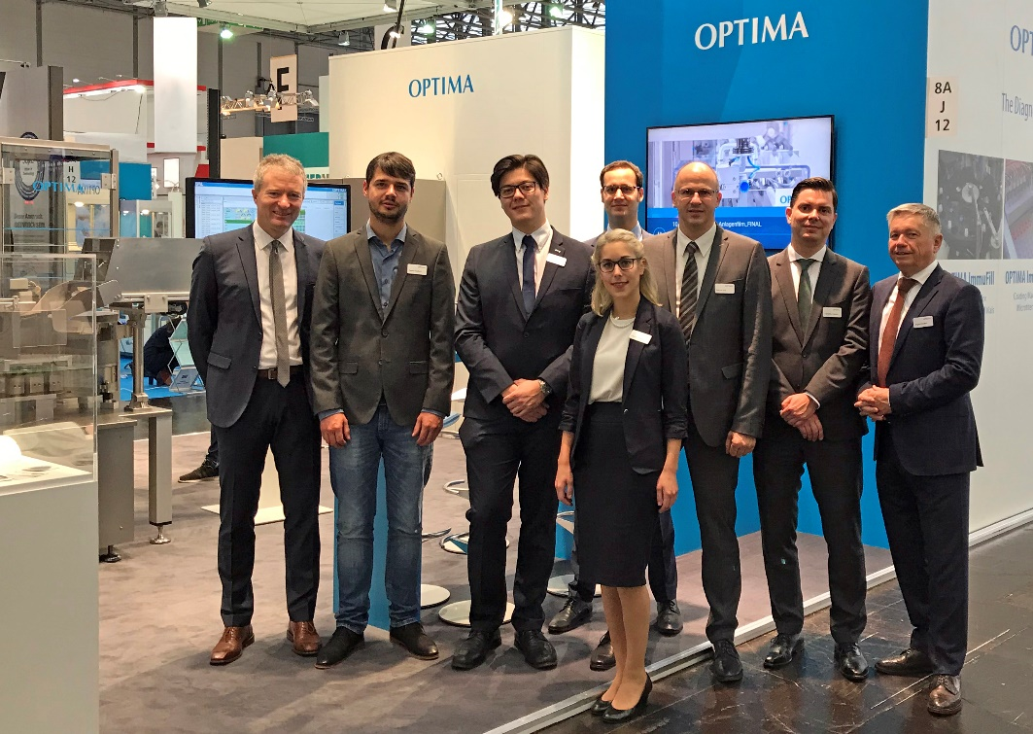
The Optima Life Science trade fair team at Compamed 2018 spoke of many new contacts they made and specific projects they discussed.

Characters (incl. spaces): 4,269

Press contact:
OPTIMA packaging group GmbH
Jan Deininger
Editor
+49 (0)791 / 506-1472
jan.deininger@optima-packaging.com
www.optima-packaging.com
Thank you very much for your publication. We look forward to receiving a specimen copy.

