New Colors: the traser P68 Pathfinder Family is Growing
A New Impetus for Boundless Adventurers
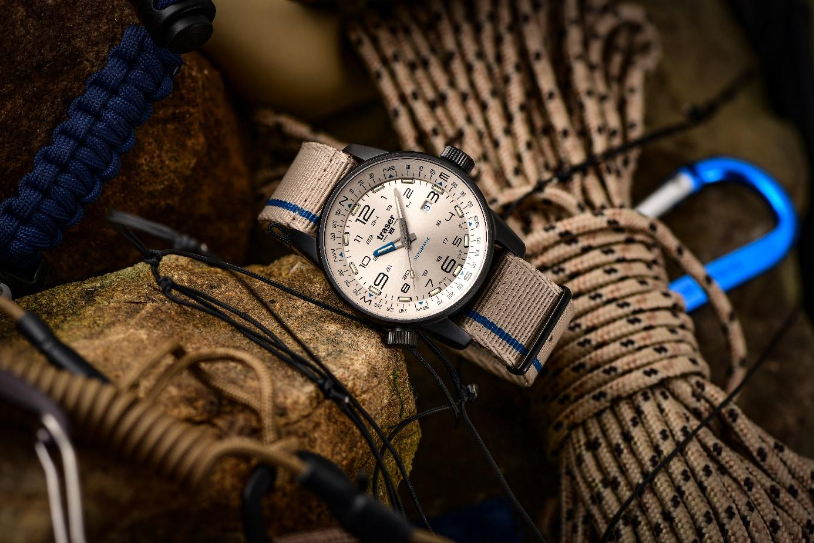
A new year means new goals. True outdoor enthusiasts want to scale the heights even when faced with icy cold weather, biting winds and snow-capped summits. And anyone who pits themselves against the world’s toughest challenges needs a reliable partner at their side. With the latest additions to its P68 Pathfinder product line, the Bern-based watch pioneer traser is offering a new impetus for all adventure-lovers.
Icy mountain landscapes, sheer cliffs and cold temperatures: at this time of year, adventure can be found at every turn and is tempting outdoor sports enthusiasts back to nature. For all those seeking extraordinary adventures, Bern-based watchmaker traser presents the P68 Pathfinder Automatic, a timepiece characterized by uncompromising functionality and extreme ruggedness. Thanks to the company’s proprietary trigalight self-powered illumination technology, the hands and indices of all traser watches light up even in complete darkness, guaranteeing constant, effortless timekeeping even in poor visibility – all without an external power source. And this year, the watch is available with new dials and in new colorways.
While the familiar gleam of the dial hasn’t changed, the new anthracite colorway gives the watch’s stainless-steel case a strong new appeal. The anti-reflective sapphire crystal and familiar traser compass ring, which can be adjusted via a screw-in crown, offer unwavering resilience even on extreme expeditions, meaning they can always reliably point you in the right direction. Whether paragliding over rugged mountain peaks or ski touring in the early hours of the morning, anyone keen to gain new perspectives, discover the unknown, and go further and higher in the new year will find a faithful companion in the P68 Pathfinder, which will never let you stray from your path.
Limitless freedom with the P68 Pathfinder Automatic Green
Climbing high up to the summit and then paragliding over valleys and forests? The P68 Pathfinder is in. During a sweaty climb and in the face of changeable winter flying conditions, the best possible preparation and the right equipment are all the more important. Equipped with trigalight illumination, this timepiece can also happily cater to those making an early-morning start – offering a feeling of freedom, day and night. The green dial and matching fabric or rubber strap rise to the challenge of nature at all times, giving the wearer a feeling of boundless adventure.

Start the Spring with the P68 Pathfinder Automatic Beige
The P68 Pathfinder Automatic isn’t just suited to the coldest time of year; even in the spring, the P68 Pathfinder Automatic in the Beige colorway blends effortlessly into the rugged mountain landscape. Whether climbing the next mountain peak or scaling steep mountain ledges, this watch is up to every challenge thanks to its extreme ruggedness. Likewise, the integrated compass ring ensures that you’ll never lose your sense of direction even when descending into the valleys. Whether with a textile or rubber strap, the P68 Pathfinder Automatic ensures a comfortable and secure fit on the wrist at all times. No matter how rugged nature may be, the wearer and the watch form a single unit, ready to face any test of endurance.

No matter the weather and no matter the color, adventurers who see the beauty of nature even in the remotest corners of the world can make the unattainable achievable with the P68 Pathfinder Automatic.

Technical specifications – P68 Pathfinder Automatic – Swiss Made
Illumination: Trigalight self-powered illumination technology on the hour markers,
hands and under the traser logo
Super-LumiNova marking on dial
Luminescent glass seal
Movement: Swiss Made Automatic
Size: Ø 46 mm
Glass: Anti-reflective sapphire
Case: Anthracite PVD-coated stainless steel
Matt, screw-down crown
Dial: Beige and Green
Date window at 3 o’clock
Strap: Fabric and rubber strap
Water resistance: 10 atm / 10 bar
Price: CHF 895.00 with fabric strap
CHF 950.00 with rubber strap
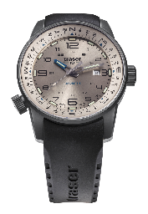
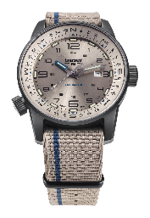
Series models:
110454 P68 Pathfinder Automatic, Beige
PVD-coated stainless-steel case, beige-colored dial
Fabric strap
110455 P68 Pathfinder Automatic, Beige
PVD-coated stainless-steel case, beige-colored dial
Rubber strap

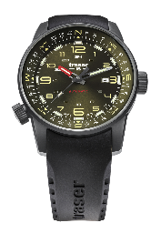
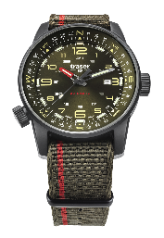
110456 P68 Pathfinder Automatic, Green
PVD-coated stainless-steel case, green dial
Fabric strap
110457 P68 Pathfinder Automatic, Green
PVD-coated stainless-steel case, green dial
Rubber strap

About traser swiss H3 watches – #theoriginal #unlimited #illumination

traser swiss H3 watches are developed and manufactured under the SWISS MADE quality seal in Niederwangen, Bern, in Switzerland. All traser watches boast a unique feature: permanent, non-stop illumination of the time in darkness and poor visibility thanks to traser’s proprietary trigalight self-powered illumination tubes. These trigalights require no external energy or power source and deliver constant luminescence day and night for decades. Customers from all over the world, for whom reliable timekeeping is essential for every environment and occasion (including active individuals, explorers, athletes, nature-lovers, and tactical and special forces professionals), rely on the functional, rugged watches from traser.

Press contact:
Ferris Bühler Communications GmbH
Stadtturmstrasse 8
5400 Baden
Switzerland
Svenja Peters, +41 (0)56 544 61 68, svenja@ferrisbuehler.com

