Messe- und Kongress-GmbH
Joseph-Dollinger-Bogen 7
D-80807 Munich, Germany
Phone: +49 89 32 391 259
Fax: +49 89 32 391 246
www.euroexpo.de/en
www.logimat-messe.de/en
www.tradeworld.de/en

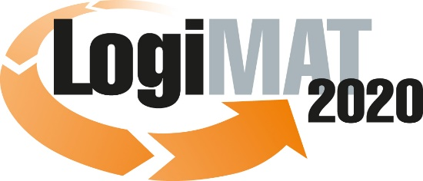

18th International Trade Show for
Intralogistics Solutions & Process Management
March 10–12, 2020 | Messe Stuttgart

Also featured at LogiMAT:
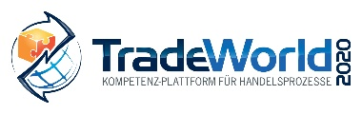

Munich, March 4, 2020

LogiMAT 2020 in Stuttgart
LogiMAT 2020 Canceled

LogiMAT, the 18th International Trade Show for Intralogistics Solutions & Process Management, has been canceled due to an official injunction.

Despite the problems associated with the coronavirus, LogiMAT event organizer EUROEXPO Messe- und Kongress-GmbH in Munich, together with the Messe Stuttgart convention center and the relevant local authorities, had up to now considered it feasible to host LogiMAT 2020—the 18th International Trade Show for Intralogistics Solutions & Process Management in Stuttgart. The local Office of Public Health in Esslingen saw no heightened threat to exhibitors and visitors.

At this point, however, the risk of infection has become more acute due to the increased and accelerated spread of the coronavirus in Germany, with the region of Stuttgart among those particularly affected. The responsible Office of Public Order in Leinfelden-Echterdingen, acting on the urgent recommendation of the responsible Office of Public Health for the region of Esslingen, instructed organizers at 5:17 p.m. today to cancel LogiMAT 2020.

“This is bitter, given the overwhelming importance of LogiMAT Stuttgart for the global intralogistics industry. The cancellation of LogiMAT 2020 for external, unforeseeable circumstances is unprecedented in the event’s 18-year history. Despite tremendous efforts working with Messe Stuttgart, we were unable to find a later date to host the event in 2020, so it is with great regret that we have decided to cancel LogiMAT 2020,” announced Christoph Huss, Managing Partner of EUROEXPO, explaining the cancellation.

The next LogiMAT will take place in Stuttgart from March 9 to 11, 2021.

Organizer: EUROEXPO Messe- und Kongress-GmbH
Joseph-Dollinger-Bogen 7 | 80807 Munich, Germany
Phone: +49 89 32 391 259 | Fax: +49 89 32 391 246
www.logimat-messe.de | www.tradeworld.de
1,588 characters (with spaces)
Munich, March 4, 2020—This text may be reprinted free of charge, but please send a copy to EUROEXPO Messe- und Kongress-GmbH, Press and Public Relations Department, 80912 Munich.

