More flexibility, less construction work: GEA presents new frame solution for Grasso V packages

Düsseldorf (Germany), October 14, 2026 – At Chillventa 2026 in Nuremberg, GEA is presenting a new, highly rigid frame design for reciprocating compressor packages of the GEA Grasso V series. The frame significantly reduces the vibration generated by the compressor. Any remaining vibration is absorbed by vibration dampers or spring systems. As a result, the units can be installed without the concrete foundations that were previously often required. The frame solution complies with the requirements of the standard “Mechanical vibration – Measurement and evaluation of machine vibration – Part 8: Reciprocating compressor systems” (ISO 20816-8). The concrete foundation can be omitted. For operators of refrigeration and heating systems, this creates considerably more freedom in terms of installation. In future, the compressor packages can be installed on a wider range of floor and building structures, including existing buildings, upper floors and structurally flexible plant areas. At the same time, the new design reduces both the space required and the total weight of the installation.

The GEA Grasso V series: established reciprocating compressors for industrial refrigeration and heating applications
The GEA Grasso V series comprises energy-efficient reciprocating compressors for industrial refrigeration and heating applications. Offered as complete packages, the systems are delivered pre-assembled and ready for operation and include the compressor, drive, oil management, valves, sensors and controls. They predominantly use the natural refrigerant ammonia. Typical fields of application include the food industry, cold storage and data centres. Robust technology, low energy consumption and extended maintenance intervals reduce operating costs, downtime and the CO₂ footprint.

Frame design to be introduced for first models of the GEA Grasso V series by the end of 2026
The new, highly rigid frame design will initially be introduced for the first models of the GEA Grasso V series by the end of 2026. Availability for the complete product range is scheduled for the months thereafter.

Overview: the key features of the new frame design at a glance

- simpler and more flexible installation
- fewer site restrictions
- fewer constraints on positioning
- compliance with ISO 20816-8
- use in existing buildings and plants
- reduced footprint
- significant weight reduction
- less structural work during installation

Photo:
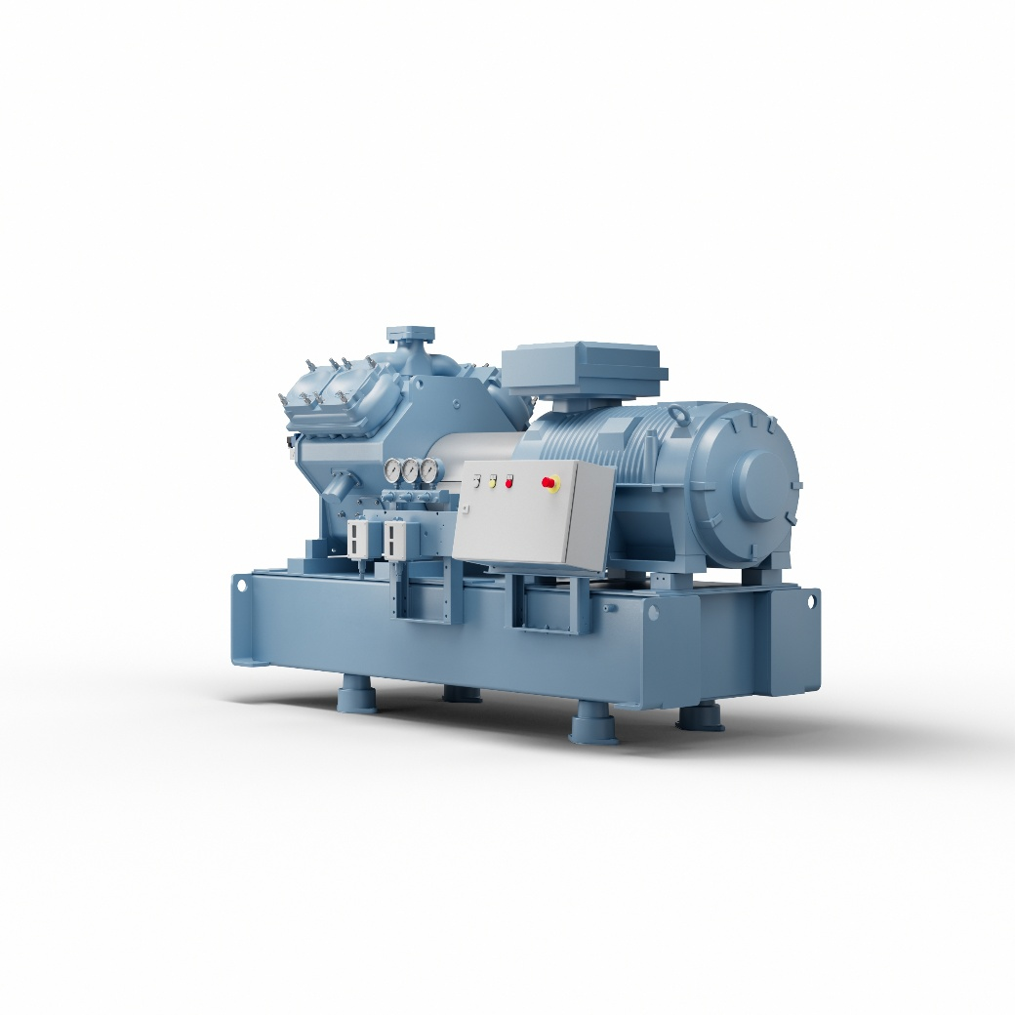
Photo, caption: At Chillventa 2026 in Nuremberg, GEA is presenting a new, highly rigid frame design for reciprocating compressor packages of the GEA Grasso V series.

NOTES TO EDITORS
- Further information about GEA
- To the GEA Media Library
- Features on current topics
- Overview press events
- Follow GEA on  

About GEA
GEA is one of the world’s largest suppliers of systems and components to the food, beverage and pharmaceutical industries. The international technology group, founded in 1881, focuses on machinery and plants, as well as advanced process technology, components and comprehensive services. For instance, every second pharma separator for essential healthcare products such as vaccines or novel biopharmaceuticals is produced by GEA. In food, every fourth package of pasta or every third chicken nugget are processed with GEA technology.

With more than 18,000 employees, the group generated revenues of about EUR 5.5 billion in more than 150 countries in fiscal year 2025. GEA plants, processes, components and services enhance the efficiency and sustainability of customers’ production. They contribute significantly to the reduction of CO2 emissions, plastic usage and food waste. In doing so, GEA makes a key contribution toward a sustainable future, in line with the company’s purpose: “Engineering for a better world.”

GEA is listed on the DAX, the STOXX® Europe 600 Index and is also a constituent of the leading sustainability indices DAX 50 ESG, MSCI Global Sustainability and Dow Jones Best-in-Class World.

More information can be found online at gea.com.
If you do not want to receive any further information from GEA, please send an e-mail to pr@gea.com.

Media Relations
GEA Group Aktiengesellschaft
Dr. Michael Golek
Ulmenstraße 99, 40476 Düsseldorf, Germany
Phone +49 211 9136-1505
michael.golek@gea.com

