PRESS RELEASE
Schwaebisch Hall, October 11, 2022

Closer proximity to customers, quicker support
OPTIMA pharma increases service presence in the U.S.

Optima Pharma, part of the Optima Group, opened a new service hub in Knightdale, a suburb of Raleigh, North Carolina. Optima Pharma is an innovative turnkey partner for customer-specific filling and process equipment for the pharmaceutical and biotech industry. Over 175 guests attended the inauguration ceremony and open house. Optima can now offer customers even faster and better local service and support.
“The opening of a local branch in Knightdale is an important step for Optima Pharma. This ensures enhanced support for our customers in this region”, said Ulrich Unterriker, Managing Director at Optima Machinery Corporation in Green Bay, WI. After the official welcome, he presented Optima’s strategies to increase the service capabilities in the United States. The presence of Optima Pharma in the U.S. steadily increased over the last several years, with the service personnel doubling since 2019. In his keynote address, Gerhard Breu, Chairman of the Optima Pharma Division, referred to the importance of integrated solutions offered by Optima Pharma as a turnkey partner, and emphasized the significance of local experts and support.

Six industry professionals from Eli Lilly, Fujifilm Diosynth Biotechnologies, Thermo Fisher, Merck, CRB, and the North Carolina Department of Commerce presented on industry relevant and economic topics. Guests had the opportunity to network throughout the afternoon and visit expert zones to learn more about Optima's service capabilities. A ribbon cutting ceremony marked the official opening of the service hub. The event ended with guests attending an Oktoberfest themed celebration.

Over 7,800 square feet of warehouse, office, and meeting space

The new service hub offers remote and local support for customers in cooperation with the Green Bay office. The state-of-the-art meeting and training rooms provide local maintenance and operator training as well as meeting space for sales and service experts. The local warehouse ensures optimum availability of spare parts. Comprehensive qualification services for pharmaceutical equipment are also part of the service offering.

From left to right: Mevluet Yilmaz (Director Sales Pharma, Optima Machinery Corporation), Ulrich Unterriker (Managing Director, Optima Machinery Corporation), Gerhard Breu (Chairman of the Optima Pharma Division), Matthias Poslovski (Vice President Sales, Optima Pharma), Juergen Rothbauer (Managing Director, Optima Pharma) and Doug Nash (Team Leader Technical Field Service/Office Manager, Service Hub Knightdale) open the Service Hub. (Source: Optima)

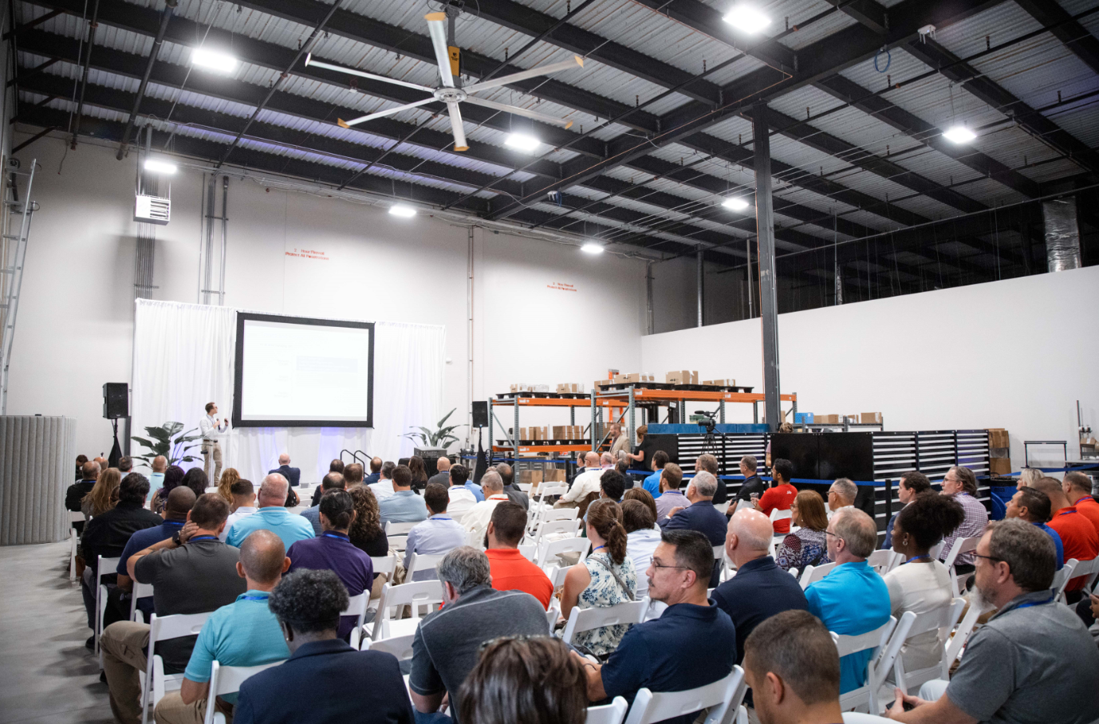
More than 175 guests from politics and business followed the speeches at the opening of the new service hub. (Source: Optima)

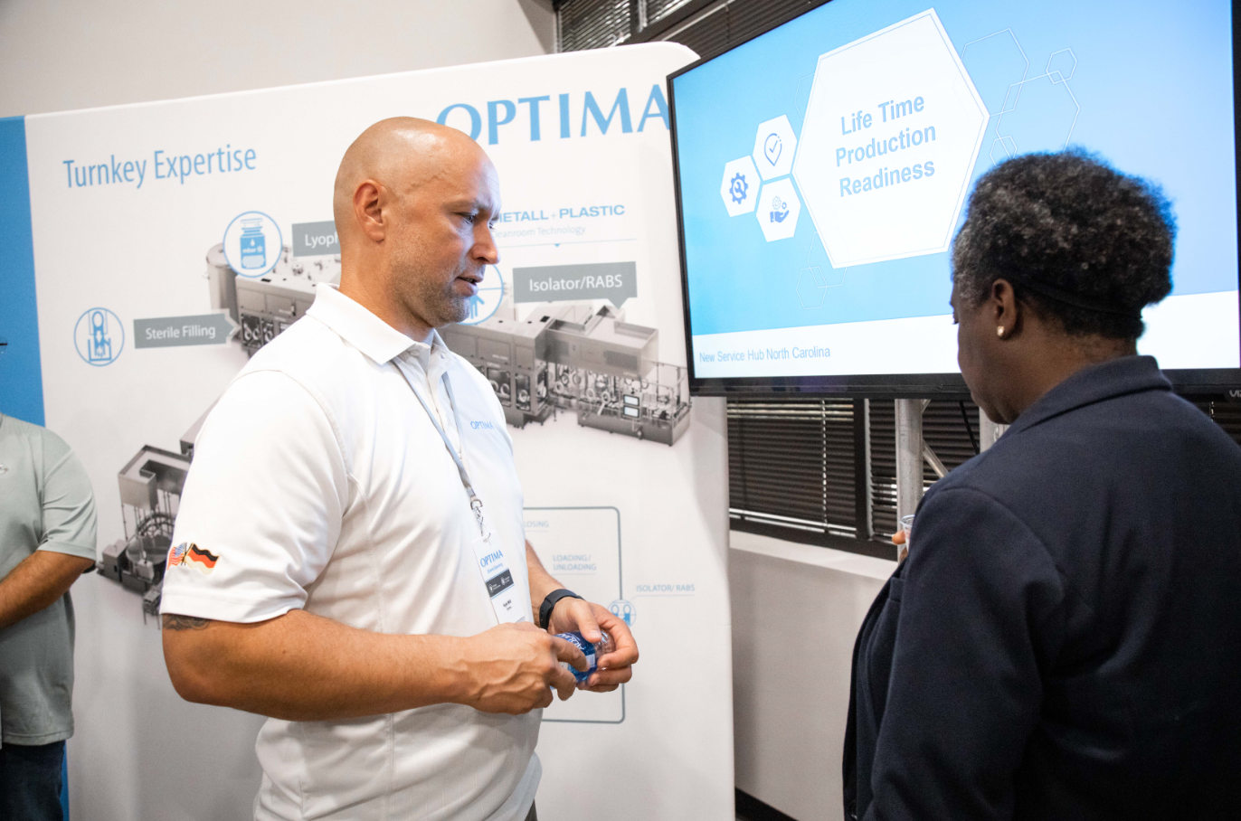
Kyle Will (Team Leader Customer Support, Optima Machinery Corporation) presents Optima's service capabilities at one of the event’s expert zones. (Source: Optima)

Characters (incl. spaces): 2,222

Press contact:
OPTIMA packaging group GmbH
Jan Deininger
Group Communications Manager
+49 (0)791 / 506-1472
jan.deininger@optima-packaging.com
www.optima-packaging.com

About OPTIMA
Optima supports companies worldwide with flexible and customer-specific filling and packaging machines for pharmaceuticals, consumer goods, paper hygiene and medical devices markets. As a provider of solutions and systems, Optima accompanies these companies from the product idea through to successful production and throughout the entire machine life cycle. Over 2,800 experts around the globe contribute to Optima's success. 20 locations in Germany and abroad ensure the worldwide availability of services. In 2022, Optima celebrates the company's 100th anniversary.
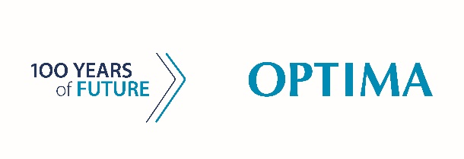
Exciting stories from 100 years of Optima: www.100-years-of-future.com

Thank you very much for your publication. We look forward to receiving a digital specimen copy.

