traser swiss H3 watches: the new P69 Black Stealth
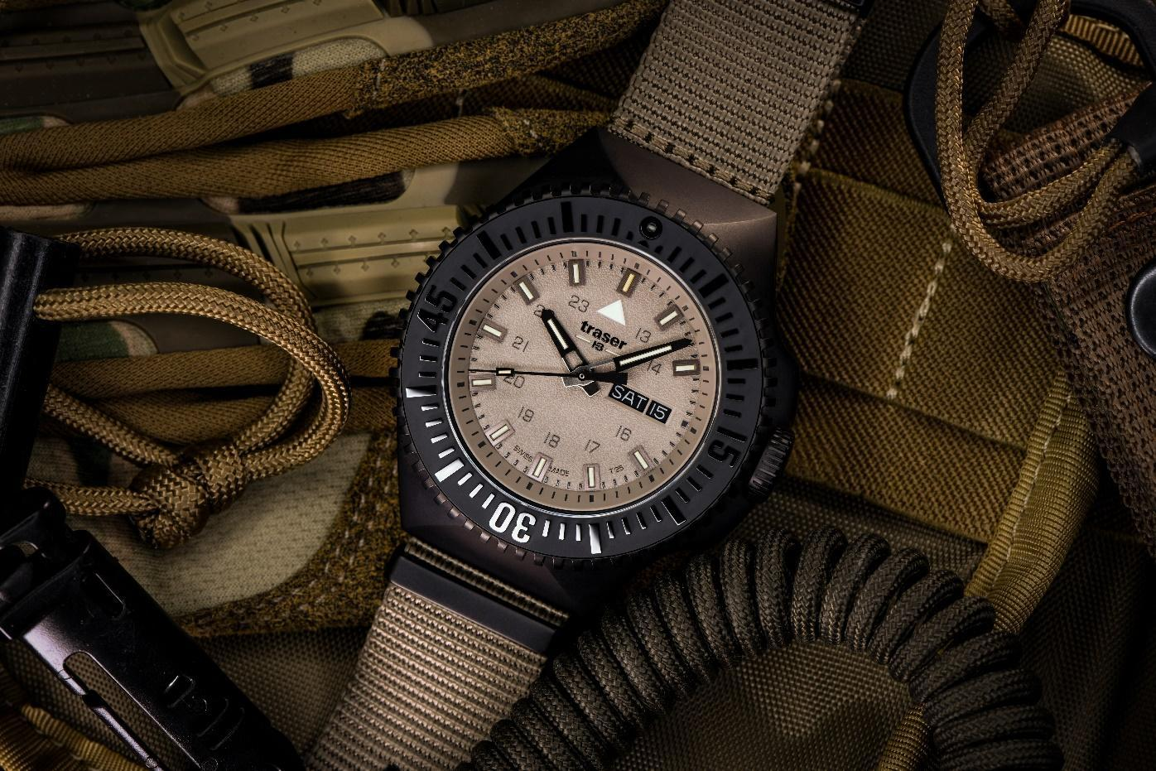
Back to the roots: tough and uncompromising as a comradely unit

With the new P69 Black Stealth, traser swiss H3 watches is roving back to its roots in the tactical field, as first in 1989, with a rugged timepiece you can count on in any situation. Boasting an unshakeable identity and reliable functionality, the watch embodies the unique strength that is the team spirit of a comradely unit. This special kind of camaraderie that inspired the Bern-based watchmaker traser to develop the new P69 Black Stealth.

The everyday lives of emergency forces demand a permanent state of readiness, strong stamina and an iron will. Physical strain, precarious situations and unpredictable scenarios meld emergency crews into an unparalleled unit – because amid all their daily challenges, they can rely on one thing: the incomparable support of their comrades. Readiness, stamina and willpower: this is also what the new P69 Black Stealth from traser stands for. A timepiece that stands by your side without compromise, come what may, whether in professional settings or everyday situations where these qualities are required.
Back to our roots
In designing the P69 to fully meet the requirements of the tactical forces, traser has delved into its own DNA: as early as 1989, the Swiss watch pioneer developed the world’s first self-illuminating timepiece for the US Army. The P69’s hands, hour indices and bezel are equipped with the in-house–developed trigalight self-powered illumination technology. The tritium-filled glass capillaries guarantee reliable timekeeping in complete darkness and adverse conditions – for decades and with no need for an external energy source.

A rugged timepiece
The P69 Black Stealth’s robust design leaves no doubt in anyone’s mind – this is a watch you can rely on in extreme situations. Boasting a screw-down crown, an angular case and water resistance of 20 bar, the Swiss quartz movement is effectively protected from shocks, mud and dust. An anti-reflective sapphire glass and a PVD-coated stainless steel bezel with ceramic inlay provide reliable protection against scuffs and scrapes. An ergonomically profiled ridge allows you to make precision adjustments to the bi-directional rotating bezel even while wearing gloves.

Whether in dense forest, endless desert or on the high seas, the P69 Black Stealth available in the colours sand, black, green and blue will blend seamlessly into every setting, no matter the time of day. The colour matching rubber or textile strap ensures that the watch sits comfortably and securely on your wrist. The new P69 Black Stealth is as versatile as the challenges that emergency forces face every day. Designed to withstand even the most extreme conditions, you can unquestionably rely on this companion in any situation.

Technical specifications – P69 Black Stealth – Swiss Made
Illumination: trigalight self-powered illumination technology on the hour indices,
hands, under the traser logo and an insert on the bezel
Super-LumiNova marking on dial
Luminescent glass seal
Movement: Swiss Made Quartz
Size: Ø 46 mm
Glass: Anti-reflective sapphire
Case: Black PVD-coated stainless steel
matt, screw-down crown
Bezel: PVD-coated stainless steel bezel with a ceramic inlay and
trigalight at 12 o’clock, bidirectional rotation
Dial: Sand, black, green and blue
Date window at 3 o’clock
Strap: NATO or rubber strap
Water resistance: 20 atm / 20 bar
Price: CHF 495.00 with NATO strap
CHF 535.00 with rubber strap

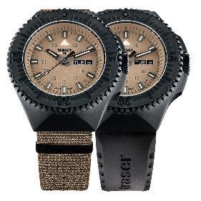
Series models:
109860 P69 Black Stealth, Sand
PVD-coated stainless steel case, sand-coloured dial
NATO strap
109861 P69 Black Stealth, Sand
PVD-coated stainless steel case, sand-coloured dial
Rubber strap

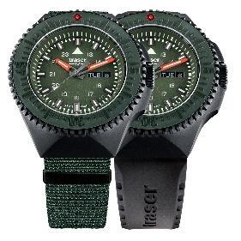
109858 P69 Black Stealth, Green
PVD-coated stainless steel case, green dial
NATO strap
109859 P69 Black Stealth, Green
PVD-coated stainless steel case, green dial
Rubber strap

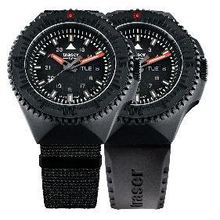
109854 P69 Black Stealth, Black
PVD-coated stainless steel case, black dial
NATO strap
109855 P69 Black Stealth, Black
PVD-coated stainless steel case, black dial
Rubber strap

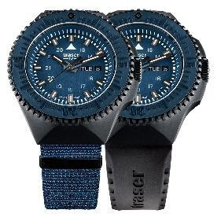
109856 P69 Black Stealth, Blue
PVD-coated stainless steel case, blue dial
NATO strap
109857 P69 Black Stealth, Blue
PVD-coated stainless steel case, blue dial
Rubber strap

About traser swiss H3 watches – #theoriginal #unlimited #illumination

traser swiss H3 watches are developed and manufactured under the SWISS MADE quality label in Niederwangen near Bern, Switzerland. traser watches have a unique feature: permanent and consistent readability of the time in total darkness and poor visibility This is achieved with the in-house–developed trigalight self-powered illumination capillaries. They require no external energy source and deliver constant luminescence day and night for decades.

Customers from all over the world (including active people, adventurers, athletes, nature enthusiasts, tactical professionals and special forces) rely on traser's robust and functional watches.

