GEA opens new technology center, strengthening its position in the growing pharmaceutical applications market

Duesseldorf, February 11, 2026 – Together with Mona Neubaur, Minister of Economic Affairs of the German state of North Rhine-Westphalia, GEA CEO Stefan Klebert has opened a new technology center for pharmaceutical freeze-drying systems in Elsdorf, Germany. GEA employs approximately 260 people at the facility, which combines research and development with production and service under one roof. The site is carbon-neutral thanks to power supplied by photovoltaic systems. The investment of more than EUR 80 million underscores GEA’s commitment to strengthening its position as a technology partner for the growing global pharmaceutical industry. At the same time, the company is making a positive contribution to structural change in Germany’s Rhineland lignite mining region.

At the opening ceremony, GEA CEO Stefan Klebert said: “With our new technology center in Elsdorf, we are investing in one of our key growth areas and further strengthening our innovative capabilities in the pharmaceutical sector. We are also significantly expanding our production capacities. Together, these measures help us expand our leading position in this highly innovative market segment.”

Mona Neubaur, Deputy Minister President and Minister of Economic Affairs of the German state of North Rhine-Westphalia, was a guest at the opening. “Today is a good day for the future of Elsdorf and the entire region. From the heart of North Rhine-Westphalia, GEA Group is driving the global transformation towards climate-neutral production. Efficient, digitally networked production methods and sustainable technologies are helping to drive the transition toward a resilient and climate-neutral economy. Elsdorf demonstrates that North Rhine-Westphalia offers reliable framework conditions to enable investments with significant impact. This way, we secure good jobs, industrial value creation, and competitiveness, even in challenging times.”

Digital on the inside, green on the outside

The new building in Elsdorf replaces an existing GEA freeze-drying plant in neighboring Hürth, where production capacities had reached their limits. The more than 260 employees will find ideal conditions for their work in development, design, manufacturing, assembly, and service at the new location. Production capacities can be expanded, particularly through shorter production times.
Photovoltaic systems and green roofs on the production facilities and office buildings will ensure carbon-neutral operation. GEA uses the electricity from the roof to operate air-to-water heat pumps for freeze-drying, heating and cooling at the site. This can save up to 7,000 metric tons of CO₂ annually in production. Moreover, the photovoltaic system powers 30 charging stations for e-cars and fleet vehicles as well as six stations for e-bikes. As much of the approximately 45,000 square meter site as possible remained unsealed thanks to the use of grass pavers.

A leader in pharmaceutical freeze-drying

Freeze-drying is a necessary production step for many temperature-sensitive medicines to extend their shelf life or make them transportable in the first place. Alongside vaccines, these include antibiotics, serums, diagnostic agents, protein-based and biotechnological products, cells, tissues and chemicals. Production must meet the pharmaceutical industry’s exceptionally high quality and safety standards. Many of the corresponding manufacturing processes are traditionally energy-intensive. GEA significantly reduces this energy requirement through its innovative systems and processes. The company has been systematically expanding its capacities and capabilities in this growth market for years.

Photos:

Photo 1:

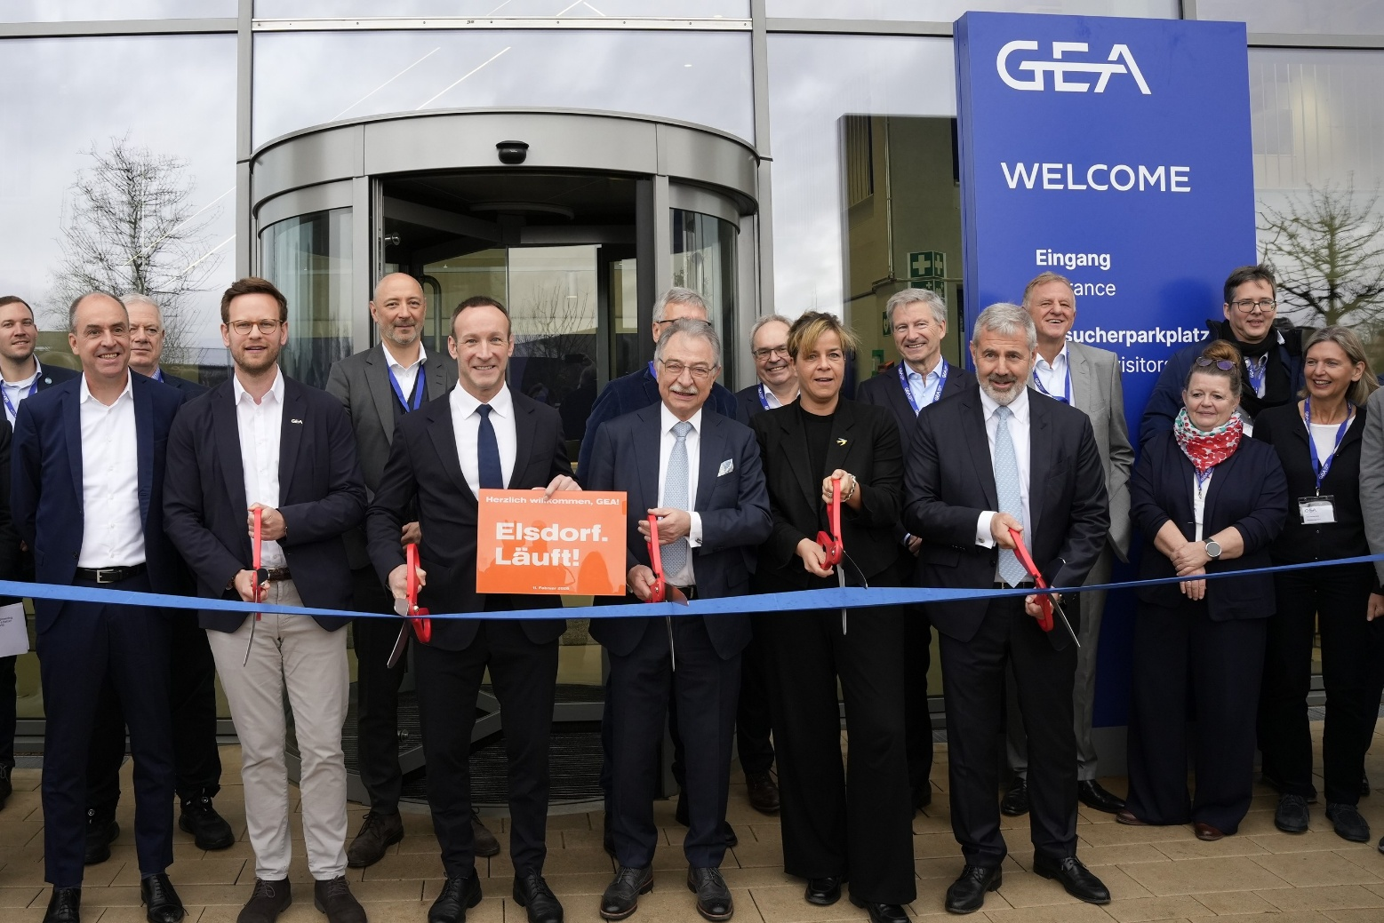

Photo 1, caption: Opening of the new GEA Pharma Technology Center in Elsdorf: Johannes Gilloth, Johannes Giloth (COO, GEA), Michael Asenkerschbaumer (Managing Director Lyophilization), Andreas Heller (Mayor of Elsdorf), Prof. Dieter Kempf (Chairman of the Supervisory Board, GEA), Mona Neubaur (Minister of Economic Affairs of North Rhine-Westphalia) and GEA CEO Stefan Klebert (front row, from left to right). (Photo: GEA)

Photo 2:

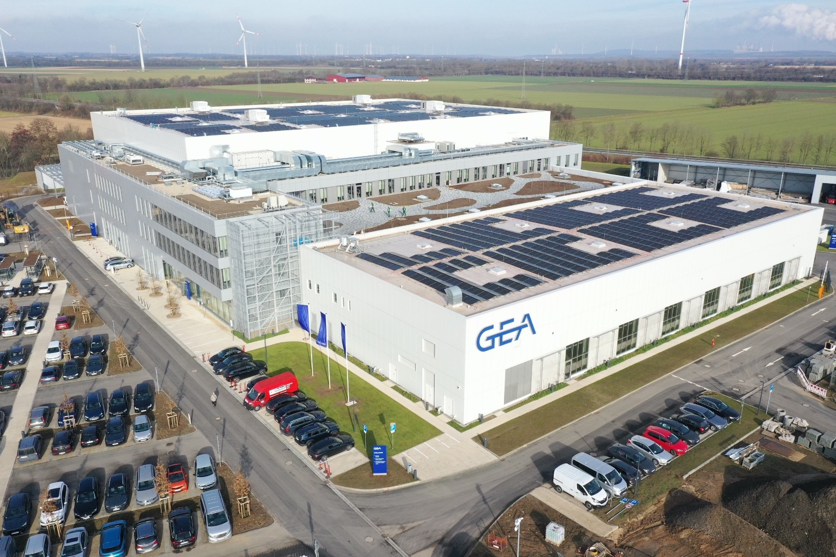

Photo 2, caption: On February 11, 2026, GEA opened a new pharmaceutical technology center in Elsdorf (North Rhine-Westphalia). (Photo: GEA)

About GEA
GEA is one of the world’s largest suppliers of systems and components to the food, beverage and pharmaceutical industries. The international technology group, founded in 1881, focuses on machinery and plants, as well as advanced process technology, components and comprehensive services. For instance, every second pharma separator for essential healthcare products such as vaccines or novel biopharmaceuticals is produced by GEA. In food, every fourth package of pasta or every third chicken nugget are processed with GEA technology. With more than 18,000 employees, the group generated revenues of about EUR 5.5 billion in more than 150 countries in the 2024 fiscal year. GEA plants, processes, components and services enhance the efficiency and sustainability of customers’ production. They contribute significantly to the reduction of CO2 emissions, plastic usage and food waste. In doing so, GEA makes a key contribution toward a sustainable future, in line with the company’s purpose: ”Engineering for a better world.”

GEA is listed on the DAX, the STOXX® Europe 600 Index and is also a constituent of the leading sustainability indices DAX 50 ESG, MSCI Global Sustainability and Dow Jones Best-in-Class World.

More information can be found online at gea.com.
If you do not want to receive any further information from GEA, please send an e-mail to pr@gea.com.

NOTE TO EDITORS

- Further information about GEA
- To the GEA Press page
- To the GEA Media Center
- Background information on current topics can be found at Features
- Follow GEA on  

GEA
Media Relations
GEA Group Aktiengesellschaft
Matthias Schnettler
Ulmenstraße 99, 40476 Düsseldorf
Telefon +49 211 9136-1500
matthias.schnettler@gea.com

