GEA AWP expands design program – ValveCalc 9.0 for industrial refrigeration and heating technology

Duesseldorf, November 21, 2025 – GEA AWP is expanding and optimizing its design program for industrial refrigeration and heating technology with additional content, components, and advanced functions. In addition to updating standards (e.g., DIN EN ISO 24664) and the integrated media database, ValveCalc 9.0 also includes the new HSX high-pressure float product range in a separate calculation module. The introduction of a convenient project overview allows users to list all calculations within a project and enables direct access for adjustments to design parameters. Furthermore, intuitive operation in ValveCalc 9.0 has been made easier thanks to a modern layout with vector-based symbols. New convenience functions (search, fixation, and color coding functions) in the design tables make it easier for users to work.
ValveCalc 9.0 with many new modules
In the safety valve design module, it is now possible, for example, to clearly display the blow-off capacities of series per nominal diameter in tabular form for a freely configurable pressure range. It is now easy to compare series across different nominal diameters. This data can be printed out conveniently and flexibly. In the catalog module, users now also have the option of directly accessing the necessary additional documents, such as certificates and operating instructions for the respective components. In the pipe design module, the new performance pressure loss diagram now allows pressure losses to be easily compared and visualized in relation to cooling capacity for each nominal diameter. Important system parameters are now also displayed directly in the diagram. In the pipe design module, pressure losses for different nominal diameters can now be easily compared in a clear table.
ValveCalc 9.0 as a downloadable program or cloud solution
In addition to the new features mentioned above, version 9 will be available both as a downloadable and installable program and as a virtual desktop infrastructure in the cloud. Thanks to the innovative streaming technology used, ValveCalc 9.0 can be used via a browser. This eliminates restrictions imposed by security policies within company networks, for example. ValveCalc is operated on a high-performance infrastructure in a GDPR-compliant German data center, so that even users with less powerful computers can benefit from the program's high response speed, especially when it comes to resource-intensive processing steps.
ValveCalc 9 free of charge for customers on request – free online live training
GEA AWP supports users who have further questions in addition to the extensive online tutorials available with free online live training. ValveCalc 9.0 is available free of charge to customers on request.

Graphics:

Graphic 1:

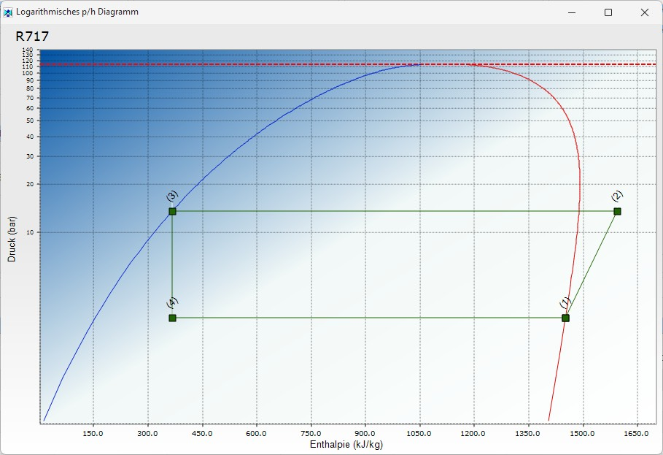

Graphic 1, caption: In the pipe design module, pressure losses for different nominal diameters can now be easily compared in a table. (Graphic: GEA AWP)

Graphic 2:

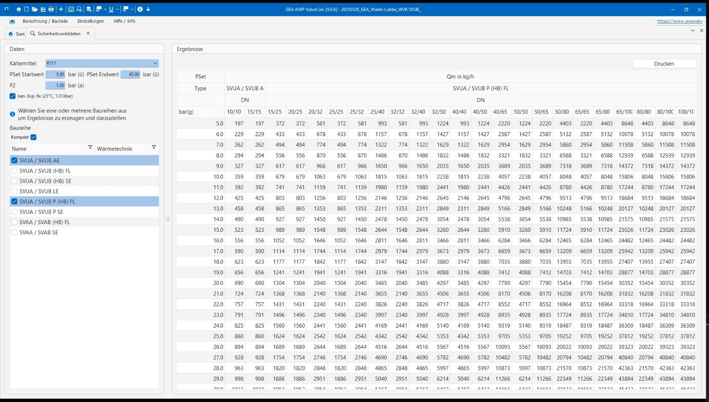

Graphic 2, caption: In the catalog module, users now also have the option of directly accessing the necessary additional documents, such as certificates and operating instructions for the respective components. (Graphic: GEA AWP)

About GEA
GEA is one of the world’s largest suppliers of systems and components to the food, beverage and pharmaceutical industries. The international technology group, founded in 1881, focuses on machinery and plants, as well as advanced process technology, components and comprehensive services. For instance, every second pharma separator for essential healthcare products such as vaccines or novel biopharmaceuticals is produced by GEA. In food, every fourth package of pasta or every third chicken nugget are processed with GEA technology. With more than 18,000 employees, the group generated revenues of about EUR 5.5 billion in more than 150 countries in the 2024 fiscal year. GEA plants, processes, components and services enhance the efficiency and sustainability of customers’ production. They contribute significantly to the reduction of CO2 emissions, plastic usage and food waste. In doing so, GEA makes a key contribution toward a sustainable future, in line with the company’s purpose: ”Engineering for a better world.”

GEA is listed on the DAX, the STOXX® Europe 600 Index and is also a constituent of the leading sustainability indices DAX 50 ESG, MSCI Global Sustainability and Dow Jones Best-in-Class World.

More information can be found online at gea.com.
If you do not want to receive any further information from GEA, please send an e-mail to pr@gea.com.

NOTE TO EDITORS

- Further information about GEA
- To the GEA Press page
- To the GEA Media Center
- Background information on current topics can be found at Features
- Follow GEA on  

GEA
Media Relations GEA
Dr. Michael Golek
Ulmenstraße 99, 40478 Düsseldorf
Phone +49 211 91361505
Tel. +491736205746
michael.golek@gea.com

