PRESS RELEASE
Schwaebisch Hall, March 08, 2023

“Where best partners meet”:
OPTIMA at Interpack 2023
As a strategic innovation partner, OPTIMA will be showcasing a future-oriented technology portfolio for sophisticated consumer goods, customized services and new approaches to sustainable packaging solutions

From May 4 to 10, Düsseldorf will again become the international center for the packaging industry. As a strategic innovation partner, Optima will be presenting at Interpack 2023 future-oriented packaging and filling systems designed for medium and high outputs for demanding powder, liquid and chunky products such as cosmetics, coffee and hygiene products. With one goal in mind: providing current and new partners from the consumer goods industry valuable incentives for reaching their respective business and sustainability targets. Another focus will be customized services for safe and efficient production. In the area of sustainability, Optima will be showing a number of new approaches for packaging solutions that take into account the complete circular economy. A strong team of experts will provide live demonstrations on numerous exhibits of the opportunities that working together with Optima can bring. Technology, service and sustainability topics will be further explored in the new, exclusive Expert Zone.
Rapidly changing market requirements, ambitious sustainability goals, rising costs: Packaging and filling companies are facing growing challenges. As a committed partner, Optima sees its most important task as demonstrating how success can be ensured even in times of rapid change.
Maximum efficiency and productivity are essential, but so are compelling answers in the areas of the circular economy, resource conservation, digital technologies and product safety. Optima is ideally positioned in all of these topic areas, which are likewise the focal points for Interpack 2023. "Thanks to our 100 years of experience and countless ideas, we will find the solution that really moves our customers forward – from start-ups to multinationals – and together we will drive innovation forward," promises Dr. Stefan König, Managing Director of the Optima Group. Visitors to Interpack can see this for themselves with the help of exciting exhibits and cutting-edge technologies in the three main topics chosen by Optima: technology, service and sustainability. "We're presenting highly automated systems, extremely flexible transport systems, turnkey systems including secondary packaging as well as customized service solutions that leave nothing to be desired for the customer. In addition, we're showing our customers how they can become a game changer in sustainability," says König.

One example of Optima's innovative power is the new OPTIMA Moduline Smart filling and closing system for cosmetic products, which will be introduced at Interpack for the first time. It will be setting new standards in terms of space requirements, format flexibility and delivery times. Optima's expertise in the high performance segment has been incorporated into the development of the new system. The company has thereby enhanced its system portfolio in the mid-range performance segment – with proven Optima quality.

One partner for the entire system life cycle

Comprehensive and individualized service is becoming increasingly important from the customer's perspective. "We're on our partner's side, from the very beginning and over the entire service life,“ confirms Michael Weber, Director Service at Optima Consumer. The comprehensive service program OPTIMA Total Care leaves nothing to be desired. With a worldwide service network, Optima oversees the systems of its customers for the entire life cycle. The Lifetime Production Readiness approach provides customers with a customized service package that optimally combines conventional services with market-leading digital solutions. At Interpack, customers and interested parties can dive into this exciting world and discover what potential for improvement is hidden in production processes and which cutting-edge options for employee training are available.

A new HMI designed and developed together with users for ease of operation, fault analysis and optimization of complex systems will be presented for the first time at the trade show. "Operators will be enthusiastic about the ease of operation and personalized options that come with the new HMI," König explains.

Innovative leap for sustainable comprehensive solutions

Efficiency and reliable processes are important success factors in production – but they are by no means the only ones. After all, climate change and the energy crisis are changing the rules of the game for the industry. For exactly that reason, Optima wants to turn its customers into game changers in sustainability and is therefore developing sustainable total solutions for machines and packaging together with selected partners.
The focus is on cup- and can-shaped, mostly fiber-based packaging for food and cosmetics, which Optima develops together with partners. This also includes approaches for barriers without restrictions for recyclability and compostability. Hygiene products in paper packaging or mono materials will also be exhibited.

In addition, Optima will demonstrate how to calculate, reduce and possibly offset a product carbon footprint and how it is contributing to reducing material, energy and media consumption in the development and utilization phases of machines. In 2022, Optima was awarded the EcoVadis silver medal. The company is also systematically working on further emission reduction goals using the approach of the Science Based Targets Initiative (SBTi).
The company is pursuing concrete goals in line with its holistic sustainability strategy “We care for tomorrow”. "Our common goal is to make further contributions to climate protection in the short term and to be holistically excellent in the areas of environment, social affairs and corporate governance in the medium term," adds König.

The Optima Group's presence will be topped off by solutions for liquid pharmaceuticals and diagnostics. Optima Pharma will be presenting itself as an innovative turnkey partner for the pharmaceutical and biotech sectors and will be demonstrating the new OPTIMA FillCell filling and closing system with isolator for producing and filling cell and gene therapeutics. In addition, it will demonstrate smart digital features for even greater process reliability in pharmaceutical production.

Optima's appearance at the leading trade show Interpack 2023: For Dr. Stefan König it's clearly "an excellent opportunity to quickly and concisely get up to date with the latest technologies and trends, as well as move into the future as best partners with renewed strength."

Optima at Interpack 2023 (Düsseldorf), May 4 - 10, 2023: Hall 16, booth no. F54 and F55

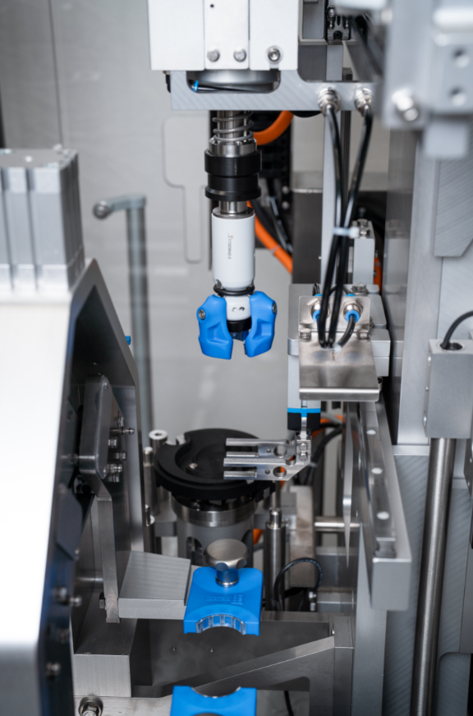
The new OPTIMA Smart Moduline sets new standards in the mid-range performance segment for cosmetics applications and will be on display for the first time at Interpack. This shows a closing module that can be flexibly equipped with format parts from a 3D printer. (Source: Optima)

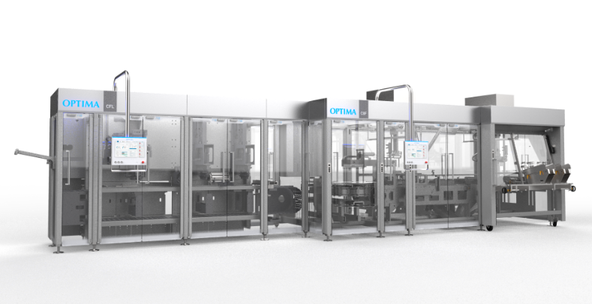
The Consumer business unit will present a major high-tech solution for filling and cartoning single-serve packets: a combination of the OPTIMA CFL filling and closing machine and the OPTIMA CBF cartoner with integrated gap-closing system. (Source: Optima)

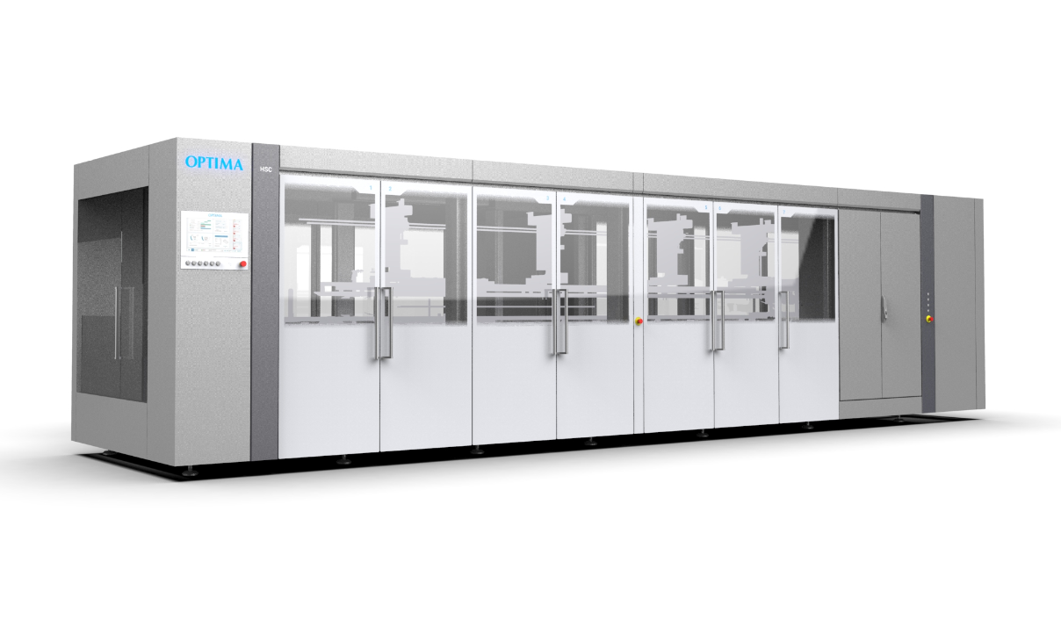
The new high-speed OPTIMA HSC cartoner opens up new possibilities in terms of packaging flexibility for the paper hygiene sector. (Source: Optima)

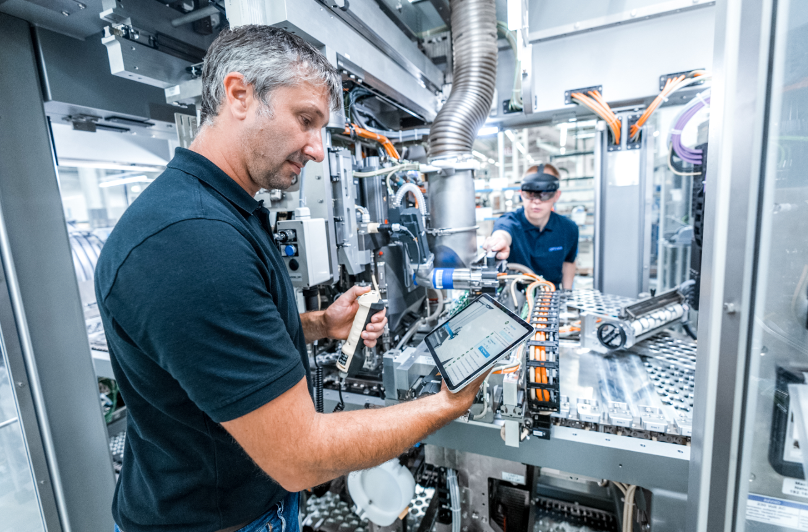
Competent support during the format change on all conceivable end devices – this is one of the comprehensive services offered by Optima Service. (Source: Optima)

Working together with customers and partners, Optima is developing sustainable packaging solutions – from the initial idea through to production. At Interpack, the company will be presenting new approaches to packaging solutions that will raise sustainable packaging to a new level. (Source: Optima)

Characters (incl. spaces): 6,831

Press contact:
OPTIMA packaging group GmbH
Jan Deininger
Group Communications Manager
+49 (0)791 / 506-1472
pr-group@optima-packaging.com
www.optima-packaging.com

About OPTIMA
Optima supports companies worldwide with flexible and customer-specific filling and packaging machines for pharmaceuticals, consumer goods, paper hygiene and medical devices markets. As a provider of solutions and systems, Optima accompanies these companies from the product idea through to successful production and throughout the entire machine life cycle. Over 3,000 experts around the globe contribute to Optima's success. 20 locations in Germany and abroad ensure the worldwide availability of services.

Thank you very much for your publication. We look forward to receiving a digital specimen copy.

