PRESS RELEASE
Schwaebisch Hall, February 28, 2023

100 Years of Future: OPTIMA introduces its book on its big anniversary
The fascinating history and stories of the company on more than 120 pages

Optima celebrated its 100th anniversary in 2022 under the motto "100 Years of Future", including an official ceremony with Baden-Württemberg's Minister-President Winfried Kretschmann in Schwäbisch Hall and many other activities. An essence of 100 years of successful company history and a review of the anniversary year are now available in the form of the anniversary volume "100 Years of Future".

For the flagship company in Schwäbisch Hall, 2022 was dedicated to a unique anniversary: 100 years of Optima! In 1922, Otto Bühler, grandfather of the current owner Hans Bühler, laid the foundation for a success story that you don't see very often: From modest beginnings, the business grew with much hard work, entrepreneurial spirit and constant innovation into what it is today. With around 3,000 employees as well as 20 national and international locations, Optima is one of the major players in the industry and is considered the technology leader in the field of packaging machines and filling systems.

The date was fittingly celebrated over the entire year under the motto "100 Years of Future", including an official ceremony in Schwäbisch Hall with the Minister President of Baden-Württemberg, Winfried Kretschmann, in Schwäbisch Hall and many other activities.

Important milestones, anecdotes, interesting facts – in short, the essence of 100 years of successful company history – as well as a look back on the anniversary year are now available in the form of the lavishly designed anniversary volume, "100 Years of Future".

"Not a history book, but rather a book full of stories" – as stated in the foreword, it is divided into four main topics: expansion, innovation, partnership and responsibility. Richly illustrated, multifaceted and with a modern design, the book does not follow a chronological narrative; it uses instead a variety of topics to dip into the history of the company – with interesting connections to the present and future. Training in transition, trade fairs all around the world, digitalization, sustainability, partnerships, international experiences and the special "ABCs of Optima's success" – these are only a few examples of the entertaining mix of stories, facts, visuals and backgrounds.

The book is also a living portrait of the economic history of Baden-Württemberg and Germany.

The book was produced in close collaboration between Sabine Gauger (Optima's editorial staff) and Hans Bühler (Optima's Managing Director and CEO), the Fischer and Friends Agency and author Stephan Trinkl, who conducted many conversations and interviews with participants and contemporary witnesses and immersed himself in the company's history with original documents and records.

The book is available free of charge to interested parties via an online request on page: www.optima-packing.com/the-book

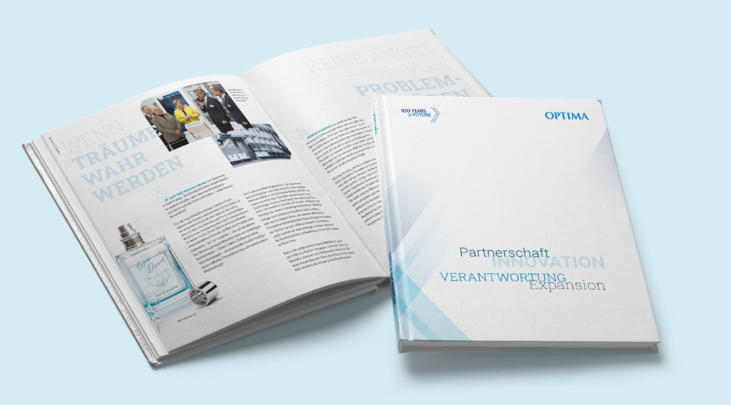
An essence of 100 years of successful company history as well as a review of the anniversary year are now available in the form of the anniversary volume "100 Years of Future". (Source: Optima)

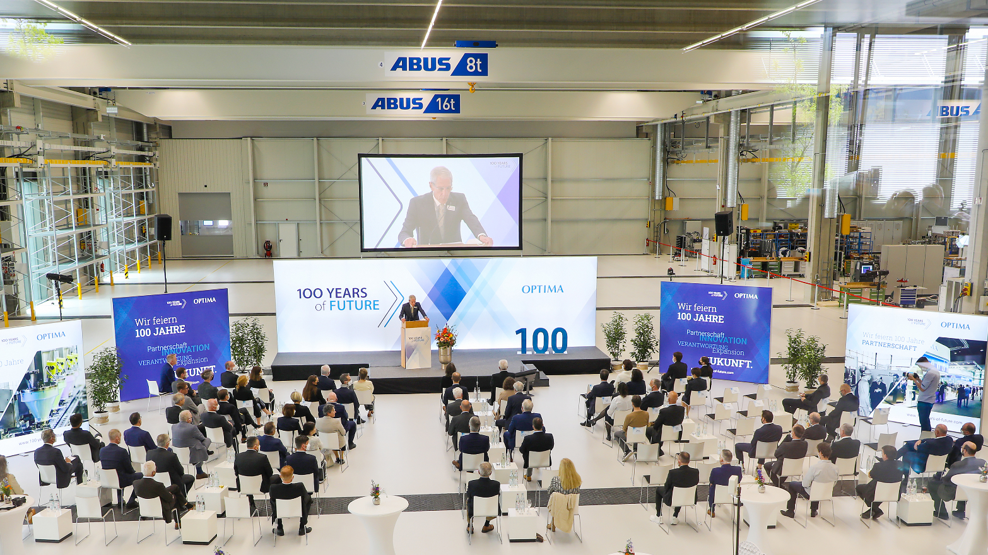
The special date was celebrated over the course of a year under the motto "100 Years of Future", including an official ceremony with Baden-Württemberg's Minister-President Winfried Kretschmann in Schwäbisch Hall and many other activities. (Source: Optima)

Characters (incl. spaces): 2,962

Press contact:
OPTIMA packaging group GmbH
Jan Deininger
Group Communications Manager
+49 (0)791 / 506-1472
pr-group@optima-packaging.com
www.optima-packaging.com

About OPTIMA
Optima supports companies worldwide with flexible and customer-specific filling and packaging machines for pharmaceuticals, consumer goods, paper hygiene and medical devices markets. As a provider of solutions and systems, Optima accompanies these companies from the product idea through to successful production and throughout the entire machine life cycle. Over 3,000 experts around the globe contribute to Optima's success. 20 locations in Germany and abroad ensure the worldwide availability of services.

Thank you very much for your publication. We look forward to receiving a digital specimen copy.

