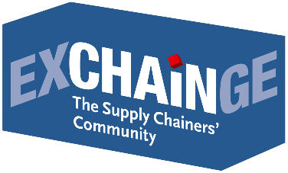
Press Release

EXCHAiNGE Supply Chain Summit 2019:
Act now! Overcome inertia, practice collaboration, create incentives

Frankfurt am Main, November 29, 2019—It’s five minutes to midnight! A sense of urgency was the common thread in all the presentations at EXCHAiNGE 2019. Some 250 leading supply chain and operations experts met to discuss the issues driving modern management at the 7th International EXCHAiNGE Supply Chain Summit, November 26–27, 2019. The theme: “New Work & Digital Business.” The elite event, organized by EUROEXPO Messe- und Kongress-GmbH in Munich, featured seven sessions, two live series of pitches for the Supply Chain Awards, and the EXCHAiNGE Award Night on the second evening. Like last year, it was featured as a special highlight of the Hypermotion trade show in Frankfurt (November 26–28, 2019).
Core question of EXCHAiNGE 2019: How is it possible to address the success-critical factors of new technologies, leadership, culture, and sustainability all at the same time while still remaining profitable? The takeaway: Those who still wish to be players in tomorrow’s marketplace must overcome their inertia—because hesitation can also threaten competitiveness. Dr. Katrin Dziekan (Head of Environment and Transport, Federal Environment Agency) summed it up nicely: “Act now! We cannot afford to lose any more time when it comes to meeting climate goals!” Supply chain managers bear a special responsibility here, she emphasized.
Key appeals of the 40 panelists at EXCHAiNGE: Traffic spaces and urban systems need to be reassessed. Cities and municipalities must finally define their roles so that businesses know where they stand. Suppliers must be encouraged to compete on sustainability, and one prerequisite for that is comparable, quantifiable parameters to measure carbon footprints. Systems of incentives must be established. Commitment and investment must be rewarded accordingly so that they don’t become negatives in the competition with non-sustainable bids. Businesses are called upon to create separate budgets for digital innovation projects. Projects need reasonable time horizons. Partnerships with start-ups require new mindsets and structures. Changes need to be communicated to employees in a way that makes sense to each target group. Attendees also found a consensus in assessing new tools: Digital innovation is not primarily a technology issue. It all comes down to the processes of transformation, which require financial flexibility and perseverance. “New business models in areas such as mobility and the last mile will only run smoothly if we work together to develop a common understanding,” remarked Dr. Petra Seebauer (Managing Director of EUROEXPO Messe- und Kongress-GmbH and Publisher of LOGISTIK HEUTE). “The only way we can master the challenges of the future is to work closely together. We have to work together to create a resilient, hybrid-integrated supply chain as a system while seizing every opportunity to gather the right people around us to accompany us and help us define this innovative path.”

Stefan Hentschel (Industry Leader for Technology & B2B at Google Germany GmbH) made the point: “Minor product tweaks are no longer enough. Only companies with a clear customer focus will survive.” The German automotive industry has already waited too long to transform and adopt new business models, Hentschel argued, and downsizing is not a solution. He also referred to the cultural factor: “Products, processes, and knowledge can be copied. But a culture adapted to the company cannot.” What matters most here is not the mix of teams, he argued. It’s the experience of psychological security when it comes to the workplace, flexibility, and trust—and this includes consciously accepting mistakes.

Thomas Holzner (Digital Program Manager & Founder of DigiNetwork, Siemens AG) founded DigiNetwork at Siemens with internal and external participants. DigiNetwork does not require ideas to have defined business cases in the traditional sense. What’s important is that every idea have a simple value case that everyone understands, “including middle management,” said Holzner. It is crucial that ideas are immediately evaluated and implemented, he added, but conceded: “We have not yet managed to bring all employees on board. We’re working on it.” In Frankfurt, the SCM expert had this piece of advice: “Get someone on board for your project who is truly passionate about issues of digital technology and collaboration. Limit yourself initially to local projects, and choose your partners carefully.”

“Partnerships don’t need to last indefinitely,” remarked Johannes Berg (Managing Director of Digital Hub Logistics GmbH)—but nothing ventured, nothing gained. Roman Siegfanz (Global Sales & Operations Leader for Inspection Technologies at Baker Hughes, a GE company) has seen larger digital transformation projects take anywhere from two to five years. “But don’t do anything to the point of excess. Look for a pilot, and when something works, roll it out.” But it’s not just the torturously long approval processes that can jeopardize the timetable or even the continuation of a project, warns Siegfanz: A fluctuation of decision-makers can also be a threat.

Co-founder and CEO Ersan Günes (Intranav | Quantitec GmbH) pointed to the financial aspect. “No money, no action. If you want innovation, you need to have enough capital.” Established companies should be aware that a partnership with a startup cannot succeed unless there is a comprehensive budget available. Günes recommended approving budgets for a pilot project, integrating innovation managers, clearly defining innovation processes, and working efficiently.
Dr. Michael Henke (Institute Director at the Fraunhofer Institute for Material Flow and Logistics) offered a broad view of a “silicon economy.” “To generate real innovation and progress, you need a coordinated strategy for blockchain, cloud, IoT, mobile apps, platforms, and logistics.” His urgent advice: “Stop asking why and just get started. In a few years, technologies like blockchain and models like the digital twin will be a matter of course. Only those who start now—even if it’s just in a small way—will have the opportunity to win big later.”
The role of executives in this era of digital transformation is an integral part of EXCHAiNGE each year. “Change can only be shaped from within. This requires neutral parties acting from outside,” affirmed business psychologist and presenter Bettina Bohlmann (Managing Partner, 3p Procurement Branding GmbH). “There is no model culture. Every company must find its own path. But the basis is always the same: Knowledge must be shared with all.” This requires first establishing trust, however—a fact reiterated by Kerstin Gliniorz (Director of Supply Chain Strategy EMEAI at ADM Europe GmbH & Co. KG). Her advice: “Teams need the experience that results from different age structures. The liberty to think outside the box is important. Go out, translate, and justify measures and goals. Speak plainly, but acknowledge your own knowledge gaps and remain authentic at all times.”

Bernd Schmid (Program Manager for Sustainable Change at Airbus Defence and Space GmbH) sees his role as an influencer. He knows full well that “change always begins with yourself, of course.” Presenter Klaus Krumme (Executive Director at Joint Center Urban Systems, University of Duisburg-Essen) echoed this in his closing remarks: “We are quick to delegate responsibilities and demands, including to politicians. But when certain sectors are then directly affected, it gets difficult.” Every year, Krumme noted, EXCHAiNGE highlights the responsibility of supply chainers to closely link economic, environmental, and cultural factors. Those who come here go home with lots of ideas and network contacts. “The interactive exchange format and this year’s stronger focus on the topic of sustainability constitute unique selling points within the supply chain community—and we are proud of this,” he stressed.

Supply Chain Awards 2019 for Continental and parcelLab
The culmination of the EXCHAiNGE Award Night on November 27 was the presentation of awards honoring outstanding and innovative supply chain concepts. The Supply Chain Management Award was presented for the 14th time, the Smart Solution Award for the second time. Global automotive supplier Continental was delighted to win the Supply Chain Management Award 2019, while parcelLab was the proud recipient of the Smart Solution Award 2019.
“In addition to the winners, the other finalists Bosch, Lufthansa Technik Logistik Services, Magazino, Metrilus, Nokia, and shipcloud also presented outstanding innovative solutions in their pitches,” noted Harald Geimer, Partner at PwC Management Consulting. “All those taking part in this final round have already made a big splash and scored a real success,” emphasized Dr. Petra Seebauer during the ceremony. The two handed out the awards as representatives of the prestigious jury alongside presenters Kerstin Gliniorz (member of the jury, Director of Supply Chain Strategy EMEAI at ADM Europe GmbH & Co. KG) and Maximilian Schäfer (Managing Director at digital forwarding service InstaFreight GmbH). In keeping with tradition, the jury considered the results of live voting by the EXCHAiNGE conference delegates in their deliberations. Stefan Hentschel (Industry Leader for Technology & B2B at Google Germany GmbH) gave the keynote speech at the Award Night .

SAVE THE DATE
EXCHAiNGE—the Supply Chainers Community 2020
with sessions, interactive supply chain roundtables, final round of awards competition, and Award Night ceremony
November 10–11, 2020 | at Hypermotion in Frankfurt am Main
Learn more: www.exchainge.de

Click here for images.

For more information, please contact:

Hendrikje Rother
Marketing/Press
EUROEXPO Messe- und Kongress-GmbH
Phone: +49 89 323 91 240
hendrikje.rother@euroexpo.de
www.exchainge.de/en

(Characters with spaces: 9,928)

EUROEXPO press releases may be reprinted free of charge. Texts and images can be found at the EXCHAiNGE press page under www.exchainge.de.
Please send a copy of any republication by email to hendrikje.rother@euroexpo.de or by postal mail to EUROEXPO Messe- und Kongress-GmbH | Presse- und Öffentlichkeitsarbeit | Joseph-Dollinger-Bogen 7 | 80807 München.

Supply Chain Awards 2019
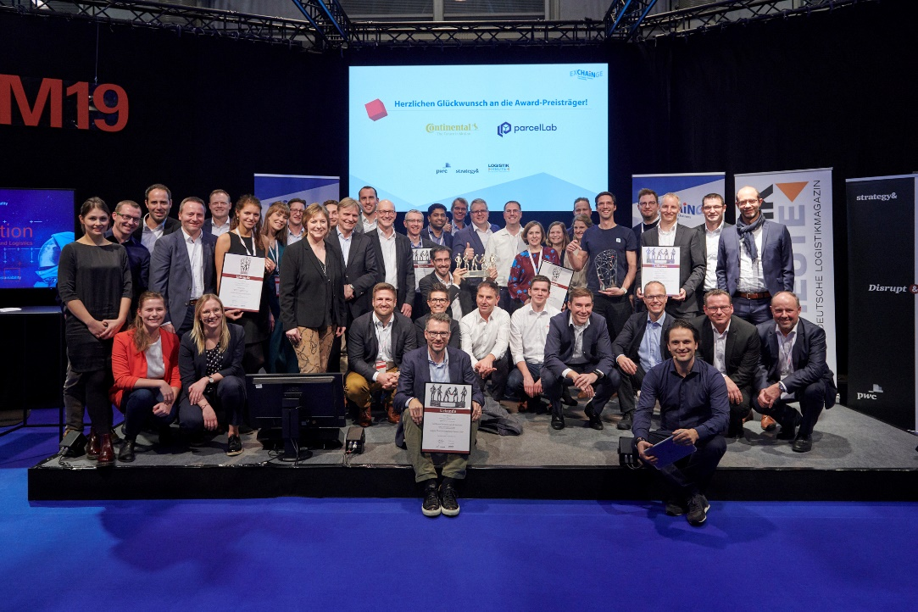
A big congratulations to the winners Continental and parcelLab and to the other finalists Lufthansa Technik Logistik Services, Magazino, Metrilus, Nokia, Robert Bosch, and shipcloud, whose pitches at EXCHAiNGE highlighted innovative solutions that define excellence in their field.

About EXCHAiNGE
EXCHAiNGE is an annual international supply chain summit that brings together decision makers and thought leaders from the worlds of SCM, finance, logistics, and purchasing. The event attracts a diverse business community ranging from innovation officers to business developers to supply chain operations managers at companies of all sizes. They all gather to talk about the strategic management issues of tomorrow: new mindsets, modern business models, digital integration, and much more.
EXCHAiNGE provides a roadmap for navigating such key issues of digital transformation as sustainability, culture and mindsets, innovation, collaboration, mobility, technology, blockchain, big data, and artificial intelligence. Finalists competing for the Supply Chain Awards offer profound insights into pre-eminent examples of best practice.
Visitors get valuable tips on repositioning their businesses to become drivers of innovation with the goal of generating a critical competitive advantage. EXCHAiNGE stands as an established networking platform where attendees can share in the personal experience of industry leaders, experience illuminating roundtables on forward-looking strategies, be actively engaged, and reflect on new ideas and trends in the supply chain.
The supply chain summit is organized by EUROEXPO Messe- und Kongress-GmbH in Munich.

About HYPERMOTION
Hypermotion—Pioneering Mobility & Logistics | November 10-12, 2020 | Frankfurt am Main

Hypermotion offers a platform for forward-looking issues with a focus on smart systems and solutions for mobility, transport, logistics, and digital infrastructure and features an innovative program mix for the mobility and logistics industries. Held for the third time this year, the event brings together the users and providers who are defining new standards for the mobility of tomorrow. The overarching objective is to provide a networking platform that transcends various modes of transport and systems and finds interfaces between mobility and logistics. Hypermotion zeroes in on the following core questions: How will digital technology and decarbonization transform transportation systems? How can we find unique, intermodal solutions for logistics and mobility chains in smart and digital regions?

The 2019 agenda blended seven interrelated topics: smart & digital regions, data analytics & security, digital & urban logistics, hypermodality (intermodal, multinational, digital), sustainability, monitoring & transparency, and connectivity. The event includes businesses of all sizes—from startups to large enterprises—together with researchers, policymakers, and representatives of professional associations. Hypermotion’s program mix of expo, conferences, pitches, workshops, and talks offered numerous opportunities to engage and network with seasoned experts from established enterprises and future innovators from the startup scene. The EXCHAiNGE conference was once again offered both as a part of Hypermotion 2019 and as a standalone event.

Learn more about Hypermotion

About EUROEXPO Messe- und Kongress-GmbH
EUROEXPO Messe- und Kongress-GmbH, founded in 1996 and headquartered in Munich, organizes LogiMAT (“the International Trade Show for Intralogistics Solutions and Process Management”) and TradeWorld (“the Professional Platform for Trade Processes”), held each year in Stuttgart, Germany. EUROEXPO has also partnered with Landesmesse Stuttgart since 2014 to present the annual LogiMAT China in Shanghai in parallel with transport logistic China. LogiMAT | Intelligent Warehouse debuts in Bangkok in 2020, focusing on the Southeast Asian market.
EUROEXPO also organizes “EXCHAiNGE—the Supply Chainers Community.” The international supply chain summit, which took place for the seventh year in 2019, targets leaders from the areas of SCM, finance, logistics, and purchasing at companies ranging in size from startups to global enterprises. EUROEXPO is also a service provider offering B2C and B2B event management services, such as the organization and implementation of the LOGISTIK HEUTE series.
For more information, please visit www.euroexpo.de.

