GEA expands pharmaceutical separator portfolio with new GEA aseptic 15 and GEA pure 15 models

Düsseldorf (Germany), September 17, 2026 – GEA is expanding its pharmaceutical separator platform with the new GEA aseptic 15 and GEA pure 15 models. These compact separators complement the existing series by offering a solution for smaller throughput ranges and help pharmaceutical and biopharmaceutical manufacturers with development, pilot, and production processes in a flexible, safe, and cost-effective manner. The compact separators for smaller production volumes combine high process flexibility, hygienic design, and efficient product recovery. With capacities ranging from 250 to 500 liters per hour in the clarifier version and 350 to 600 liters per hour in the nozzle bowl version, the new models bridge the gap between laboratory and larger production separators. They are particularly well-suited for smaller batches, clinical applications, and the development and scaling of new biopharmaceutical processes. “With the aseptic 15 and pure 15, we’re bringing the proven advantages of our new pharmaceutical centrifuge fleet to smaller production volumes,” says Rüdiger Göhmann, Product Manager at GEA. “Customers get the same technological platform, high hygiene standards, and full flexibility for varying products and solids content — all in a compact design tailored for demanding pharmaceutical environments.”

Maximum flexibility through the flexChange concept
A key feature of the new size is the flexChange concept. It enables users to employ different bowl configurations on the same separator skid, thereby adapting the machine to varying process requirements, product viscosities, and solids content. Four drum options are available for the aseptic 15 and pure 15. The following are available:

• HighSigma clarifying drum for solids content up to 5 percent by volume
• HighVol clarifying drum for solids content up to 10 percent by volume
• flexiCon nozzle drum for solids content up to 30 percent by volume
• visCon nozzle drum for demanding applications with higher throughput
This allows manufacturers to adapt to changing products without having to maintain a separate machine for each application. This supports higher plant utilization, facilitates process development and scale-up, and can help improve yield and process efficiency.

Hygienic design for various requirements
The GEA pure 15 is designed for hygienically demanding applications and can be configured according to specific process requirements. The GEA aseptic 15 is intended for applications with particularly high requirements for product safety, cleanroom compatibility, cleanability, and validation, and is designed for Sterilization-in-Place (SIP). Both models are based on the modular hygiene concept of GEA Pharma separators. This includes excellent cleanability, smooth product-contact surfaces, automatic CIP capability, and – depending on the configuration and customer requirements additional documentation, material, and surface certifications.

Integrated Direct Drive reduces maintenance requirements and space needs
For the new size 15 model, GEA relies on an Integrated Direct Drive with a replaceable drive cartridge. The XDD drive concept reduces the number of moving and wear-prone parts, simplifies maintenance, and supports high system availability. The compact design helps to save floor space in cost-intensive cleanroom environments. At the same time, the new drive concept contributes to energy-efficient operation and reduced noise emissions.

Part of a scalable pharmaceutical platform
With the aseptic 15 and pure 15, the pharmaceutical separator series now comprises five sizes. The capacity range extends from 250 to 20,000 liters per hour, enabling a seamless technology platform from the development and pilot scale through to industrial production. For manufacturers, this facilitates safe process transfer, validation, and subsequent upscaling.

For more information on the new GEA aseptic 15 and GEA pure 15 separators, visit www.gea.com.

Photos:

Photo 1:

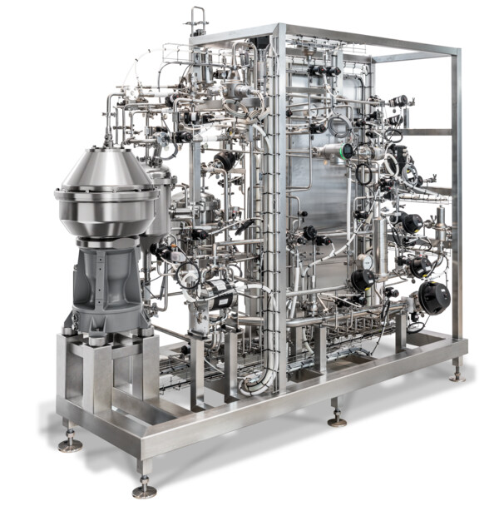

Photo 1, caption: GEA is expanding its pharmaceutical separator platform with the new GEA aseptic 15 (Photo: GEA)

Photo 2:

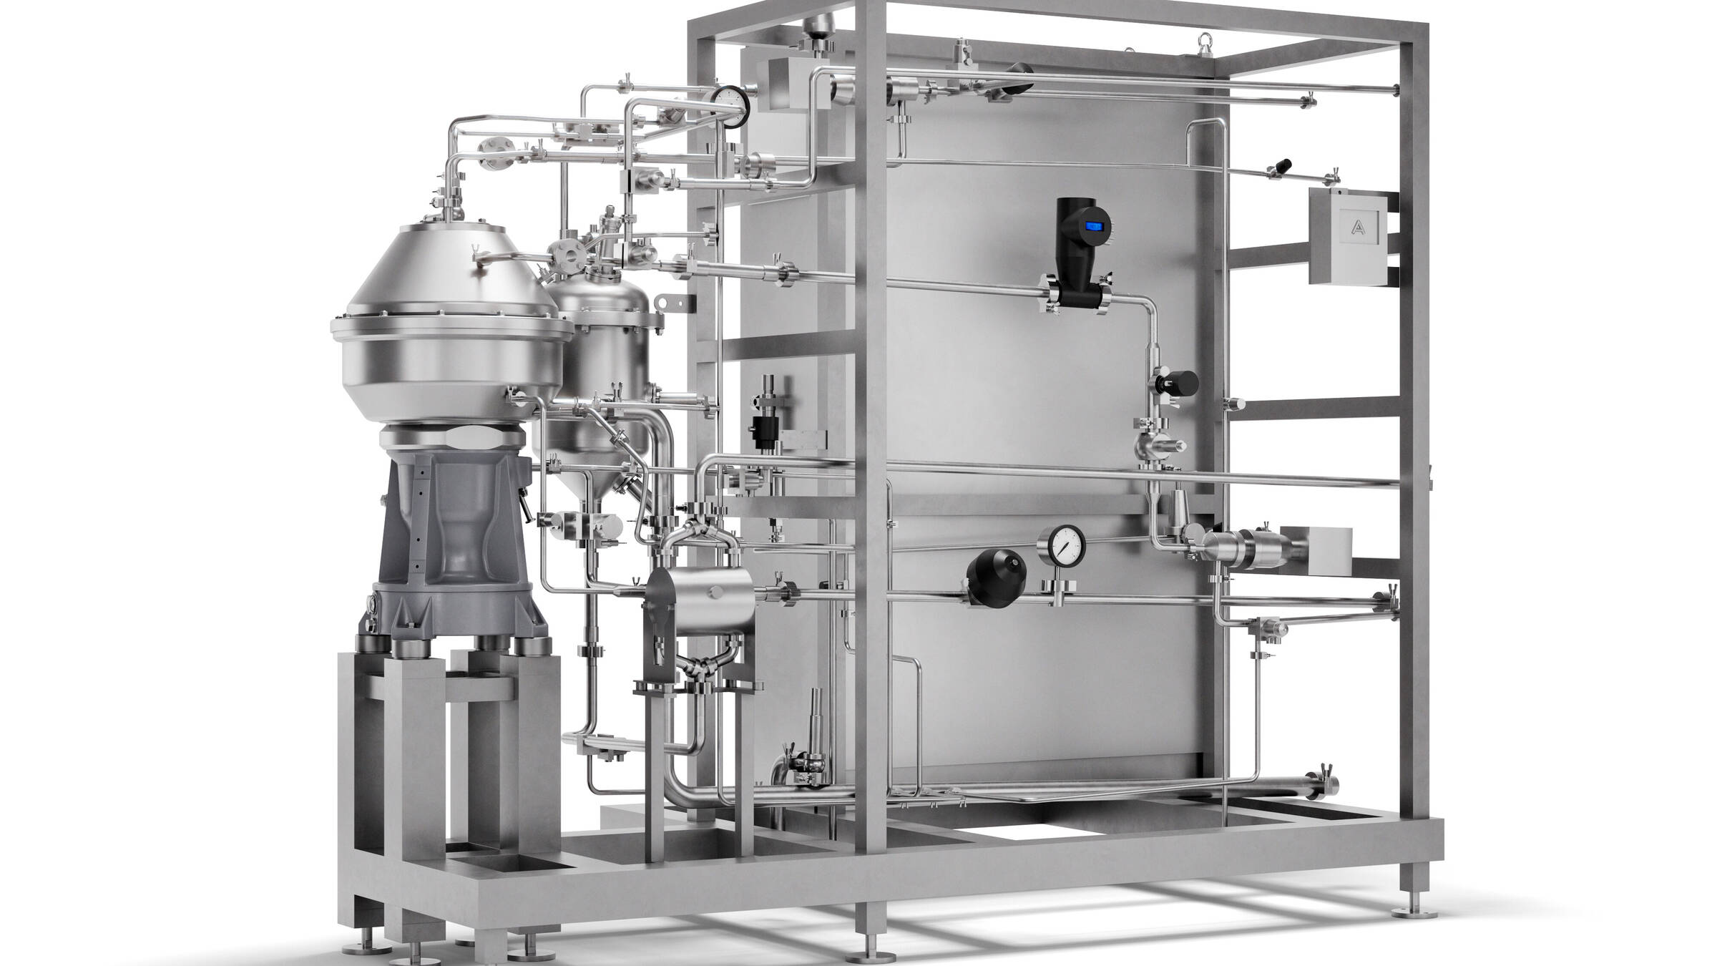

Photo 2, caption: GEA presents the pure 15 model. (Photo: GEA)

NOTES TO EDITORS
- Further information about GEA
- To the GEA Media Library
- Features on current topics
- Overview press events
- Follow GEA on  

About GEA
GEA is one of the world’s largest suppliers of systems and components to the food, beverage and pharmaceutical industries. The international technology group, founded in 1881, focuses on machinery and plants, as well as advanced process technology, components and comprehensive services. For instance, every second pharma separator for essential healthcare products such as vaccines or novel biopharmaceuticals is produced by GEA. In food, every fourth package of pasta or every third chicken nugget are processed with GEA technology.

With more than 18,000 employees, the group generated revenues of about EUR 5.5 billion in more than 150 countries in fiscal year 2025. GEA plants, processes, components and services enhance the efficiency and sustainability of customers’ production. They contribute significantly to the reduction of CO2 emissions, plastic usage and food waste. In doing so, GEA makes a key contribution toward a sustainable future, in line with the company’s purpose: “Engineering for a better world.”

GEA is listed on the DAX, the STOXX® Europe 600 Index and is also a constituent of the leading sustainability indices DAX 50 ESG, MSCI Global Sustainability and Dow Jones Best-in-Class World.

More information can be found online at gea.com.
If you do not want to receive any further information from GEA, please send an e-mail to pr@gea.com.

Media Relations
GEA Group Aktiengesellschaft
Dr. Michael Golek
Ulmenstraße 99, 40476 Düsseldorf, Germany
Phone +49 211 9136-1505
michael.golek@gea.com

