Optimal Training at LAUDA

Training Workshop for Apprentices Redesigned

Lauda-Königshofen, July 15, 2024 – LAUDA DR. R. WOBSER GMBH & CO. KG, the world market leader in precise temperature control, has successfully completed the renovation and expansion of its training workshop. The project, which began in mid-May 2023, now offers optimal training opportunities for commercial apprentices and underscores LAUDA's commitment to the future of the company and its employees.

Dr. Gunther Wobser, President and CEO of LAUDA, emphasizes the importance of this investment: “As a world market leader, it is our responsibility to create optimal conditions for training our future skilled workers. By modernizing our training workshop, we are establishing new standards for ourselves in vocational training and enhancing our reputation as an attractive regional employer.”

The extensive modernization includes doubling the number of workstations from six to twelve with state-of-the-art standard workbenches. In addition, the number of soldering tables with solder fume extraction has also been increased from four to eight, enabling comprehensive soldering training for apprentices and skilled workers. A special highlight is the equipment of the workbenches with separate power supplies, which indicate various safety levels through signal lights.

Dr. Mario Englert, CFO of LAUDA, explains: “The investment in our training workshop is an investment in the future. We have spent a six-figure sum in renovation and modernization to provide our trainers and apprentices with the best teaching and learning conditions.”

Further improvements include the enclosure of the room for better noise protection, a trainer's office with two workstations, and a huge 86-inch digital flipchart for interactive presentations and training sessions. The project concept was developed internally by an experienced team of production planners and training managers. It is particularly noteworthy that the implementation was largely carried out in-house by the commercial apprentices. Under the expert guidance of experienced trainers and project managers, the apprentices were able to directly apply their theoretical knowledge to practice and gain valuable experience in project realization.

With the completion of the modernized training workshop, LAUDA once again underscores its commitment to training and developing young talent. The company offers a wide range of future-oriented apprenticeship occupations, including Electronics Technician for Devices and Systems (m/f/d), Warehouse Logistics Specialist (m/f/d), Mechatronics Technician (m/f/d), and Mechatronics Technician for Refrigeration Technology (m/f/d). The new workshop provides optimal conditions for practical, high-quality training in commercial occupations and simultaneously serves for the further education and training of existing personnel, thereby promoting knowledge exchange and continuous professional development within the company.
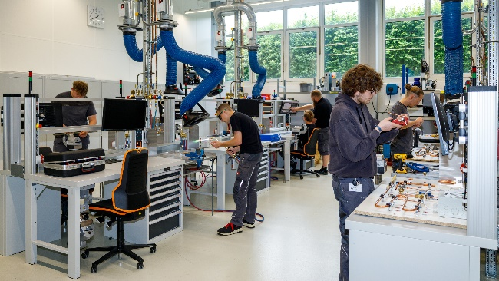 | 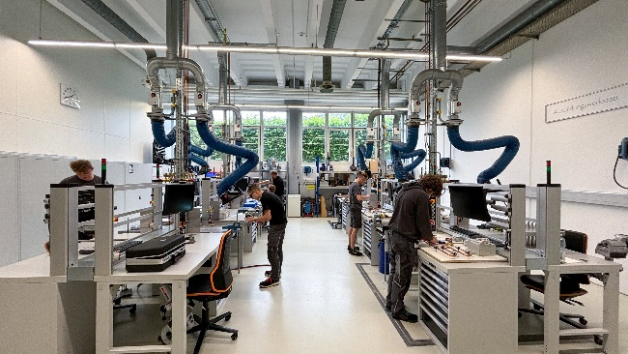
Fig. 1: The modernized LAUDA training workshop offers optimal conditions for aspiring skilled workers. The improved infrastructure enables comprehensive and modern training in various manufacturing techniques. © LAUDA | Fig. 2: Learning at the world market leader for precise temperatures: The apprentices utilize the twelve top-equipped workstations and the expanded possibilities of the modernized training workshop at LAUDA. © LAUDA

We are LAUDA – the world leader in precise temperature control. Our constant temperature equipment and systems are at the heart of important applications, contributing to a better future. As a complete one-stop supplier, we guarantee the optimum temperature in research, production and quality control. We are the reliable partner for electromobility, hydrogen, chemicals, pharmaceuticals/biotech, semiconductors and medical technology. We have been inspiring our customers for almost 70 years with our expert mentoring and innovative solutions – every day anew and all over the world.

In our company, we always go one step further. We support our employees’ development and are constantly developing ourselves: to create a better future together.

Press contact
We are more than happy to make prepared information about our company, the LAUDA Factory Gallery and our projects in the area of innovation promotion, digitalization and idea management available to the press. We look forward to hearing from you – just give us a call!

CHRISTOPH MUHR
Director Corporate Communications
T + 49 (0) 9343 503-349
christoph.muhr@lauda.de

LAUDA DR. R. WOBSER GMBH & CO. KG, Laudaplatz 1, 97922 Lauda-Königshofen, Deutschland/Germany. Limited partnership: Headquarters Lauda-Königshofen, Registration court Mannheim HRA 560069. General partner: LAUDA DR. R. WOBSER Verwaltungs-GmbH, Headquarters Lauda-Königshofen, Registration court Mannheim HRB 560226. Managing Directors: Dr. Gunther Wobser (President & CEO), Dr. Mario Englert (CFO), Dr. Ralf Hermann (CSO), Dr. Marc Stricker (COO)

