Fachpack in Nuremberg (Germany)

GEA presents new thermoforming packaging machine especially for small and medium-sized companies in the food sector

Düsseldorf (Germany), August 22, 2024 – Under the motto RE:THINK PACKAGING, GEA will present the latest machine and control technology for the food sector at the Fachpack in Nuremberg (Germany) from September 24 to 26 (Hall 7A/Stand 563). The focus will be on the new PowerPak 1000 thermoformer for the packaging of meat and meat substitutes, poultry or cheese, which has been specially developed as an entry-level machine for the thermoforming segment and offers advanced functions previously reserved for machines in the higher performance range.

Playing in a higher league with the PowerPak 1000

"We are delighted to be able to introduce the PowerPak 1000 to a wider audience. With this machine, we can now help smaller companies improve the efficiency of their packaging processes and increase their output, offering them our many years of expertise and flexible service," says Stefan Runkel, Product Manager Thermoforming at GEA Food Application Solutions. For companies looking to move away from traditional methods such as vacuum chamber machines or traysealers to increase capacity and flexibility, the new GEA solution offers many other benefits, such as flexibility in pack size or reduced plastic consumption.

The PowerPak 1000 can produce vacuum, MAP or skin packs to meet a wide range of product and packaging requirements, allowing customers to quickly adapt the machine to changing consumer needs. The new packaging machine can be seen and tested live at the GEA Technology and Application Center XLAB in Biedenkopf-Wallau, Germany.

SmartPacker CX400 – another technology highlight at Fachpack

Another highlight is the SmartPacker CX400 vertical pillow bag packaging machine.
The packaging machine produces four different types of pouches for many different products such as frozen and fresh fruit, vegetables, potatoes or protein foods. This form-fill-seal model is designed for high capacity and maximum productivity. It processes bag widths between 55 mm and 400 mm and up to 120 bags per minute.

Other benefits include fast changeover of bag formats and film types in less than 5 minutes and sensitive detection of product in the seal. Hand-crafted forming shoulders with a high-tech composite surface ensure smooth over-the-shoulder film transport, even in humid or wet environments. The CX400's Smart Sealing System can seal up to one million bags before the sealing strips need to be replaced. With the click-and-go device, this is done without long downtime and at maximum output.

gea.com
Picture Overview

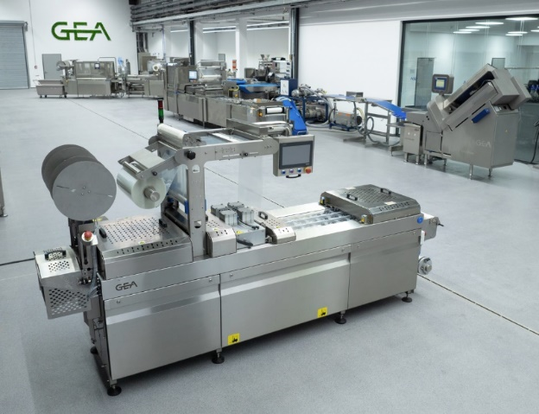
Pic. 1: The new GEA PowerPak 1000 thermoformer packaging machine is specially designed for small companies and can be tested at the GEA XLAB Technology Center in Biedenkopf-Wallau, Germany. (Source: GEA)

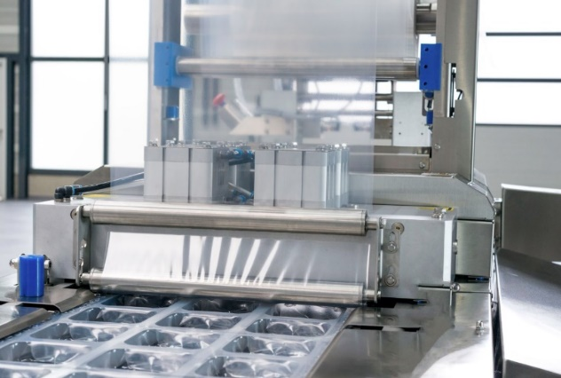

Pic. 2: Film infeed and the sealing station of the new GEA PowerPak 1000 thermoformer. (Source: GEA)

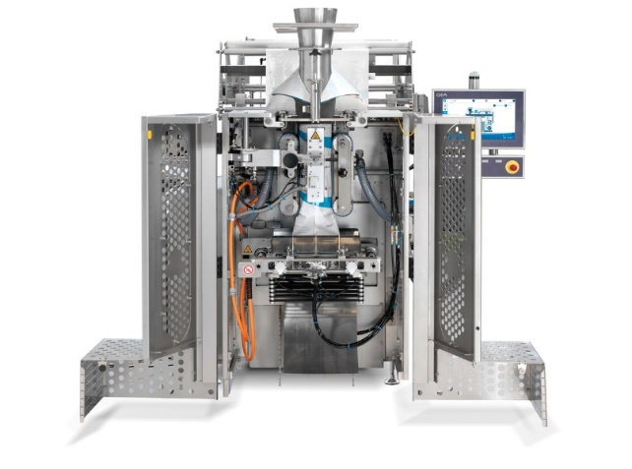
Pic. 3: GEA SmartPacker CX400 (Source: GEA)

NOTES TO THE EDITORS
- Further information about GEA
- To the GEA Media Library
- Features on current topics
- Overview press events
- Follow GEA on  

Media Relations
GEA Group Aktiengesellschaft
Nicole Hoffmann
Peter-Müller-Str. 12, 40468 Düsseldorf, Germany
Phone +49 211 9136-1503
nicole.hoffmann@gea.com

About GEA
GEA is one of the world’s largest suppliers of systems and components to the food, beverage and pharmaceutical industries. The international technology group, founded in 1881, focuses on machinery and plants, as well as advanced process technology, components and comprehensive services. With more than 18,000 employees, the group generated revenues of about EUR 5.4 billion in more than 150 countries in the 2023 fiscal year. GEA plants, processes, components and services enhance the efficiency and sustainability of customer’s production. They contribute significantly to the reduction of CO₂ emissions, plastic usage and food waste. In doing so, GEA makes a key contribution toward a sustainable future, in line with the company’s purpose: ”Engineering for a better world“.

GEA is listed on the German MDAX the European STOXX® Europe 600 Index and is among the companies comprising the DAX 50 ESG, MSCI Global Sustainability as well as Dow Jones Sustainability World and Dow Jones Sustainability Europe Indices.

More information can be found online at gea.com.
If you do not want to receive any further information from GEA, please send an e-mail to pr@gea.com.

