Glass Skylight renovation with LAMILUX - from planning to installation with a single source

Safe and economic renovation

Daylighting elements can be of such high quality: After several decades of use, there comes a time when they need to be optimised for energy efficiency or replaced due to damage. To ensure that their renovation complies with both building regulations and health regulations, planners and building operators should rely on a competent partner. "Thanks to our decades of experience, customers can rely on the expertise of LAMILUX. We offer a comprehensive service - starting with a detailed consultation, through the development of an economic concept, to the actual installation," explains Dr. Alexander Strunz, managing director of LAMILUX.

Deteriorationg glazing, breakages or cracks: The age of certain materials as well as extreme weather with storms and hail can severely affect daylight elements. To be on the safe side, legally, and to protect the health of building users, outdated or damaged rooflights should be replaced immediately. Manufacturer LAMILUX is there to provide advice and support throughout all renovation phases. Furthermore, a renovation - like new construction - must be carefully planned.

Everything from a single source - offering full planning reliability
First, the LAMILUX consultants visit the building to assess the current condition of the property to be refurbished. All functional and energy requirements for the new daylight systems are defined in close consultation with the customer. It must be clarified, in which condition the existing material is in and whether the current constructions can still be used. LAMILUX offers customised solutions for the respective requirements - such as energy-efficient Rooflights or Glass Skylights. Renovation frames are used for their installation: for simple replacement, LAMILUX can use them to attach to any upstand. If the entire roof is to be renovated for energy efficiency - and thus the roof structure is usually also adapted - extension elements are the right choice.

All renovation processes are customer- and result-oriented: For a high degree of planning and cost security, both the disassembly of outdated constructions and the installation of new daylight systems are carried out in the shortest possible time - without interfering with production or operational processes in the building. The Caritas Association in Hagen (NRW) was also able to convince itself of this. There, outdated and dirty rooflights ensured that only little daylight fell into the interior rooms of the Caritas workshop for people with disabilities. Thanks to LAMILUX, this is no longer the case: Now, a total of 54 Glass Skylight F100 and nine Glass Skylight FE adorn the roof of the workshop. Due to the structural glazing design and the associated flush glazing in the frame of the windows, water runs off unhindered, reducing dirt deposits in the future.

The right solution for every project
“STUTE Nahrungsmittelwerke” in Paderborn (NRW) is once again pleased to have plenty of daylight: Here, 36 Continuous Rooflight B in various sizes and 15 Smoke Lift Continuous Rooflight B were installed. Thanks to their effective smoke extraction effect, the latter ensure a high level of safety in case of fire whilst enabling daily ventilation. The hall roofs and daylight elements had previously been damaged by a storm. The energy values were also no longer satisfactory. "Here we offer planners real relief with our renovation concept," summarises LAMILUX Managing Director Dr. Alexander Strunz.

Interested planners can find further information on safe Glass Skylight renovation using LAMILUX daylight systems in the manufacturer's own renovation brochure - available at www.lamilux.de.

…

www.lamilux.com

LAMILUX Heinrich Strunz Group, Rehau
Continuous Rooflights, Glass Roofs or Rooflights: the LAMILUX Heinrich Strunz Group is one of the leading manufacturers of daylight systems in Europe. The skylights ensure efficient use of natural daylight in a wide variety of buildings. In addition, special smoke and heat extraction systems provide safety in the event of fire and are thus essential components of fire protection concepts. LAMILUX is also known for its solutions for building smoke extraction. Furthermore, the medium-sized family business founded in 1909 is one of the world's largest producers of carbon and glass fibre reinforced plastics. These composite materials provide stability, lightweight construction and impact resistance, for example as roof, wall and floor linings in commercial vehicles. The company currently employs around 1,300 people and has a turnover of around 392 million euros in 2022.

Photo captions

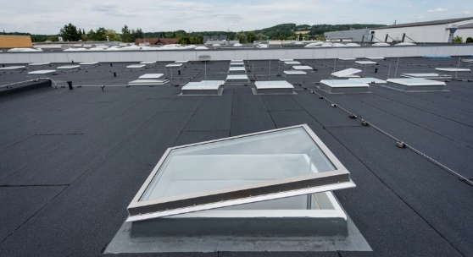
[22-01 Glass Skylight]
Roof of the Caritas workshop in Hagen: Here, dirty rooflights were replaced with Glass Skylights "F100" and "FE" from LAMILUX.
Photo: LAMILUX

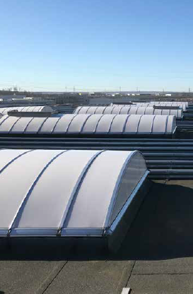
[22-02 STUTE Paderborn]

The new LAMILUX continuous rooflights that now adorn the roof of “STUTE Nahrungsmittelwerke” in Paderborn guarantee a high level of fire protection and enable daily ventilation.
Photo: LAMILUX

[22-01 expert advice]
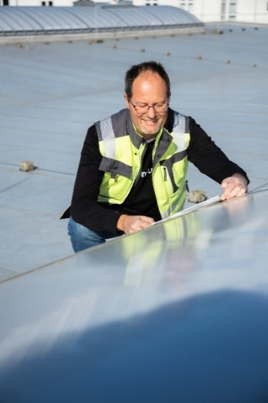

Many years of experience guarantee a high level of expertise: with LAMILUX, planners have a competent partner for new buildings and energy-efficient renovations at their side.
Photo: LAMILUX

